Nourish Hub Manager

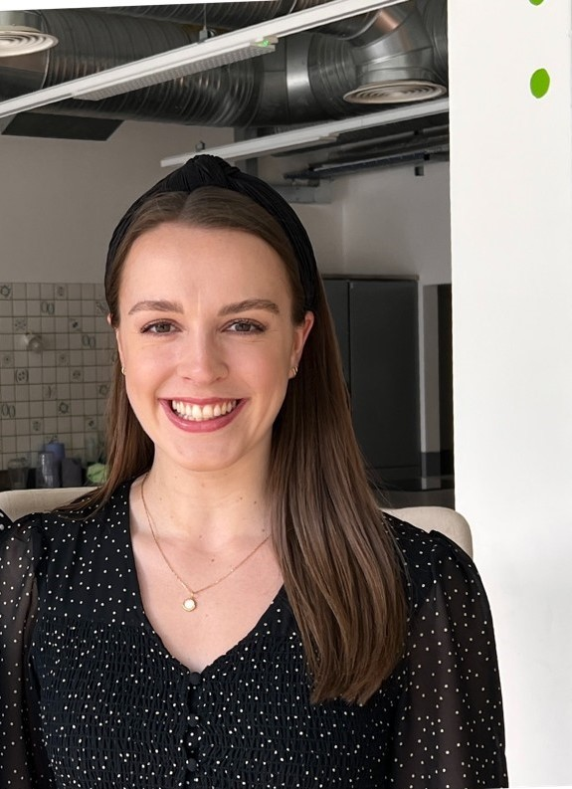
Ffion Hayward, UK Harvest

What qualifications do you have?

BSc Nutritional Sciences

Registered Nutritionist AfN

What does your job involve?
I am the Nourish Hub Manager. The Nourish Hub is a community food hub that uses food as medium to support the most socially isolated and lonely, and to provide personal and development and enrichment through nutritious food and education.
From the sociable nature of sharing food, to the formal training opportunities afforded via its training kitchen and education programme, the Nourish Hub builds the capacity of the local community.
Community empowerment and ownership are core principles to Nourish Hub. The space brings people together to achieve positive change using their own knowledge, skills and experience and result in long-lasting behavioral change and empowerment.
My day to day includes the management of the brilliant team, business operations, data collection and reporting, alongside the delivery of our education programme and developing a network of partnerships and funders.

What, or who, inspired you to take your chosen career pathway?
My parents and certain teachers inspired me to take this career pathway. My parents always told me to do what I enjoyed and what excited me – this was food and sport when I was younger which led me to take the A levels I did (Food Technology, Physical Education and English Language). My PE teacher especially, Miss B, opened my eyes to the many opportunities that existed within food. I always wanted to go to university, so when looking at university degrees Nutritional Sciences stood out and that’s the route I took.

What route did you take from leaving school to your current job?
After GCSE’s I completed my A Levels (English Language, Physical Education and Food Technology) and then went straight to university to complete my BSc Nutritional Sciences for 4 years, which included a placement year.

What is the key knowledge, skills and experience needed for your job?
Knowledge and skills: building relationships, leadership, organisations, nutrition and health, computer literacy, understanding of the community/area you are working in/with, health promotion and communications.
Experience: working on the ground with communities, collecting data and compiling reports, delivery of educational programmes and service provision.

What is the best thing about your job?
The best thing about the job is seeing the impact the hub has on individual lives each day - providing people with nutritious food, seeing individuals grow in knowledge and confidence and ensuring people get the support they require.

What questions are you often asked about your job?
Do you enjoy working for a charity?
Who do you support?
How are you able to do what you do?
Where do you rescue food from?

What advice would you offer to someone interested in doing what you do?
Gain experience wherever possible, preferably in customer/client facing roles, building your confidence and knowledge in speaking with people from all backgrounds. Take up the opportunity to do training wherever possible and always do what you enjoy.

