Soda bread
Ingredients
Complexity: low-medium
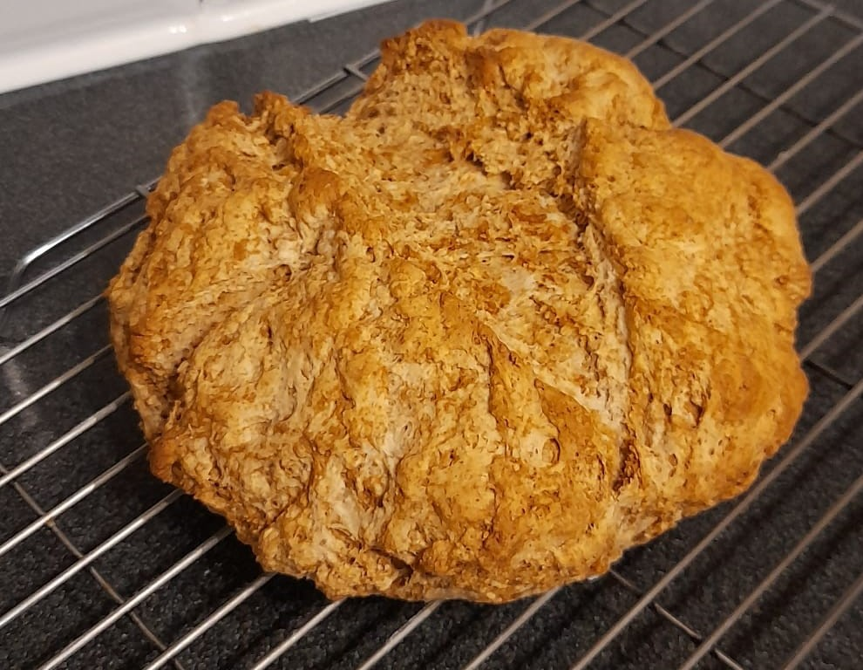170g plain flour
170g self-raising wholemeal flour
250ml milk
1 x 15ml spoon of lemon juice
1 x 5ml spoon bicarbonate of soda

Equipment
Weighing scales, measuring jug, measuring spoon, sieve, large bowl, fork, flour dredger, baking tray, knife, oven gloves, cooling rack.

Method
- Preheat the oven to 200°C or gas mark 6.
- Stir the lemon juice into the milk to make it curdle.
- Sift both flours, and the bicarbonate of soda, into the large bowl. Tip in the bran from the sieve.
- Add the milk and mix everything together quickly to form a soft dough.
- Place the dough onto a floured surface and knead lightly for a few moments to form a round, flattened ball.
- Place the dough onto a floured baking tray and score a cross on top of the dough, pressing half way through the dough.
- Carefully, place the bread into the hot oven, wearing oven gloves.
- Bake for 25 - 30 minutes.
- Wearing oven gloves, remove the bread from the oven, and place onto a cooling rack.

Top tips
- Eat whilst the bread is still warm, perhaps with soup.
- Why not try adding dried fruit or seeds?

Food skills
- Weigh.
- Measure.
- Sift.
- Mix.
- Knead.
- Form and shape.
- Bake.

