Serving size and energy
Weigh out 100g of each of each food. Read the food packaging and record the energy in kilojoules (kJ) and in kilocalories (kcals) provided by 100g.

Think about the amount of this food that you would eat and weigh that amount.

Calculate the energy in this serving size.

Food | Energy (kJ/kcals) per 100g | I would eat… (g) | This would provide…
Spread
Breakfast cereal
Bread
Carrots

Oranges
Baked beans

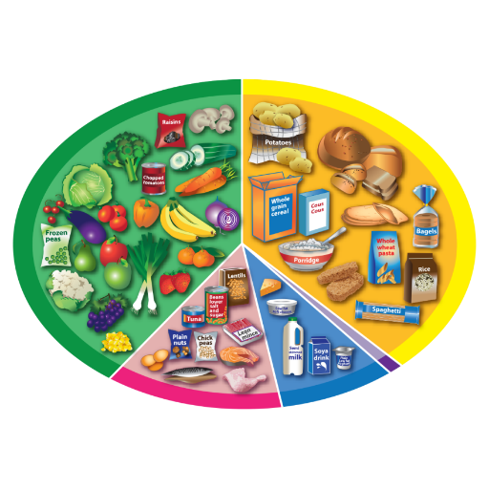
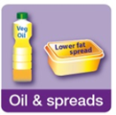
Write three points explaining what you notice about how much energy is in food.

