Fruit and vegetables group
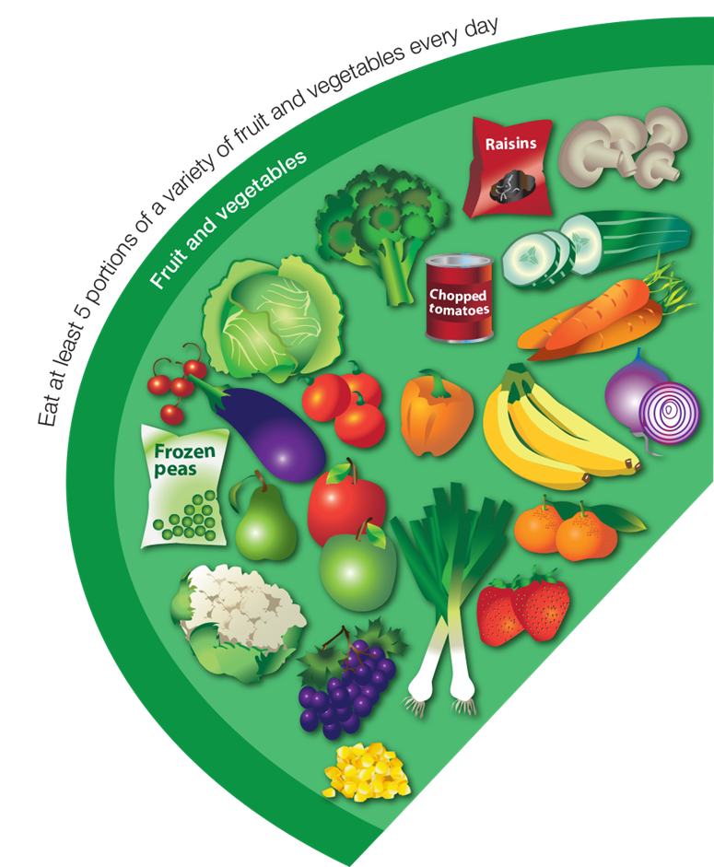

Potatoes, bread, rice, pasta and other starchy carbohydrates group
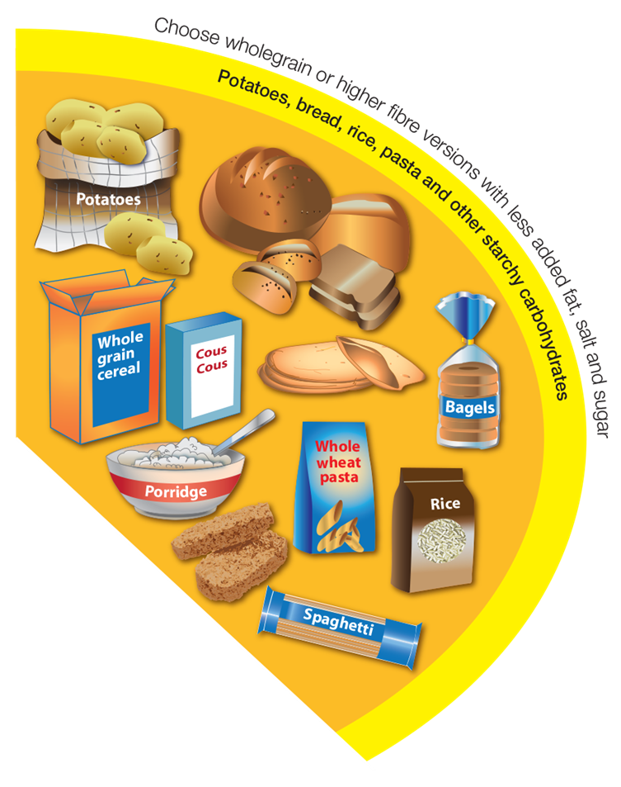

Beans, pulses, fish, eggs, meat and other proteins group

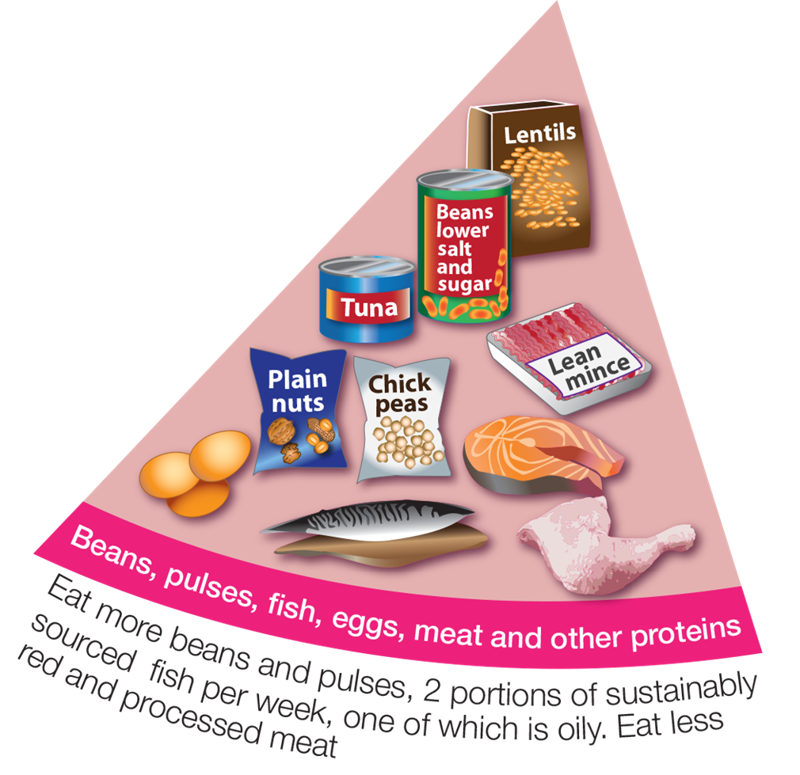

Dairy and alternatives group
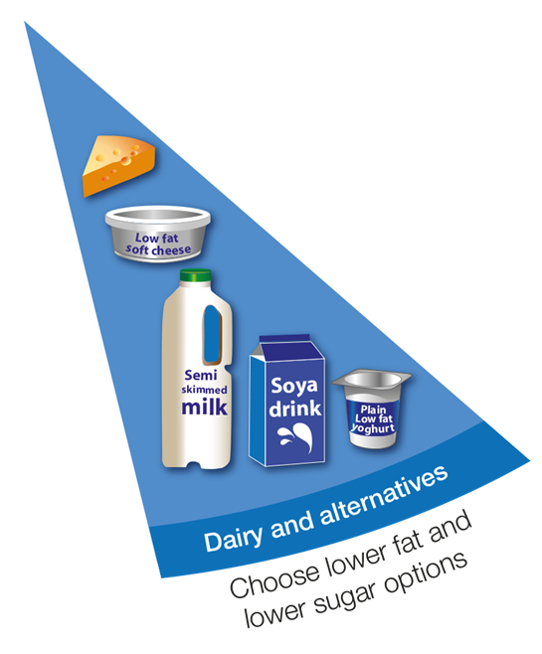

Oil and spreads group

