Modified starches – student activities

Modified starches in ‘instant’ products
An important function of modified starches is in convenience foods that are designed to last a long time in storage at room temperature and be quickly readied for eating (usually by adding hot or cold liquid). Comparing these products to homemade versions of the same item can be a useful tool to explore how these starches work and to compare sensory characteristics.

Useful comparisons include:

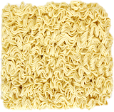
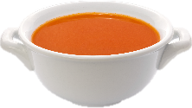
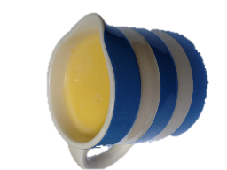
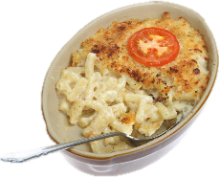
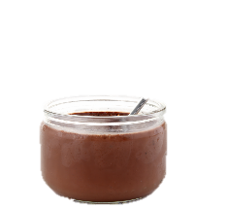
- Make a homemade tomato soup, such as the ‘Spicy tomato soup’ recipe. Compare this with a tomato cup-a-soup, prepared according to the instructions on the packet.
- Use the ‘Macaroni cheese’ recipe to prepare a basic macaroni cheese. You could compare this to a box of instant macaroni cheese, or make a macaroni cheese with dried cheese sauce powder or granules.
- Make and compare a homemade custard, custard using custard powder (prepared on the stove) and a packet of instant custard mix. Use the Custard making activity.
- Compare a cooked batch of fresh egg noodles to a dried ‘block’ of instant noodles. You may also want to compare a pre-made noodle convenience snack, which often also comes with a dried powder for an instant sauce.
- Make and compare a homemade chocolate mousse and a ‘chocolate instant dessert’. Use the Chocolate mousse activity.

Questions:
(Students may wish to use the Modified starch information sheet).
- How long does each homemade product take to make, compared with the ‘instant’ version?
- How do the sensory characteristics of the homemade and instant products compare (e.g. smell, taste, texture)?
- Explain how modified starch (particularly pregelatinised starch) enables instant products to be rapidly hydrated and be ready to eat quickly.
- Describe two other applications of modified starches in food.
- Name the three ways in which starches may be modified.

