Eatwell Guide and nutrients
What are the main nutrients provided by each food group in the Eatwell Guide?
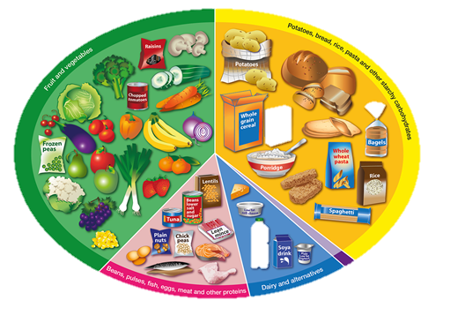
Fruit and vegetables
Potatoes, bread, rice, pasta and other starchy carbohydrates

Beans, pulses, fish, eggs, meat and other proteins
Dairy and alternatives
Oil and spreads

