Healthy eating

Try some of these activities!
Make a healthy human game  Play the Make a healthy human game!  You will need:  - A copy of the Make a healthy human sheet    - A dice  - A copy of the Eatwell Guide  (to help) |   Top taster  Eating a variety of foods is good for our health.  Make a plan to try a new food each week! You can use the Tasting ingredients sheet to track what you taste and what you think of the food.
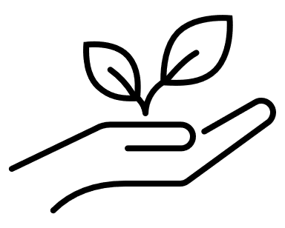  Wonderful water!  Water is a great choice for a drink!  Colour in a glass on the Drink tracker every time you have a drink of water this week.  Can you get up to 20 glasses? | 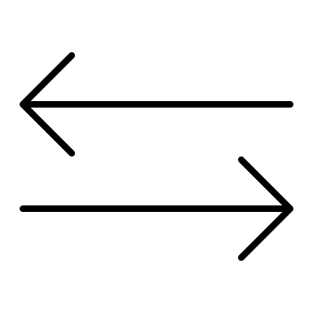  Super swaps  Foods like sweets, biscuits, crisps and chocolate are not needed by our body to keep us healthy.  Try to swap one of these foods for a fruit or a vegetable instead this week.

