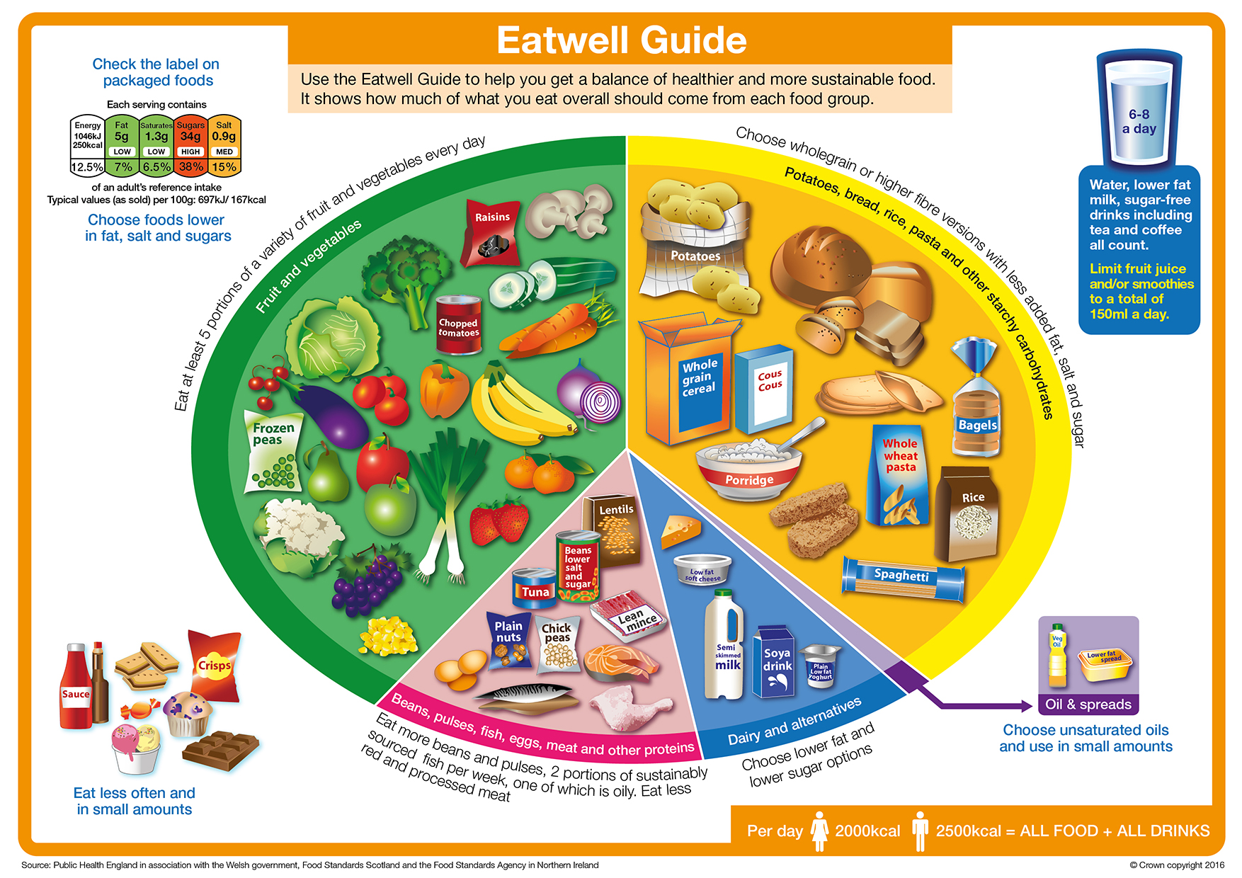

Seasonal fruit and vegetables
The Eatwell Guide shows the recommended proportions of different types of food in the diet.

List 8 foods shown in the Fruit and vegetables food group.

 | Do they grow in the UK? | When are they in season?
1.
2.
3.
4.
5.
6.
7.
8.

