Chicken nuggets

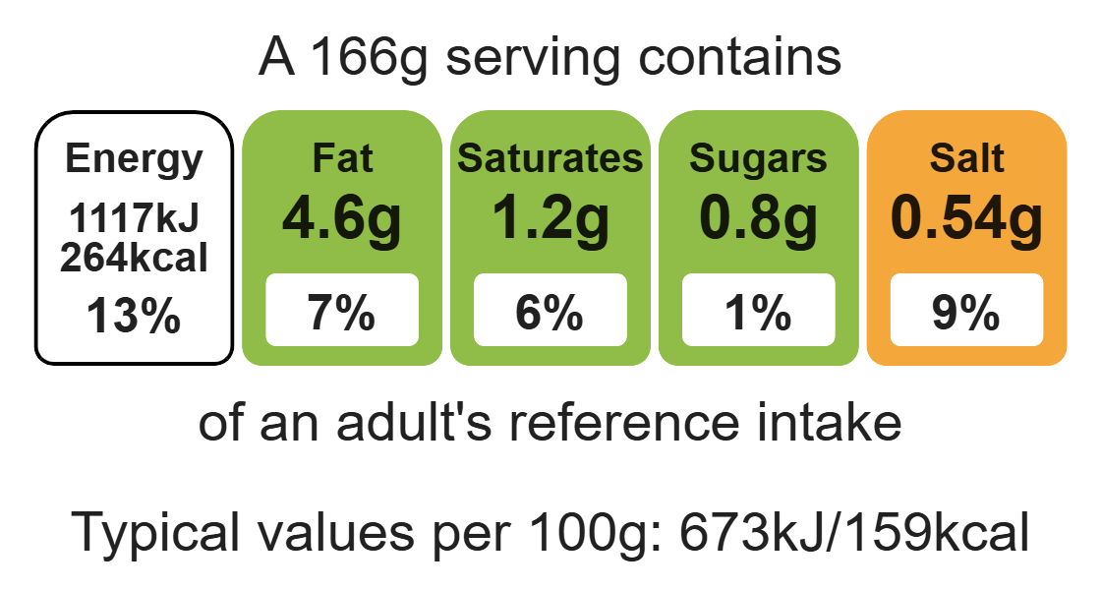
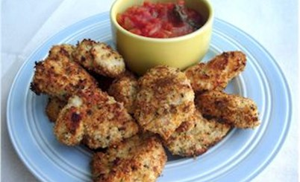

Ingredients (serves 2)
Complexity: low - medium

50g breadcrumbs

1x5ml spoon mixed herbs

Equipment

Baking tray

Two small bowls

Fork

Small plate

Chopping board

Sharp knife

Baking tray

2 chicken breasts

1x15ml spoon plain wholemeal flour

1 egg

Method
- Preheat the oven to 200ºC or gas mark 6.
- Add the breadcrumbs, and herbs and mix into a small bowl.
- Pour the flour onto a small plate.
- Beat the egg in a small bowl.
- Cut the chicken into nuggets (approximately 4cm x 3cm chunks) using a clean red chopping board.
- Breadcrumb the chicken nuggets:
  - dust the chicken pieces in the flour;
  - dip in the beaten egg;
  - roll in the breadcrumb mixture
- Place the chicken nuggets on the baking tray.
- Repeat the steps for breadcrumbing the chicken with all the chicken pieces. Thoroughly wash and dry your hands after.
- Bake in the oven for 20 minutes, until golden brown. Check the chicken is cooked through with no pink remaining.

Top tips
- Turn up the flavour: Add garlic, chilli, fresh herbs, spices or parmesan cheese to the breadcrumbs to enhance the flavour.
- Vary your protein: Swap the chicken for pieces of fish, such as cod and haddock.
- Focus on fibre: Make your own breadcrumbs using wholemeal bread. Place the breadcrumbs in a blender or grate them.
- These chicken nuggets can be cooked in an air fryer also, cook at 180ºC for 15 minutes.

Food skills
Weigh, measure, mix, stir and combine, beat, cut, chop, slice, dice and trim, bake.

