Chemical raising agents

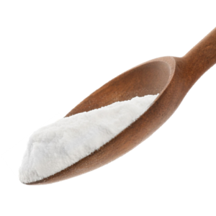
Learning
The aim of this session is to:
- demonstrate the reaction of baking soda with an acid.

You will need:
- 75g baking soda;
- 200ml white vinegar;
- 1 2 litre, clean, empty plastic bottle;
- 1 regular party balloon.

Instructions:
- Fill a balloon with the 75g of baking soda.
- Pour 200ml of white vinegar into the empty plastic bottle.
- Taking great care, place the balloon over the neck of the bottle, without allowing any baking soda to fall in.
- Once secure, allow the baking soda to drop into the bottle and mix with the vinegar.
- Make sure to keep the balloon tightly over the neck of the bottle.
- What can you observe happening in the bottle? What happens to the balloon? Write down your observations.
- Take care not to let the balloon burst! Remove it if necessary.

Questions
Think about these questions after you have completed the experiment:
- Which gas is produced through the reaction of baking soda and vinegar?
- What do you think would happen if you used water instead of vinegar?

Bonus scientific experiments
- Tie off the filled balloon and blow up another balloon, filling it with air (to about the same size). Drop both balloons from a height. Which hits the ground first and why?

- Place a thermometer in a cup and mix more baking soda and vinegar together. Does the temperature go up or down?

