My senses

First|: Name the senses.
Then: Write or draw an example of a food for each sense.
Sense | Part of the body | Foods
 | 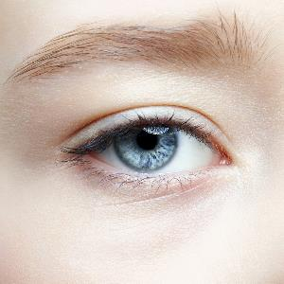
 | 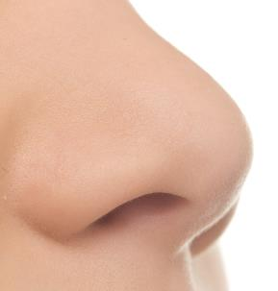
 | 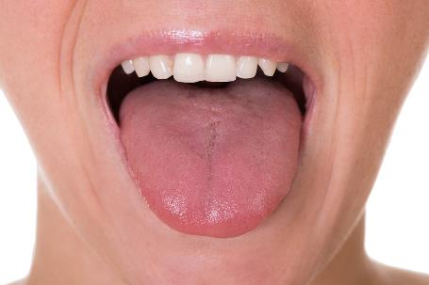
 | 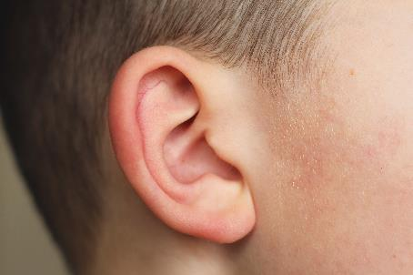

Key words:

Eye Sound Ear Mouth

Taste Smell Sight Nose

