Speedy flatbreads
Complexity: low-medium

Ingredients
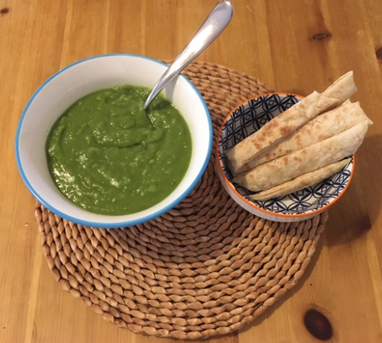
150g self-raising flour
150g low fat natural yogurt
Black pepper
Extra flour for kneading

Equipment
Mixing bowl, mixing spoon, non-stick frying pan.

Method
- Mix the flour, yogurt and black pepper in a bowl.
- Tip onto a clean, floured surface and knead gently until smooth.
- Divide the dough into four and shape into balls.
- Flatten and shape into a circle, about the size of a saucer or 12-14 cm.
- Heat the non-stick frying pan and cook the flatbreads one by one until they are crisp and golden, approximately 2-3 minutes each side.

Top tips
- Use wholemeal flour for extra fibre. For a non-wheat version of this recipe, use gluten free flour.
- No yogurt? Use water instead – slowly add enough to form a soft dough.
- For added flavour scatter the shaped dough with cumin seeds, chopped garlic, coriander or chillies. Use up green carrot tops or spring onion green ends. Stems/stalks of herbs have lots of flavour and can be chopped and added, e.g. coriander. Fold the dough in half, roll-out or shape again into a circle and cook in the same way.
- Serve cut into slices with homemade soup. Why not try this quick, easy and affordable recipe for pea soup using canned mushy peas?
Pea soup
1 small onion, peeled and chopped
1 clove garlic, crushed
2 cans mushy peas
1 vegetable stock cube
500ml boiling water
1 teaspoon oil or spray oil
Black pepper

Method
- Peel and chop the onion.
- Peel and crush the garlic.
- Heat the oil in a saucepan and fry the onion and garlic until soft, approximately 3-4 minutes.
- Add the mushy peas, crumble over the stock cube and add the boiling water.
- Stir well and bring to the boil.
- Simmer for 15 minutes.
- Serve.

Food skills
- Weigh
- Measure
- Mix
- Shape
- Fry

