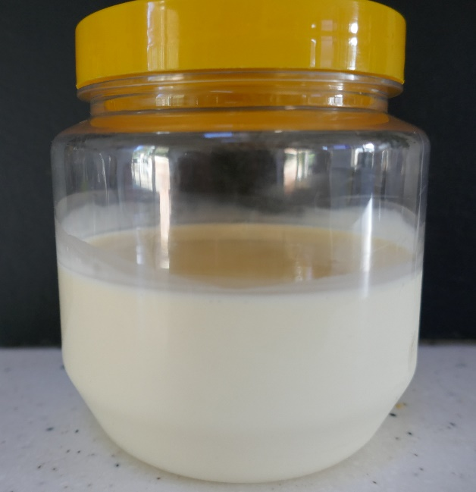
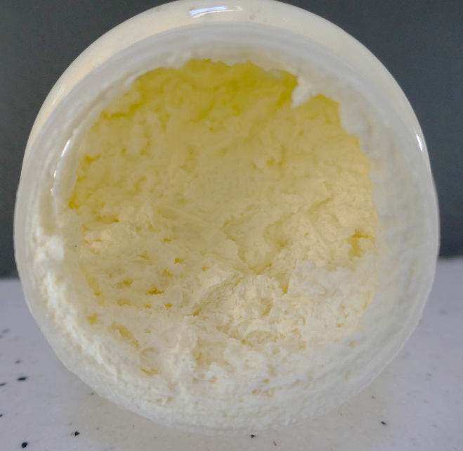
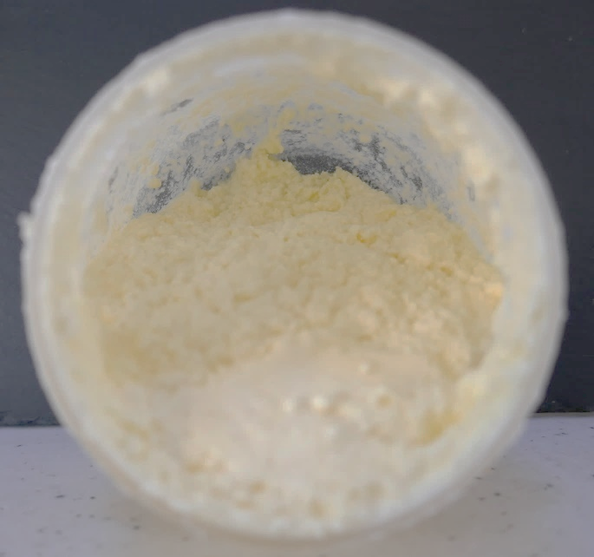
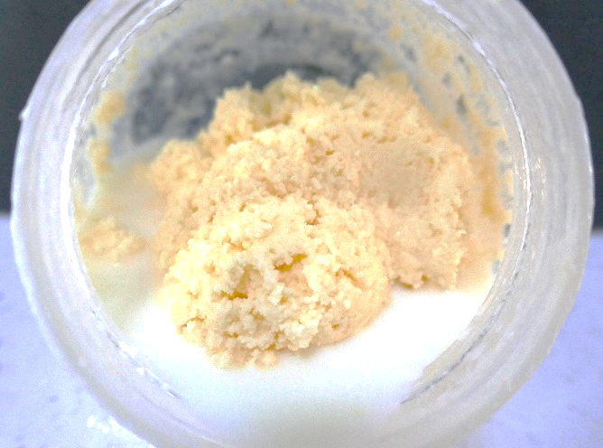
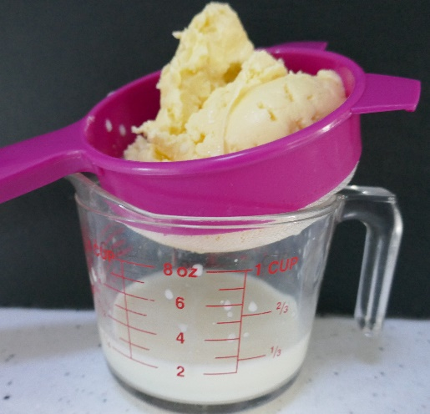
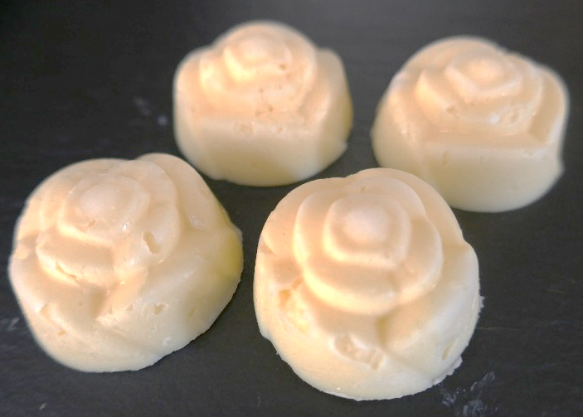
Homemade dairy free butter

What you will need per person
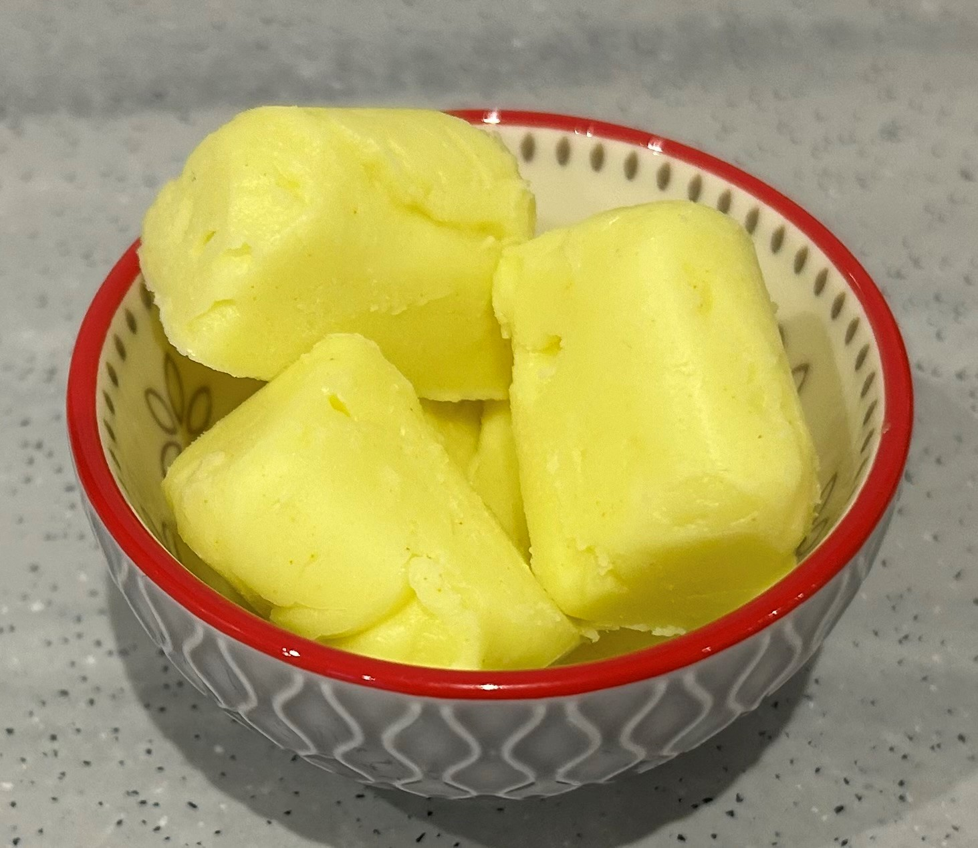
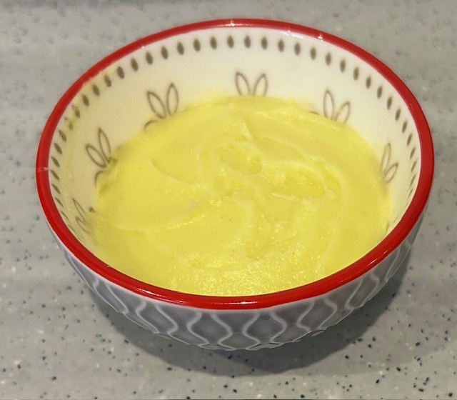
- 40ml coconut oil
- 20ml vegetable oil
- 10ml dairy free milk
- Pinch of turmeric
- Measuring jug and measuring spoons
- Small saucepan or microwavable bowl
- An empty plastic or glass screw top jar
- Ice cube tray, butter mould or small dish

Method
- Gently melt the coconut oil in the microwave or on the hob. Be careful as this may become hot – do not allow to boil.
- Place the melted coconut oil, vegetable oil, dairy free milk and turmeric in the jar. Screw on the lid.
- Shake until you get a well-mixed and homogenous pale mixture, approximately 1-2 minutes.
- Refrigerate for about 10 – 15 minutes, until a bit firmer.
- Then shake again until the mixture is pale, smooth and thick. You will hear and feel that the liquid has become much thicker. If need be, chill for a few more minutes for the mixture to firm up and then shake again.
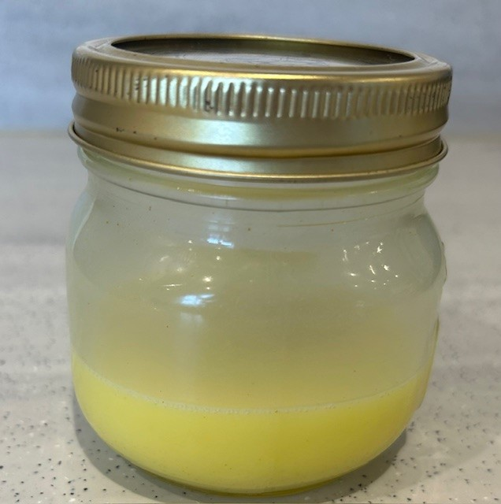
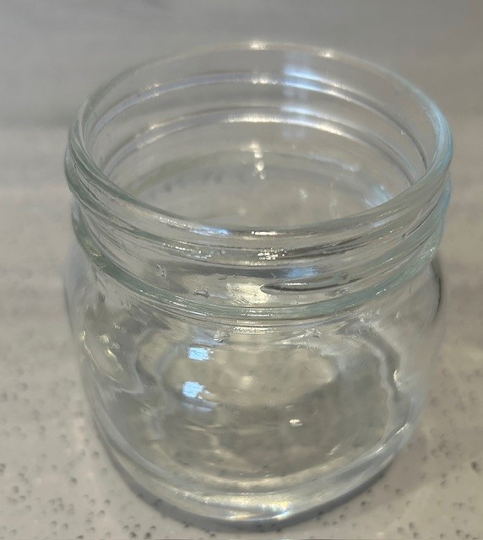
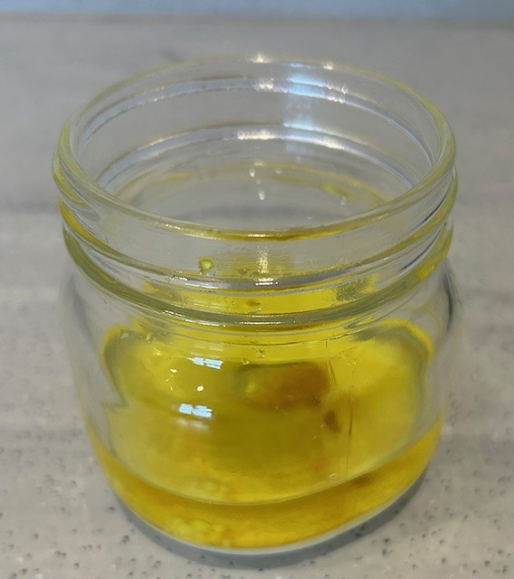
- Press the dairy free butter into an ice cube tray, butter mould or small dish and chill in a refrigerator until firm.
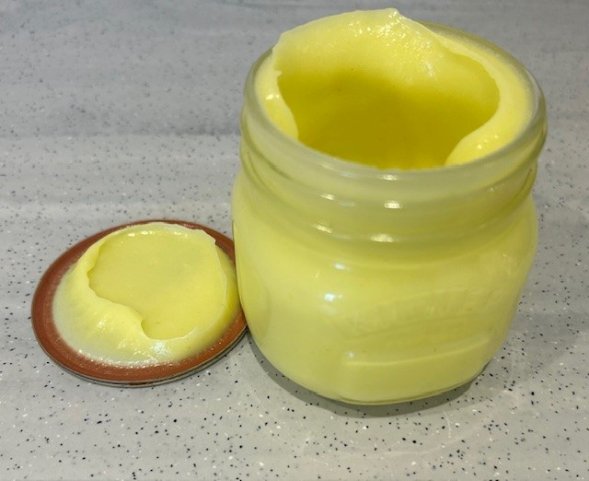
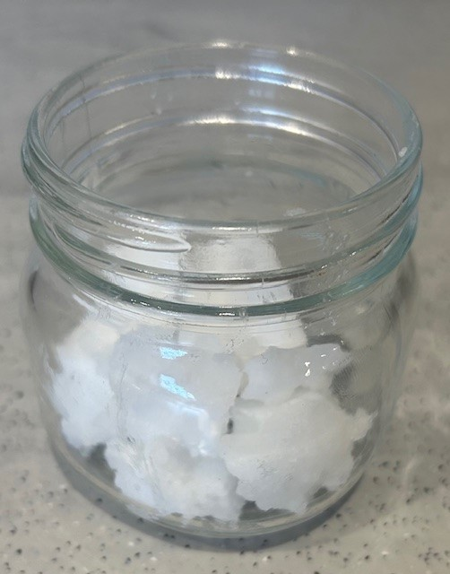
Alternatively, the dairy free butter can be made in pairs or groups using an electric hand whisk. Melt the required amount of coconut oil and add to the rest of the ingredients in a large mixing bowl. Whisk with a hand whisk until you have a well-mixed and homogenous pale mixture. Refrigerate for 10-15 minutes, until a bit firmer. Then, using an electric hand whisk, beat the slightly firmed up dairy free butter for about 2 minutes. It will become pale and fluffy. Press the dairy free butter into an ice cube tray or butter mould and chill in a refrigerator until firm.

Top tips
- Why not try flavoured butter? Great to add to meat or fish dishes. Just beat in the flavourings before you shape your butter. Some suggestions are:
  - garlic and parsley;
  - basil, vegan Italian hard cheese and tomato;
  - chilli, coriander and lime;
  - honey, sriracha and garlic.

This homemade dairy free butter recipe and associated activities have been created as part of the Agriculture and Horticulture Development Board (AHDB) Ingredients into Schools programme.

This resource meets the Guidelines for producers and users of school education resources about food.

