Twarog (homemade cottage cheese)

Ingredients
Complexity: low
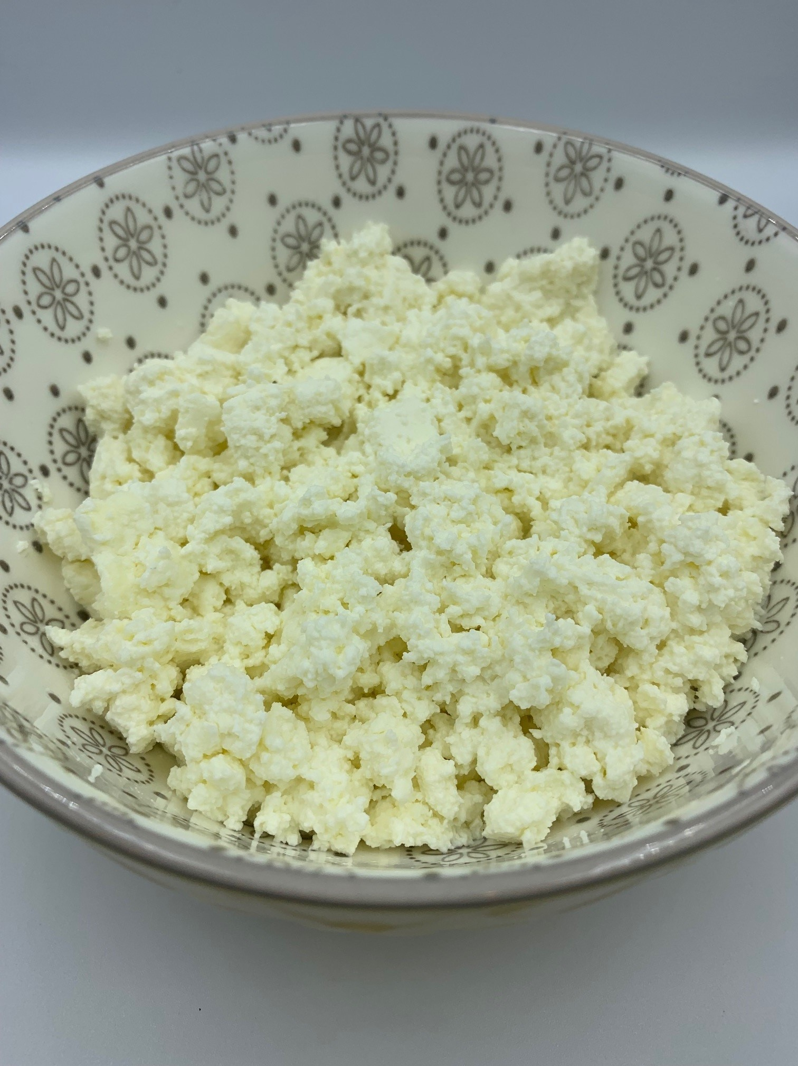
1.136 litres (2 pints) fresh, full fat milk
225g kefir, buttermilk or natural yogurt

Equipment
Measuring jug, large saucepan, slotted spoon, sieve, muslin/clean dish cloth, bowl for draining.

Method
- Pour the milk into a large saucepan and heat for a few minutes over a medium heat.
- When it is warm, reduce the heat to low.
- Add the kefir, buttermilk or yogurt and mix gently.
- Heat until you notice the separating whey.
- Remove the curds with a slotted spoon and place in a sieve lined with muslin, cheesecloth or a clean dish cloth.
- Leave to drain any remaining whey.
- Store in the refrigerator.

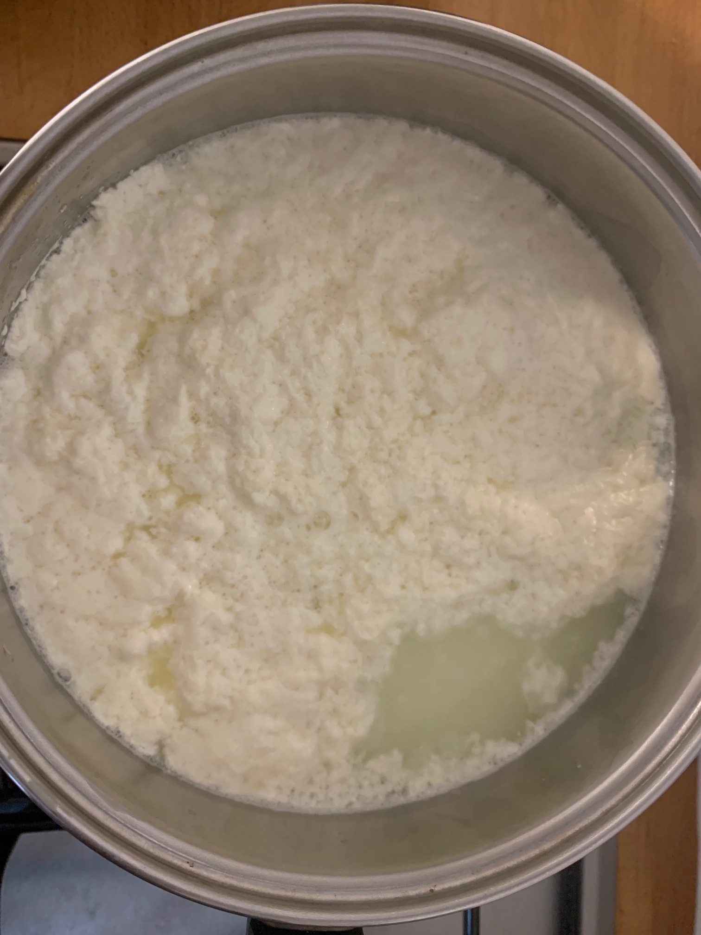
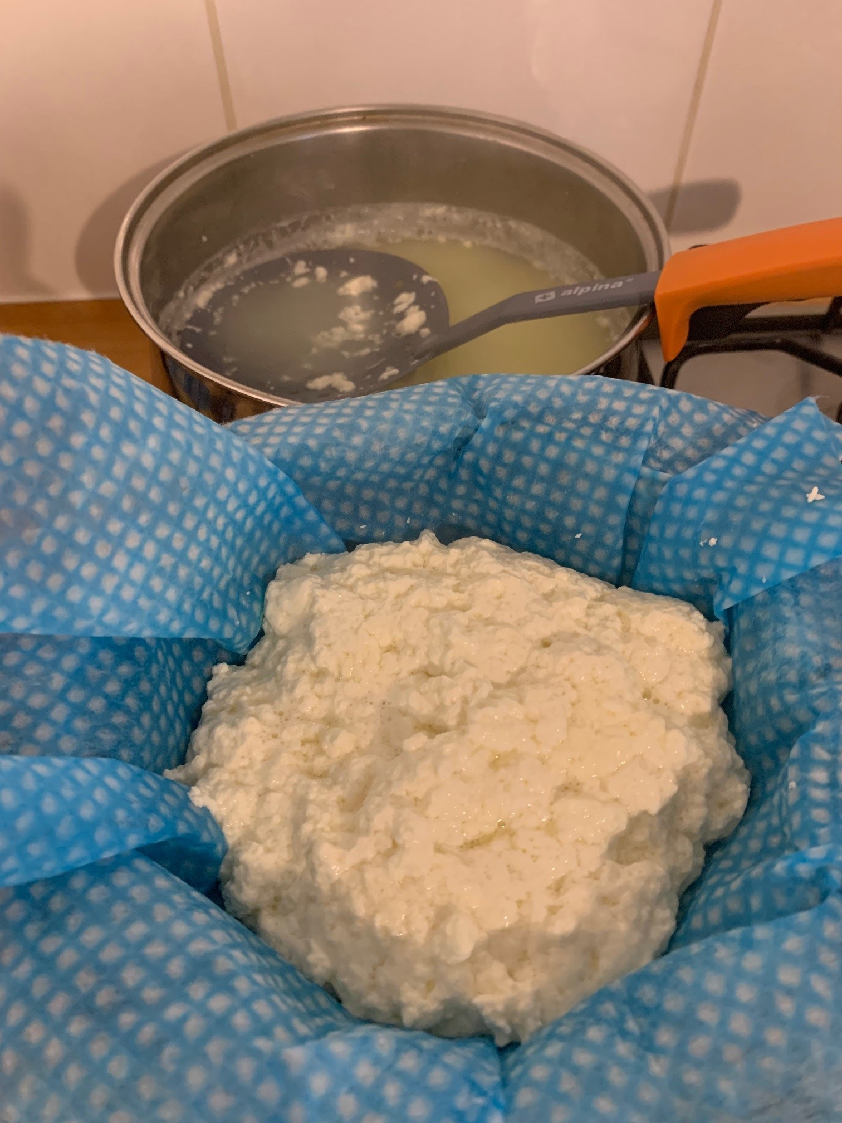
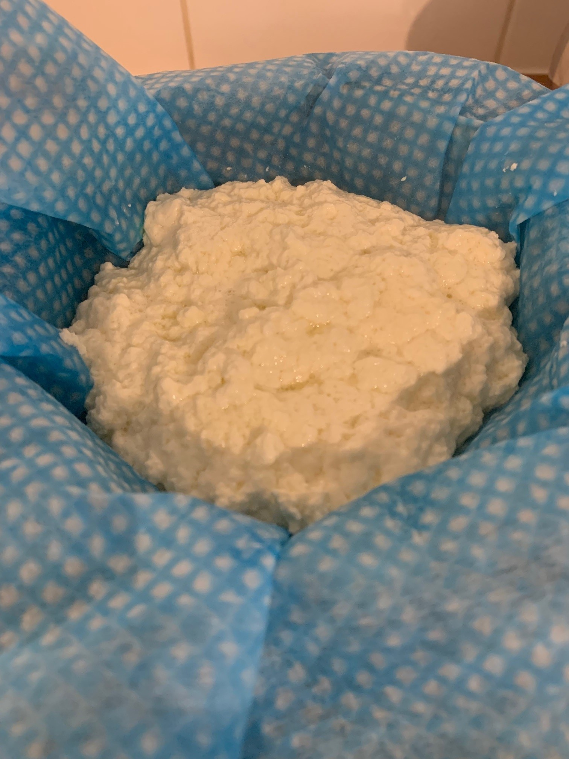
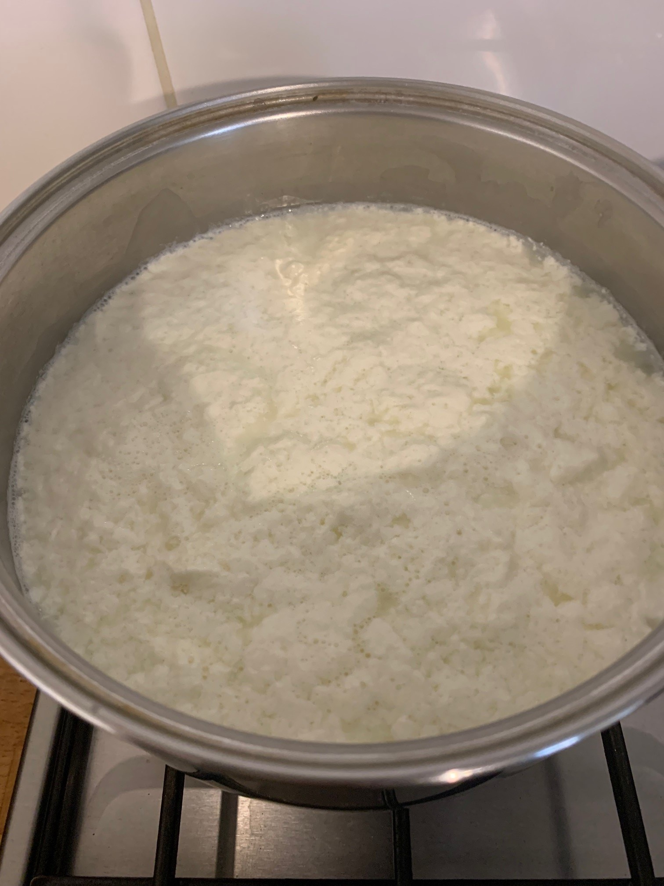
Top tips
- Use your homemade cottage cheese to make Gzik.
- Use whole or semi skimmed milk not UHT.
- Tofu can be used to make dairy-free or vegan ‘cottage cheese’. Mix 100g light or vegan mayonnaise with 1 x 15ml water, 1 x 15ml white miso paste and 3/8 x 5ml spoon salt together until smooth. Add the mayonnaise mixture to the tofu in a bowl and thoroughly mash it together. It is ready when you have small tofu chunks and a cottage cheese like appearance.

Note: If using buttermilk, it will take longer than kefir or natural yogurt to form curds and whey. The resulting cottage cheese will also be softer in texture.

Food skills
- Measure
- Simmer
- Mix
- Drain

Did you know?
Kefir (pronounced kee-feer) is a cultured, fermented milk drink originating from the mountainous Northern Caucasus region in Russia. Traditionally, milk kefir was made by combining fresh milk and kefir grains inside goatskin bags. The goatskin bags were hung in the sunshine of the doorways, and prodded or pushed by each person who went through the doorway. As the milk kefir was consumed, more fresh milk was added to the goatskin bag, forming a continuous fermentation cycle.

Kefir is similar to yogurt but thinner in consistency. It has a tart, sour taste and a slight ‘fizz’, due to carbon dioxide which is the end product of the fermentation process. The length of the fermentation time determines the flavour of the kefir.

The method used to make kefir is one of the main differences between kefir and yogurt. Although there are many different types of fermented milk around the world, milk kefir is unique because it is made with kefir “grains.” Kefir grains are not true grains but are actually symbiotic colonies of bacteria and yeast in a protein and fat matrix. Kefir grains ferment the milk through breaking down the lactose into lactic acid.

‘SCOBY’ is the commonly used acronym for "symbiotic culture of bacteria and yeast", and is formed after the completion of a unique fermentation process of lactic acid bacteria, acetic acid bacteria and yeast to form sour foods and drinks such as kombucha and kimchi.

