North African style za’atar roast

cauliflower with herby couscous salad

Ingredients
Complexity: medium

1 cauliflower

1½ x 15ml spoons za’atar seasoning*

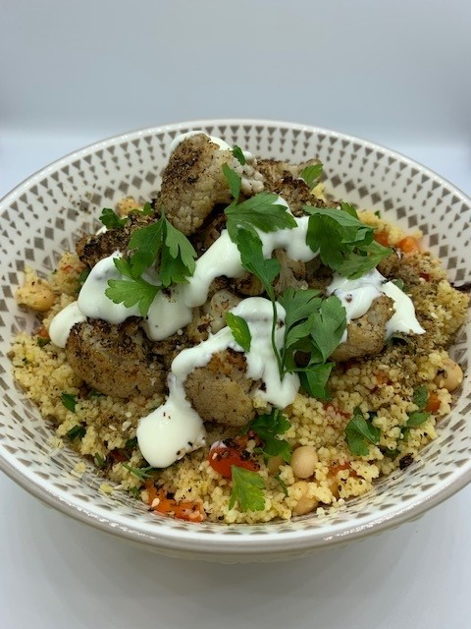
1 red pepper

½ reduced salt vegetable stock cube

1 lemon

1 red onion

½ x 400g can chickpeas

25g fresh parsley

120g couscous

1 x 15ml spoon Greek yogurt

Equipment

Chopping board, vegetable knife, measuring jug, kettle, zester, lemon squeezer, sieve/colander, roasting tin, measuring spoons, large mixing bowl, mixing spoon, fork.

Method
- Preheat the oven to 220°C/200°C fan or Gas mark 7.
- Line a baking tray with greaseproof paper.
- Cut the cauliflower into large florets and place into a roasting tin, spray with oil and scatter with 1 x 15ml spoon za’atar seasoning. Mix, then add 100ml water to the tin.
- Bake for 25-30 minutes stirring halfway through, until caramelised and tender.
- Cut the red pepper in half and deseed. Place the peppers cut side down on the lined baking tray. Roast in the oven for 25-30 minutes until the skin is shriveled and slightly blistered.
- Prepare the remaining ingredients:
- zest and juice the lemon;
- peel and finely dice the onion;
- drain and rinse the chickpeas;
- chop the fresh parsley.
- Mix the ½ vegetable stock cube with 180ml boiling water.
- Put the couscous into a large mixing bowl. Add the peppers, lemon zest and red onion and mix.
- Pour over the stock. Cover the bowl with clingfilm and leave for 8-10 minutes until the stock has been absorbed, then mix well with a fork.
- Add the chickpeas, parsley and the juice of half the lemon.
- Place the couscous in a serving dish and top with the roasted cauliflower.
- Scatter with the remaining za’atar seasoning and drizzle with the yogurt.

* Note: za’atar seasoning contains sesame seeds. As an alternative, use mixed dried herbs and the zest of a lemon.

Top tips
- Try adding some toasted pine nuts to the couscous recipe for extra texture.
- Add extra flavour to the couscous by adding alternative fresh herbs such as mint or dill and sprinkle with chili flakes for a kick!

Food skills
- Weigh
- Measure
- Cut
- Slice
- Chop
- Drain
- Zest
- Juice
- Mix
- Roast

Did you know?
Variations of the herb and spice blend za’atar go back to medieval times, and it's a common ingredient in Middle Eastern and North African recipes. Typically, za'atar is a blend of dried thyme, oregano, marjoram, sumac, toasted sesame seeds, and salt. As with any ancient spice blend, there are many variations.

Sumac (used in za’atar) is a flower that is primarily grown in subtropical areas of Africa (and North America). The spice is made from the dried and ground berries of the sumac flower. Sumac is a tangy spice that has a more acidic flavour, like lemons. It is a deep maroon colour and is commonly used in Middle Eastern and North African cuisine.

This recipe is inspired by Marks and Spencer’s North African za’atar roast cauliflower with herby couscous salad.

