My diet

- List the food and drink you had yesterday.
Breakfast | Lunch | Dinner | Snack/Drinks

- Compare what you ate to the food in The Eatwell Guide.
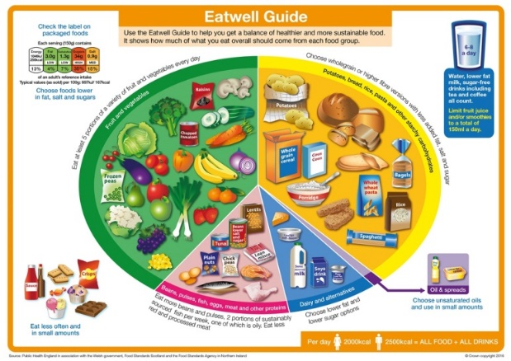
Comments:

- List the types of starchy carbohydrate you had.

- How many portions of fruit and vegetables did you have?

- My diet:

- List what is good about your diet.

- Describe what needs improving.

- Explain how you can make these changes.

