Session 12: Curry to go
Welcome
This session is about students making a simple curry dish in one pan. It demonstrates the use of simple pieces of equipment in the preparation of a dish that students could easily prepare for themselves, their family or friends. This session also provides you with the opportunity to assess student practical capability. You could use the practical observation sheet to help.
During this session, students will make a spinach, potato and chickpea curry, lamb korma or Thai green chicken curry.
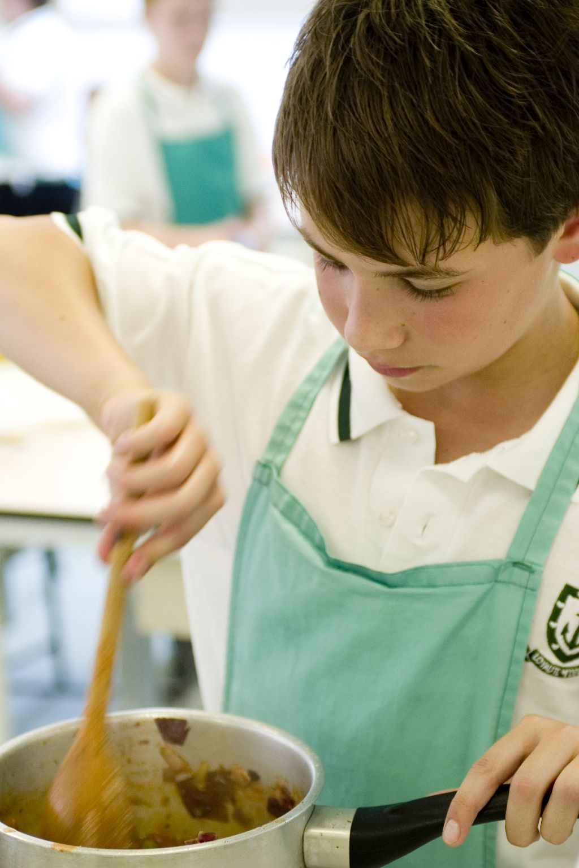
These have been chosen as they once again consolidate essential knife skills, as well as showing students another tasty meal that they could easily prepare or adapt in the future. If you have students who do not eat meat, then use an alternative, such as TVP or myco-protein, or additional vegetables.
There is lots of room for students to be creative, selecting different types of ingredients that could be combined into the dishes. You could get your students to use the spinach, potato and chickpea curry, lamb korma or Thai green chicken curry recipe writing frames before cooking to develop their own ideas. The students’ own recipe creations could then be used in this session.
If you have an established lesson plan and/or recipe, which supports the aims and objectives of this session, feel free to use it instead. Look at the support materials provided within this session as they support this activity and may well be useful in your own lessons, e.g. worksheets, PowerPoint presentations.
This session can act as a stand-alone lesson, focusing on preparing a one pot curry and the safe use of the hob. Alternatively, it could be integrated into a series of lessons, e.g. exploring different types of spices and herbs that are traditionally used in making a curry based dish.

Aims and objectives
Aim
For students to:
- demonstrate competence in cooking a curry dish, using minimal pieces of equipment.
Objectives
Students should be able to:
- prepare a range of ingredients, e.g. de-seeding chillies;
- handle meat safely, if applicable;
- use the hob safely;
- make a curry based dish, e.g. spinach, potato and chickpea curry, lamb korma or Thai green chicken curry.

Cooking session
Two cooking session plans, based on the Licence to Cook recipes are supplied within this session.

If you have your own tried and tested curry recipe, feel free to use it instead. In addition, you may wish to make other types of dishes, such as chicken rogan josh.
Each plan refers to aspects of healthy eating, wise food shopping and food safety and hygiene which are themes which run through each session.
Before the cooking session
There are a number of factors that you need to consider before the cooking session. More detailed guidance is available in the Cooking session guide.

You will need to consider:
- Ingredients: who will be providing the ingredients and where will they be stored? The recipes call for a little oil for stir-frying. It may be easier for the school to provide the oil for students to share.
- Recipe: are pupils going to use a printed-out copy or follow instructions on an interactive whiteboard?
- Equipment: is all the equipment needed for the session available, clean and in good working order? Check that all the hobs are in good working order and clean. Students will require the use of a saucepan - check that there are enough.
- Aprons: do you have enough and are they clean?
- Hair: do you have ties/bands for long hair?
- Containers: will students be able to take away the curry they make? If so, in what?
- Waste: do you have adequate disposal facilities, including recycling or composting?
- Cooking area: is it clean and ready to use?

Differentiation and inclusion
Before this practical session, you will need to consider the age, ability, previous experience and any special requirements of your students. This will determine recipe selection, any advanced ingredient preparation and equipment used.
Do any of your students need:
- partly-prepared ingredients, e.g. diced lamb or canned potatoes?
- assistance peeling the potato or onion?
- to follow different recipes? The spinach, potato and chickpea curry recipe is slightly easier than the lamb korma.
- challenging, by allowing them to adapt the recipe and include ingredients to enhance their practical skills?
- vegetarian alternatives, such as TVP or myco-protein, or additional vegetables.
Demonstration
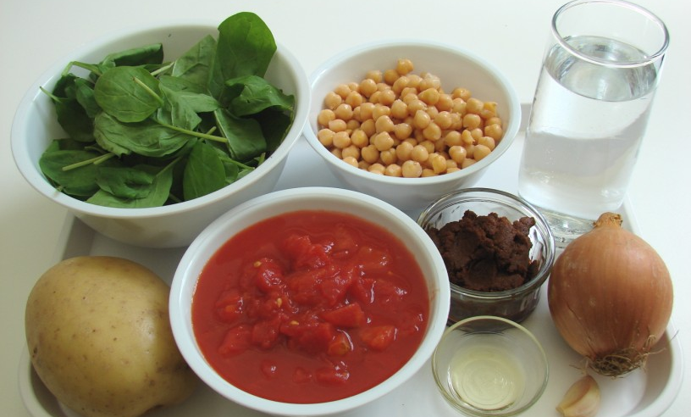
During the session you will be demonstrating how to use a wok safely. Remind students how to prepare a clove of garlic (either using a garlic crusher or knife) and de-seed a chilli. You may also need to remind students on the bridge-hold and claw-grip knife techniques. Comment on the vegetables being of a similar size to ensure even cooking.

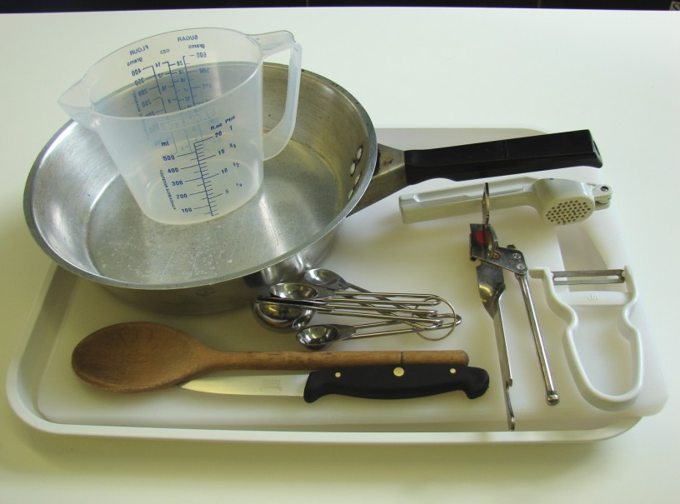
Ensure that you have all the ingredients and equipment you need before the session, perhaps on trays for ease, for your demonstration.

Think about:
- describing the ingredients and equipment used;
- highlighting the technique of chopping an onion;
- showing how to simmer;
- ensuring that students have followed and understood the method.

More detailed guidance is available in the Demonstrating guide.

Risk assessment

The two cooking session plans and recipes highlight a number of different hygiene and safety issues which need to be considered before, during and after the cooking session.

Before the cooking session, you will need to assess these risks in relation to the number of students being taught, as well as their experience, and consider measures that can be put into place to manage the risk. Below are examples of potential risks, along with preventative measures.

Spinach, potato and chickpea curry
Potential risk | Measure | Likelihood
Cuts from using knife unsafely | Demonstrate safe use of knives and monitor students’ use | Low
Dirt or food poisoning bacteria present on raw food, causing cross contamination | Wash vegetables | Med
 |  | Low/Med

Lamb korma
Potential risk | Measure | Likelihood
Dirt or food poisoning bacteria present on raw food, causing cross contamination | Wash vegetables before use | Low
Cross-contamination from raw lamb | Cut raw lamb on a separate chopping board (ideally red) with a clean knife | Low/Med
 | Thoroughly wash and dry hands after touching the raw meat
 | Do not wash meat before using

Time
The session plans are based on a 60 minute session.

If you have less time available, you will need to modify the session plan to better suit your circumstances. For example, within this session you might:
- demonstrate the safe use of the hob another time;
- demonstrate key aspects from the recipe, rather than every stage;
- have ingredients pre-measured;
- use pre-cooked potatoes or lamb;
- use pre-prepared garlic and/or chilli, e.g. tubes, jars or frozen;
- allow students to work with a partner.
During the lesson
Time (mins) | Activity: Spinach, potato and chickpea curry | Equipment/ Resources
0 | Registration.  Explain to the students that they will be making spinach, potato and chickpea curry. Go through the aims and objectives for the lesson. | PowerPoint Spinach, potato & chickpea curry recipe
5 | Gather the students around a demonstration area, with your tray of ingredients and equipment. Ensure that all students have their apron on, hair tied back and hands washed.  Briefly talk through the recipe – note your expectations, for example:  * preparing the ingredients carefully and accurately;  * peeling and dicing the potatoes;  * simmering the curry, until the potatoes are tender;  * using the hob safely;  * being hygienic and safe when preparing food. | Aprons  Demonstration ingredient and equipment tray
 | Demonstration  * Place out the chopping board, vegetable knife, vegetable peeler and garlic press.  * Demonstrate a garlic press in action. Note how the clove of garlic must be peeled first. Explain that garlic can also be chopped into small pieces using a knife.  * Explain that you will be demonstrating how to peel and dice a potato. Use the vegetable peeler to peel away from you. Use the Claw grip to cut the potato into thick slices (1-1.5cm). Take one slice and cut into thick strips – keeping the strips together. Rotate the potato by 45º and cut across the strips making cubes (dice).  * If you have time, or students require support, demonstrate how to prepare the onion and/or garlic.  * Open the canned tomatoes and chickpeas. If using a can opener, demonstrate how it works. If the can has a ring pull, demonstrate how to open it. Reinforce the dangers of the can lid and edge – both are sharp.  * Remind students about turning on and using the hob safely. Add the oil to the saucepan and allow to heat for 20 seconds. It is important that students to not over heat the oil as it will start to burn and, if allowed to heat, produce flames. Add the onion and garlic. Use the wooden spoon to stir. Keep the saucepan handle away from the front of the hob. You may need to regulate the heat, i.e. turn the heat up or down. Ensure that students understand how to do this.
 | * During their cooking, students will need to bring the curry to the boil, and then simmer. Remind students that ‘to the boil’ means rapidly bubbling, and ‘simmer’ means bubbling gently.
15 | Ensure that all students wash their hands. Allow them to start making their spinach, potato and chickpea curry.  During this time, circulate the room to ensure that students are preparing ingredients and using the oven safely. In this time, students should:  * prepare their ingredients;  * peel and dice potatoes;  * fry the onion and garlic, and then simmer the other ingredients;  * use the hob safely. | Basic equipment  Saucepans  Ingredients
35 | All spinach, potato and chickpea curries should be on the hob cooking - they take at least 20 minutes.  During the remaining time students should be washing up, cleaning work surfaces and putting away equipment.
50 | Give a 5 minute time warning.  Remind students that all washing-up should be completed, work surfaces should be clean, and their spinach, potato and chickpea curry should be served in a container.  Circulate the room, ensuring that sinks are clean, and equipment is put away properly.
55 | Plenary  Pose the following questions to the students:  * What were the main skills demonstrated today?  * Name 3 other types of beans or pulses that could be added.  * What could you serve this dish with?
60 | Finish

After the session
Check that the room is clean and tidy. Students should leave the room as they find it.

The spinach, potato and chickpea curries may need to be refrigerated until the end of the school day, if so, ensure that each container is covered and clearly labelled with the student’s name and group. The refrigerator should be between 0-5ºC.

Students may wish to reheat the curry at home. To microwave, place the curry in a suitable container and cover loosely. Cook for full power for 3-4 minutes. Alternatively, reheat the curry in a saucepan until it is boiling. Ensure that the dish is piping hot before eating.

If the same students are with you for another cooking session in the next few days or week, remind them of the ingredients and/or containers they need to bring, if appropriate. You may wish to provide students with recipes or writing frames.

During the lesson
Time (mins) | Activity: Lamb korma | Equipment/ Resources
0 | Registration.  Explain to the students that they will be making lamb korma. Go through the aims and objectives for the lesson. | PowerPoint lamb korma Recipe
5 | Gather the students around a demonstration area, with your tray of ingredients and equipment. Ensure that all students have their apron on, hair tied back, and hands washed.  Briefly talk through the recipe – note your expectations, for example:  * preparing the ingredients carefully and accurately, e.g. deseeding chilli;  * handling raw lamb carefully - avoiding cross contamination;  * using different knifes and chopping boards for vegetables and raw meat;  * simmering the curry;  * using the hob safely;  * being hygienic and safe when preparing food. | Aprons  Demonstration ingredient and equipment tray
Demonstration
* Place out the chopping board, vegetable knife, garlic press and grater.
* Explain that you will be showing how to crush garlic, de-seed a chilli and cut the lamb into cubes.
* Demonstrate a garlic press in action. Note how the clove of garlic must be peeled first. Explain that garlic can also be chopped into small pieces using a knife. Next show students how to deseed the chilli. Stress to the students that they should not touch their face (e.g. lips and eyes) when preparing a chilli. Cut the chilli in half, using the Bridge hold, then use the knife (or a small spoon) to gently push the seeds onto the chopping board. Wash your hands.
* Show students how to prepare the raw lamb. Use a different chopping board (ideally red) and knife. Remind students about washing their hands before and after touching raw meat. Trim away any visible fat. Using the Claw grip, cut the lamb into strips. Then, cut these strips into equally sized cubes. Immediately after cutting the lamb, remove the chopping board and knife (and place in the sink) and wash your hands. Cover the raw lamb with some cling film and refrigerate, if you are not using it immediately.

* Remind students about turning on and using the hob safely. Add the oil to the saucepan and allow to heat for 20 seconds. It is important that students to not over heat the oil as it will start to burn and, if allowed to heat, produce flames. Add the spices and allow to sizzle. Use the wooden spoon to stir. Keep the saucepan handle away from the front of the hob. You may need to regulate the heat, i.e. turn the heat up or down. Ensure that students understand how to do this.
* During their cooking, students will need to bring the curry to the boil, and then simmer. Remind students that ‘to the boil’ means rapidly bubbling, and ‘simmer’ means bubbling gently.
15 | Ensure that students all wash their hands. Allow them to start making their lamb korma.  During this time, circulate the room to ensure that students are preparing ingredients and using the oven safely. In this time, students should:  * prepare their ingredients;  * use different knives and chopping boards for vegetables and raw meat;  * sizzle the spices to develop flavour;  * fry the onion and chilli, and then add the other ingredients;  * use the hob safely. | Basic equipment  Saucepans  Ingredients
35 | All lamb kormas should be on the hob cooking - they take at least 20 minutes.  During the remaining time students should be washing up, cleaning work surfaces and putting away equipment.
50 | Give a 5 minute time warning.  Remind students that all washing-up should be completed, work surfaces should be clean, and their lamb korma should be placed in a container. Circulate the room, ensuring that sinks are clean, and equipment is put away properly.
55 | Plenary  Pose the following questions to the students:  * What were the main skills demonstrated today?  * Name 3 alternatives to lamb that could be successfully used in this recipe.  * What could you serve this dish with?
60 | Finish

After the session
Check that the room is clean and tidy. Students should leave the room as they find it.

The lamb kormas may need to be refrigerated until the end of the school day, if so, ensure that each container is loosely covered and clearly labelled with the student’s name and group. The refrigerator should be between 0-5ºC.

Students may wish to reheat the curry at home. To microwave, place the curry in a suitable container and cover loosely. Cook for full power for 3-4 minutes. Alternatively, reheat the curry in a saucepan until it is boiling. Ensure that the dish is piping hot before eating.

If the same students are with you for another cooking session in the next few days or week, remind them of the ingredients and/or containers they need to bring, if appropriate. You may wish to provide students with recipes or writing frames.

Areas of learning
Healthy eating
- Use lean lamb - trim away any visible fat.
- Use plenty of vegetables in a curry - try fruit too, e.g. sultanas or apple.
- Eat with naan bread or boiled rice, along with a side salad.
Wise food shopping
- Use left-over cooked meat (from the night before) to make your money go further.
- Make a large batch of curry, so that you can freeze it for another time.

Food safety and hygiene
- When getting ready to cook, always wear an apron, tie back long hair, roll up long sleeves, remove any jewellery and wash your hands.
- Use a different chopping board and knife after preparing raw meat to avoid cross contamination.
- Handle raw meat carefully. Wash hands and surfaces after handling.
Make sure the meat is thoroughly cooked.
Extending this activity
This session provides a great opportunity to be integrated into existing lessons or be developed into a mini-scheme of work.
For example, students could:
- explore different types of spices and herbs that are traditionally used in making a curry based dish;
- planand create different types of curry based dishes for school lunch menus;
- evaluate different types of side dishes that are often served with curry dishes, looking at alternatives to reduce fat and sodium (salt).
Appropriate aspects of ICT could also be integrated, including:
- recording how the dish is made using a digital camera;
- creating a recipe plan or flow-chart;
- modelling the sensory data from different class mates tasting sessions;
- exploring the internet for traditional recipes and techniques, which can be used in their own cooking sessions.

Shopping list
Spinach, potato and chickpea curry
Ingredient | x 1 | x 10 | x 20
Onion | 1 | 1kg | 2kg
Garlic clove (each) | 1 | 10 | 20
Oil | 1 x 5ml spoon | 50ml | 100ml
Curry paste | 2 x 15ml spoons | 300ml | 600ml
Potatoes (each) | 2 | 20 | 40
Chopped tomatoes (canned) | 1 x 200g | 2kg | 4kg
Chickpeas (canned) | 1 x 200g | 2kg | 4kg
Spinach, fresh | 3 handfuls | 1 big bag | 2 big bags

Lamb korma
Ingredient | x 1 | x 10 | x 20
Cloves (each) | 1 | 1kg | 2kg
Cardamon pods (each) | 1 | 500g | 1kg
Lamb leg steaks | 200g | 1 bunch | 2 bunches
Garlic clove (each) | 1 | 100ml | 200ml
Green chillies (each) | 1 | 20 | 40
Turmeric | 1/2 x 5ml spoon | 1/2 x 5ml spoon | 1/2 x 5ml spoon
Cumin | 1/2 x 5ml spoon | 1/2 x 5ml spoon | 1/2 x 5ml spoon
Chilli powder | 1/2 x 5ml spoon | 1/2 x 5ml spoon | 1/2 x 5ml spoon
Plain yogurt | 3 x 15ml spoon | 450ml | 900ml
Black pepper | a few twists | a few twists | a few twists
Coriander | 1 x 15ml spoon | a bunch | 2 bunches
Cauliflower (each | 1/2 | 5 | 10
Thai green chicken curry
Ingredient | x 1 | x 10 | x 20
Oil | 1 x 10ml spoon | 100ml | 200ml
Spring onions (each) | 3 | 30 | 60
Garlic (clove) | 1 | 10 | 20
Sugar snap peas | 80g | 800g | 1.6kg
Chicken breast (small) | 1 | 10 | 20
Thai green curry paste | 2 x 15ml spoons | 300ml | 600ml
Coconut milk (reduced fat) | 200ml | 2 litres | 4 litres
Lime (each) | ½ | 5 | 10
Coriander | Small bunch | A few bunches | Several bunches
Equipment list
Spinach, potato and chickpea curry
Vegetable knife, chopping board, garlic press, vegetable peeler, frying pan, measuring spoons, measuring jug, wooden spoon, can opener.

Lamb korma
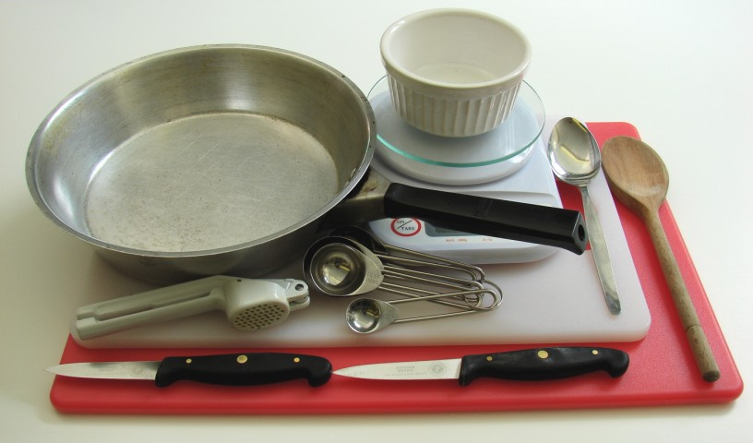
Two chopping boards, two knives, frying pan, fish slice, measuring spoons, weighing scales, garlic press, wooden spoon, metal spoon, small bowl.

Thai green chicken curry
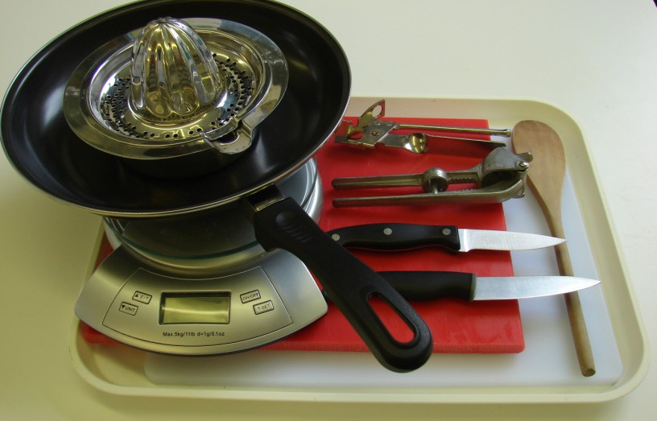
Two chopping boards, two knives, garlic press, frying pan, weighing scales, wooden spoon, can opener, juicer.

Containers

If students take their dishes, they will need to bring (or be provided with by the school) a suitable container, such as a foil container with a lid.

