Demonstrating
Demonstrating a food skill, use of a piece of equipment or recipe is an interesting, dynamic and relevant way to engage your students. However, it is important that any demonstration is well prepared in advance to ensure that the learning objectives you wish to convey are delivered as intended.
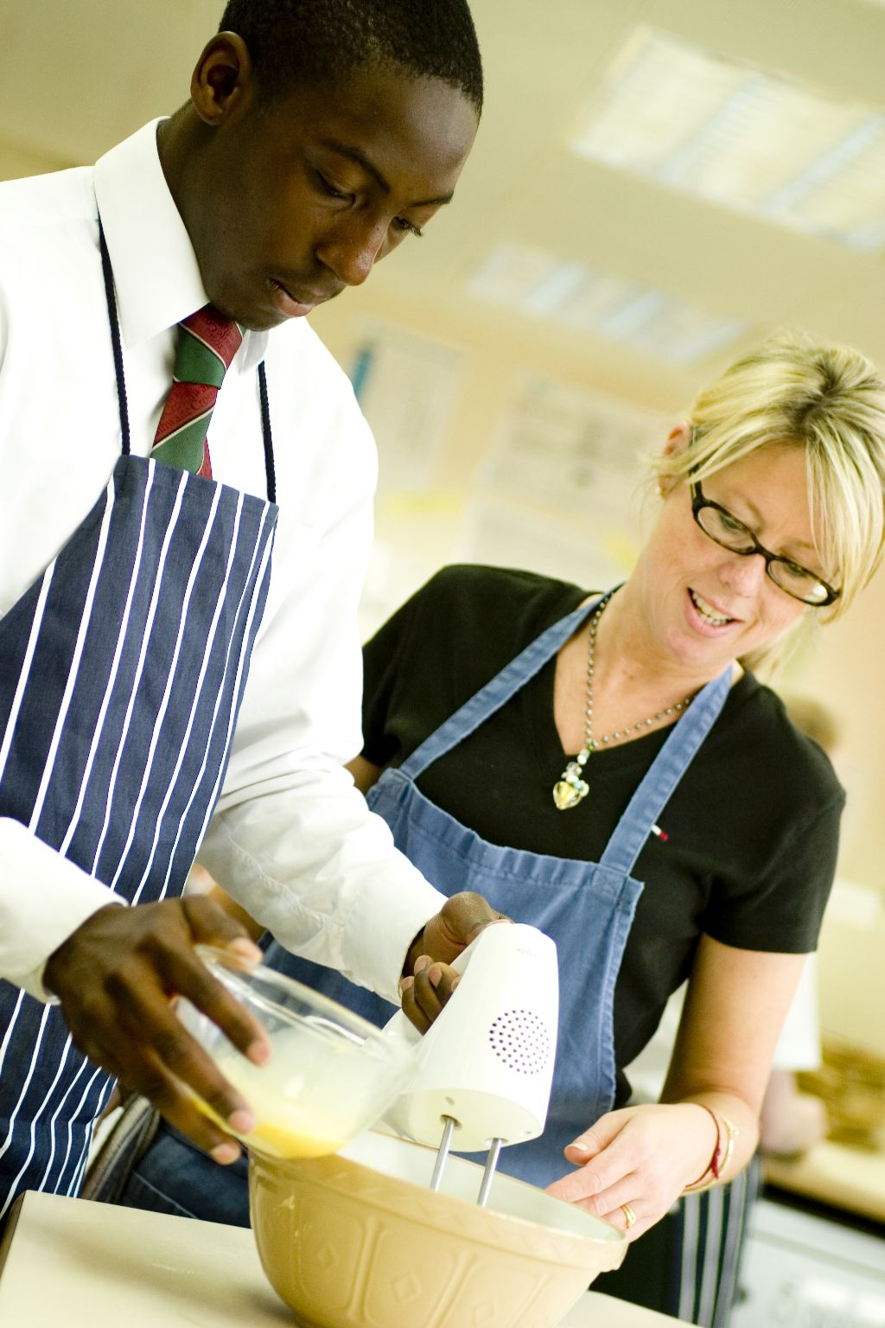
Why demonstrate?
It may seem obvious, but why do you want to demonstrate a skill? What are your learning objectives?

It may be that you want students to see:
- a particular technique being demonstrated, which they will then use in a recipe, e.g. The Bridge Hold;
- different aspects of the cooker being demonstrated, such as the safe use of the hob;
- how to prepare particular fruits or vegetables;
- an unfamiliar piece of equipment in operation, e.g. a garlic press, wok;
- good hygiene and safety in practice.

What you want the students to learn from the cooking session need to be well thought out in advance. Each of the Licence to Cook cooking sessions states learning objectives.

In addition, the plans within each unit recommend different skills and techniques to demonstrate.

Setting up
Before you start your demonstration, it is important to plan ahead. You will need to think about:

Teacher
Ensure that you are confident and competent to demonstrate a skill, use equipment safely or make a recipe – you will be the role model. What you do at school may be different from what you do at home, e.g. peel carrots using a peeler away from yourself. It is important to have a consistent approach to demonstrating each skill so that the students learn from your demonstration.

You need to show good practice with respect to demonstrating skills, handling ingredients and hygiene.

You may wish to practice at home first before you show the class. Make sure you wear an apron, tie back long hair, remove jeweller and nail varnish, roll-up long sleeves and wash your hands. It is important that you role model good food safety and hygiene practices.

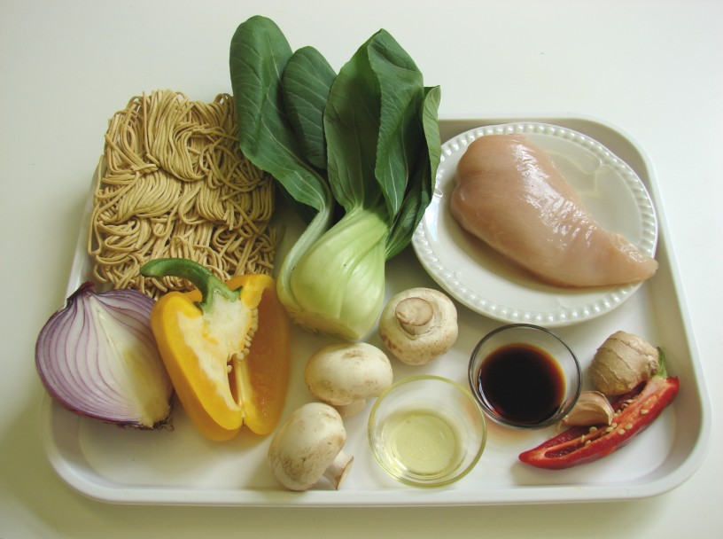
Ingredients
Ensure that you have all ingredients required and that they are stored correctly.

Some foods may need part preparing before your demonstration, if this is not part of your learning objective, time is tight or it is not appropriate for the ability of the students, e.g. cutting a slice of melon.

Some foods may need pre-measuring, if this is not part of your learning objective, time is tight or it is not appropriate for the ability of the students, e.g. weighing flour.

Place all the ingredients on a tray ready for use in the demonstration. Do not place ingredients that are not needed for the demonstration on the tray.

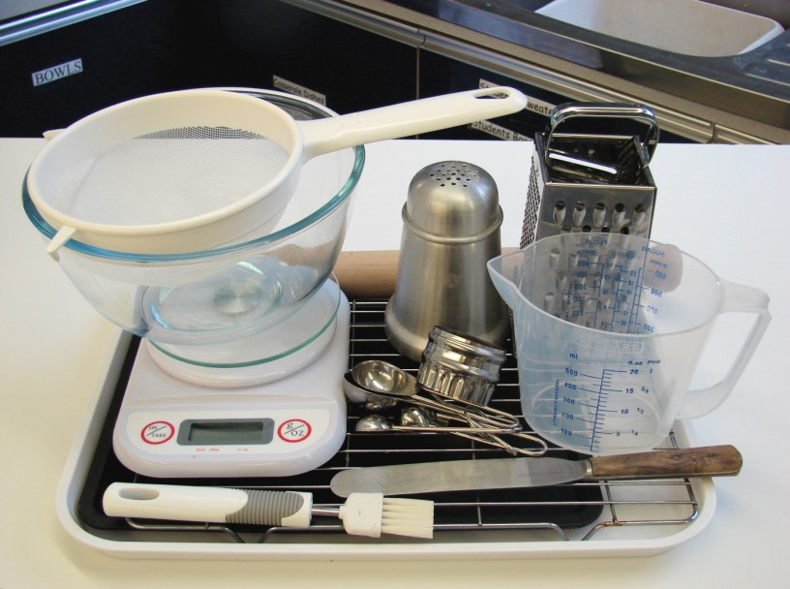
Equipment
Make sure that the equipment is clean and in good working order.

Ensure you use equipment that is appropriate for the students' age, ability and previous experience.

If you are using a mixing bowl or measuring jug, for example, ensure that it is clear so that students can see what is happening inside.

Ensure that you have all the equipment required placed on a tray ready for use.

Classroom
Set up the demonstration area so that all the students can see clearly.

Ensure that the demonstration table is clear and clean - remove any items that may distract.

Make sure there is a sink in which to wash your hands and paper towels to dry them on.

Students
Ensure that a parent/carer permission letter has been sent home if students are participating in the demonstration, tasting food or cooking.

Teaching assistant
Make sure the teaching assistant understands the learning objectives and what will be happening, along with any support they you may require.

Ensure that they wear an apron, have long hair tied back, long sleeves rolled-up, jewellery and nail varnish removed and wash their hands.

Demonstrating
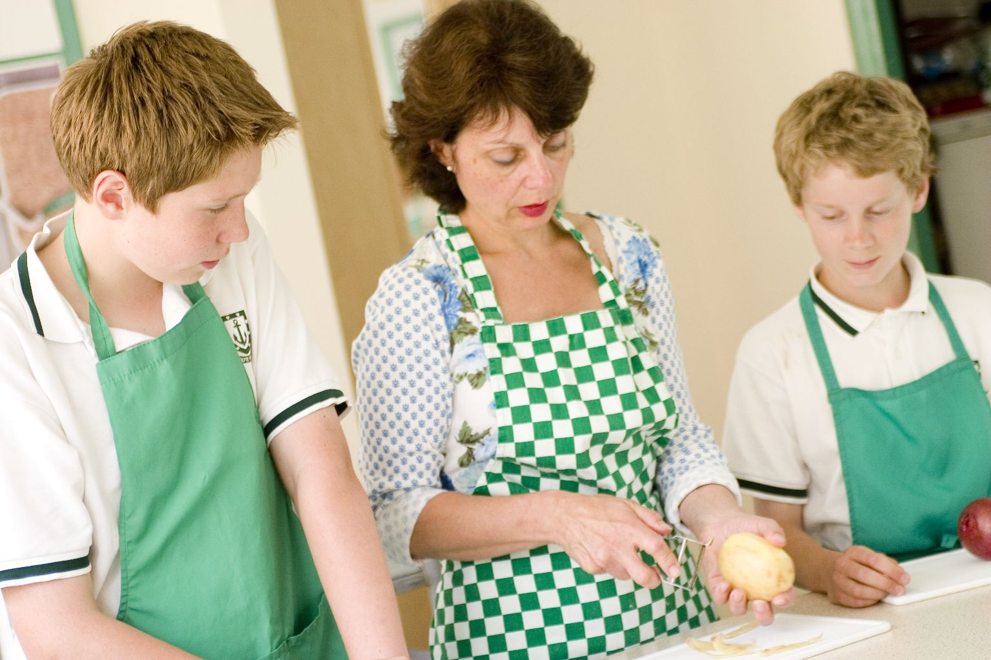
Ensure that students understand why you are demonstrating. Recap your learning objectives. Tell them what they will be watching and why.

If you are showing a knife technique, ensure that all the students can see what you are doing – it might mean that you need to move your hands out of the way or repeat the demonstration again.

Ask students questions about what is happening, e.g. can you name the ingredients or equipment? What do I need to do to get ready to cook?

Involve students in the demonstration. They could help weigh or prepare ingredients, e.g. weigh 100g flour or quarter tomatoes.

Ensure that peelings and other waste can be disposed hygienically and quickly. Having a bowl or plate on the demonstrate work surface for waste.

If you are showing students how to use different aspects of a cooker safely, ensure that they can all see. You might need to repeat parts of the demonstration on gas and electric cookers.

Finishing up
Recap the demonstration with the students, noting any important points.

Question the students. What have they seen? What can they remember?

Ensure that all students understand what they have seen and know what is expected of them, if they are to cook the dish immediately after. (If students are to cook at another time, then ensure that at the start of that cooking session you recap the main points of the demonstration.)

Tidy away your ingredients and equipment. Make sure the work area in clean and clear - this will again demonstrate your expectations.

