Layered pasta salad

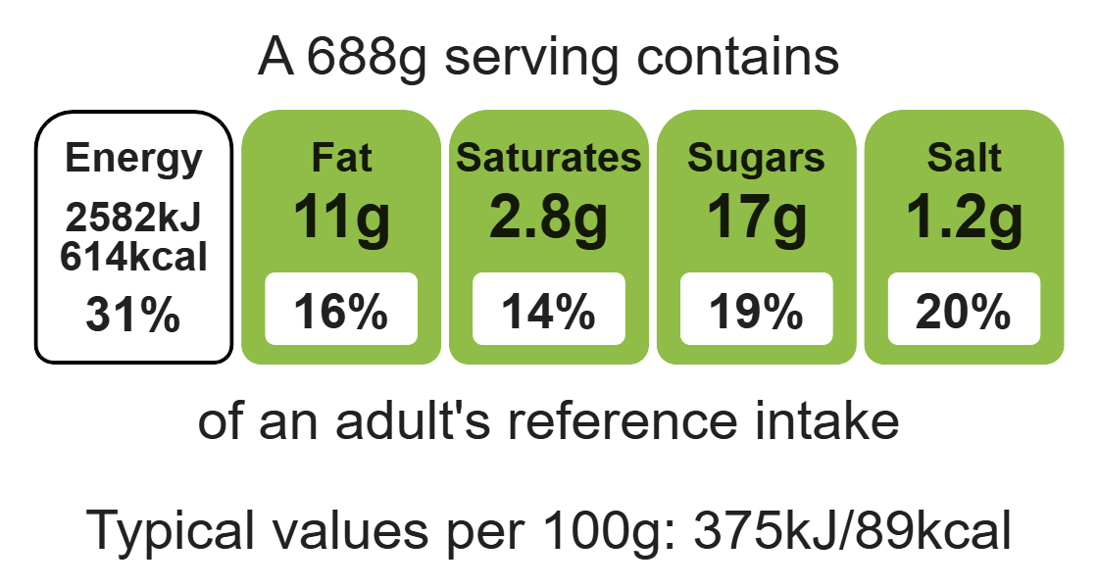
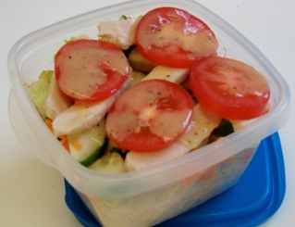
Complexity: low - medium

Ingredients (serves 1)

100g wholemeal pasta

Equipment

Weighing scales

Saucepan

Chopping board

Sharp knife

Vegetable peeler

Grater

Measuring spoons

Mixing spoon

Colander

1 carrot

100g cooked sliced chicken

1 lettuce

1 tomato

¼ cucumber

2 x 15ml spoons reduced-fat dressing

Method
1. Bring a small saucepan of water to the boil, and add the pasta. Simmer for about 8-10 minutes (check the packet instructions).
2. While the pasta is cooking, prepare the other ingredients:
- shred the lettuce;
- slice the tomato;
- chop the cucumber into small chunks;
- peel and grate the carrot.
3. Drain the boiling hot water away from the pasta into a colander in the sink. Cool the pasta by rinsing it under a cold tap for a few moments. Drain well.
4. Place the pasta in the serving dish and stir in 1x15ml spoon of reduced-fat dressing.
5. Assemble the remaining ingredients over the pasta in layers.
6. Lastly, drizzle over the remaining dressing.

Top tips
- Reduce food waste: Use up any leftover vegetables such as sweetcorn or beetroot
- Vary your protein: Add cooked chicken, grated cheese, canned tuna, slices of boiled egg, or red kidney beans.
- Focus on fibre: Use wholemeal pasta to boost the fibre content of the dish.

Food skills
Weigh, measure, melt, simmer and boil, cut, chop, slice, dice and trim, peel, grate, drain, layer.

