What has happened?

Because of their physical and chemical properties, foods perform different functions which can be used in the production of food products. These functions include:

- Binding – liquid is added to combine or hold dry ingredients together.
- Aeration –some dishes need to be made lighter through the addition of air (whisking eggs), carbon dioxide (baking powder and yeast) and steam (water in choux pastry).
- Thickening – protein in egg thickens when gently heated (coagulation); starch in flour thickens liquids when heat is added (gelatinisation) and starch in potato thickens soups.
- Setting – protein in egg thickens and sets when heated (coagulation), gelatine forms a gel when making jelly; the starch in cornflour thickens and sets sweet desserts such as blancmange; gluten in flour (a protein) thickens and sets in baked goods such as cakes (coagulation).
- Shortening –in products such as shortcrust pastry, biscuits and shortbread, fat coats the flour particles and prevents moisture absorption. This inhibits gluten formation which gives them a crisp and crumby texture.
- Adding colour to baked goods – when dry heat is added to starch, browning occurs when the starch is turned to dextrin (sugar) and caramelisation then takes place (the browning of sugar), e.g. toasting bread and browning of pastry when baking.
- Adding colour to cooked meats – when cooked, the outside surface of meat changes colour due to the proteins and carbohydrates reacting with each other. This is known as the Maillard reaction.
- Tenderising meat – some acids such as lemon juice have a tenderising or softening effect on meat fibres and so are often used in marinades.

Ingredients can also be used to add flavour, texture, moisture and bulk to a dish along with improving the nutritional value.

Explain the changes taking place during the preparation and cooking of these recipes.

Recipe | What has happened? | What is this known as (technical term)?
Beef steak

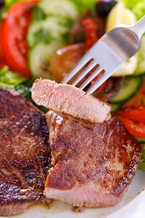
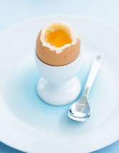
Boiled egg

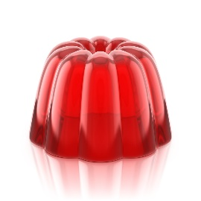
Fruit jelly
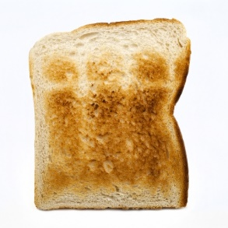
Toast

Meringue

