Acid denaturing

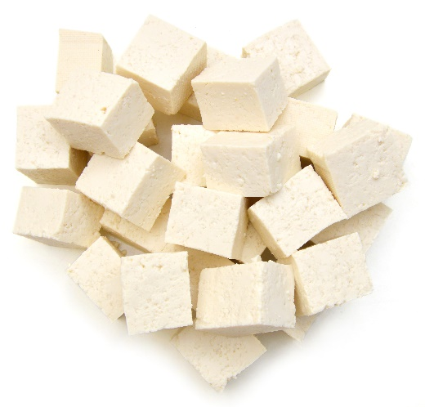
Learning
The aim of this session is to:
- demonstrate acid denaturing protein structures;
- consider other methods could be used to denature proteins.

You will need:
- 1 block of tofu;
- green or blue food dye;
- 1 x 5ml spoon salt;
- 1 x 5ml spoon white vinegar;
- 1 x 5ml spoon sugar;
- water;
- 4 cups;
- clingfilm.

Instructions:
- Cut the tofu into small, even sized cubes, about 1.5 x 1.5cm.
- Half fill each of the four cups with water and stir 3 drops of food dye into each.
- Label each cups with: control, salt, vinegar, and sugar.
- To each cup, then add:
  - nothing (control cup);
  - 1 x 5ml spoon salt;
  - 1 x 5ml spoon vinegar;
  - 1 x 5ml spoon sugar.
- Add one cube of tofu to each cup and leave for 45 minutes.
- Remove the cubes and place on a white surface, covered in clingfilm.
- Cut each cube in half and record your observations.

Questions
Think about these questions after you have completed the experiment:
- Which cube has the dye penetrated the furthest?
- Why do you think this has happened?
- Why are marinades containing acids or enzymes often used before meat, particularly from a tougher cut, is cooked?

