Spaghetti bolognese
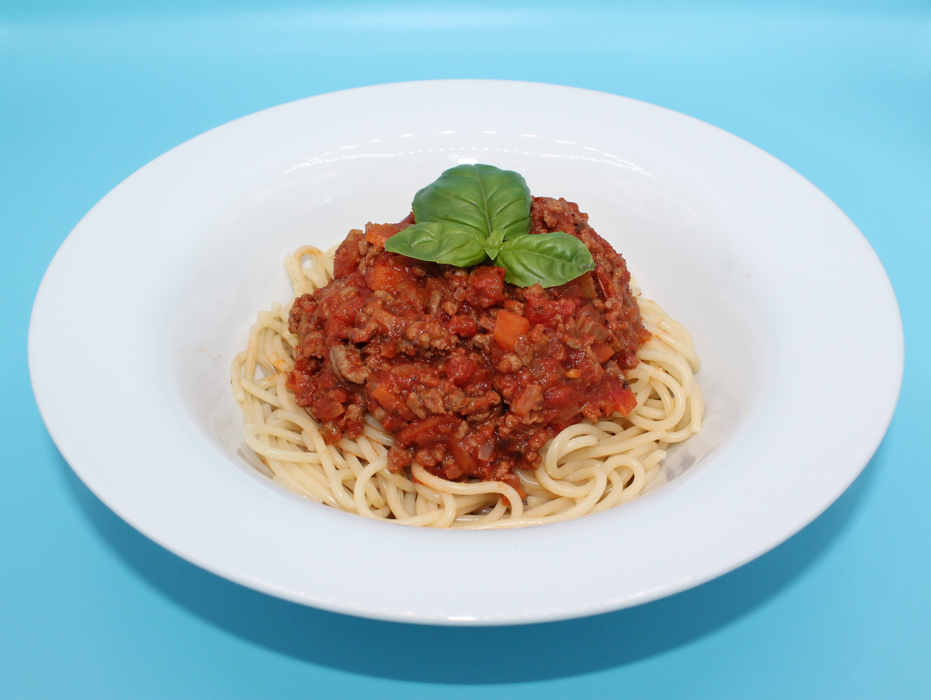
Complexity: medium- high
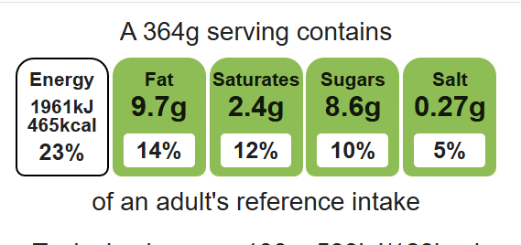

Ingredients (serves 3)

Equipment

Weighing scales

Chopping board

Sharp knife

Garlic press

Vegetable peeler

2 saucepans

Heat resistant spoon

Measuring spoons

Measuring jug

Colander

1 onion
1 clove garlic
1 carrot
1 celery stick
1 x 15ml oil or spray oil
250g lean minced beef
400g canned chopped tomatoes
1 x 15ml spoon tomato puree
1 x 5ml spoon mixed herbs
100ml water
Black pepper
240g spaghetti
Top tips
- Transform your leftovers: Use your leftover bolognese to create a new dish such as nachos, burritos or chilli con carne.
- Vary your protein: Swap the minced beef for lentils or beans.
- 5 A DAY: Serve with a seasonal side salad or roasted mixed vegetables.

Method
- Prepare the vegetables:
- peel and dice the onion;
- peel and crush the garlic;
- peel and dice the carrot;
- finely slice the celery.
- Fry the onion, garlic, carrot and celery in the oil.
- Add the meat and cook until the mince is lightly browned.
- Add the tomatoes, tomato purée, mixed herbs and water and stir. Add a few twists of black pepper.
- Bring to the boil, then simmer for 20 minutes.
- Meanwhile, place the spaghetti in a separate saucepan of boiling water. Cook for 10 - 12 minutes or until the spaghetti is al dente
- Drain the spaghetti into a colander in the sink.
- To serve, pour some of the bolognese sauce over the spaghetti.

Food skills:
Weigh, measure, crush, chop, slice, dice, trim, drain, peel, mix, stir, combine, fry and sauté, melt, simmer and boil.

