Shepherd’s pie

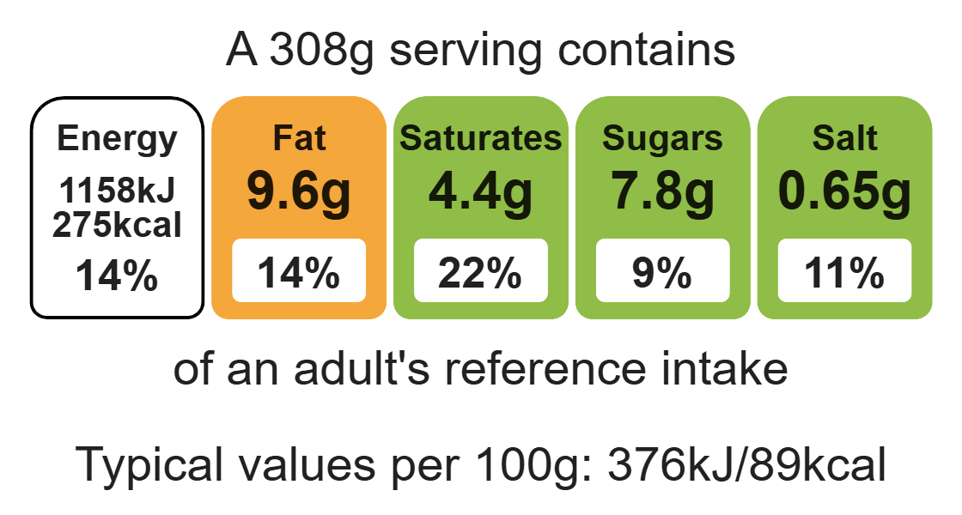


Ingredients (serves 4)
Complexity: medium - high

1 onion

1 carrot

Equipment

Measuring scales

Chopping board

Sharp knife

Vegetable peeler

Saucepan

Non-stick frying pan

Heat-reistant spoon

Measuring spoons

Kettle

Measuring jug

Colander

Potato masher

Overproof dish or foil tray

Baking tray

3 potatoes

¼ cabbage

250g lean minced lamb

1 x 15ml spoon plain flour

1 x 15ml spoon tomato purée

1 x 15ml spoon Worcestershire sauce

300ml water, boiling

1 reduced-salt stock cube

150ml semi-skimmed milk

½ tsp pepper

Method
1. Preheat the oven to 200°C or gas mark 6.
2. Prepare the vegetables:
- chop the onion;
- peel and dice the carrots;
- peel and cut the potatoes into chunks;
- shred the cabbage.
3. Place the potatoes in a saucepan of water, bring to the boil and simmer for 20 minutes, until soft.
4. Meanwhile, in a non-stick frying pan, dry fry the lamb with the onion and carrots, until the mince is browned.
5. Stir in the flour, tomato purée and Worcestershire sauce.
6. Add the stock cube to the water to make up the stock.
7. Add the stock to the meat mixture, bring to the boil and the simmer for 5-10 minutes, until the carrots are soft.
8. During the last 5 minutes of cooking the potatoes add the cabbage to the saucepan.
9. Drain the potatoes and mash with the milk and pepper.
10. Spread the meat mixture into an ovenproof dish and spoon the mash over the top.
11. Cook for 25-30 minutes, until golden brown, or take home and cook in the oven for this amount of time.

Top tips
- 5 A DAY: Serve with a seasonal side salad or roasted mixed vegetables.
- Transform your leftovers: Use your leftover mince mixture to create dishes like spaghetti bolognese or nachos. Just add some passata or chopped tomatoes.

Food skills
Weigh, measure, peel, cut, chop, slice, dice and trim, fry and sauté, mix, stir and combine, melt, simmer and boil, drain, mash, layer and bake.

