Find your fibre fortune - instructions
Introduction
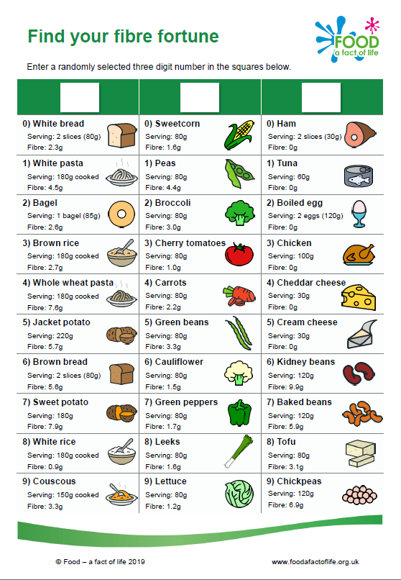
Get creative and make a fibre-filled meal based on three randomly selected ingredients.

Task 1:

- Before looking at the Find your fibre fortune worksheet, pick three numbers between zero and nine.
- Write your numbers into the boxes at the top of the worksheet. The number you have written in each column tells you the food item you will have to use to make your meal.
- You also have access to the Store cupboard worksheet, which contains additional ingredients that you can use.
- Calculate the total amount of fibre your meal provides, using the information given.

Questions:

- How much fibre do your three foods provide? _______ grams

- Name one item you could swap in your dish to increase the fibre content.
________________________________________________________________

- Name one item you could add to your dish to increase the fibre content.
________________________________________________________________

- Name three items from the store cupboard that could also add to the fibre in your meal.
________________________________________________________________
________________________________________________________________

Task 2:

- Make changes to your dish, in order to increase the fibre content.
- Go to Explore Food http://explorefood.foodafactoflife.org.uk/
- Enter in all of the ingredients and quantities for your updated dish.
- Print the results.

How many additional grams of fibre have your changes provided? ______ grams

