Asian style hoisin pork noodles

Ingredients
Complexity: medium-high
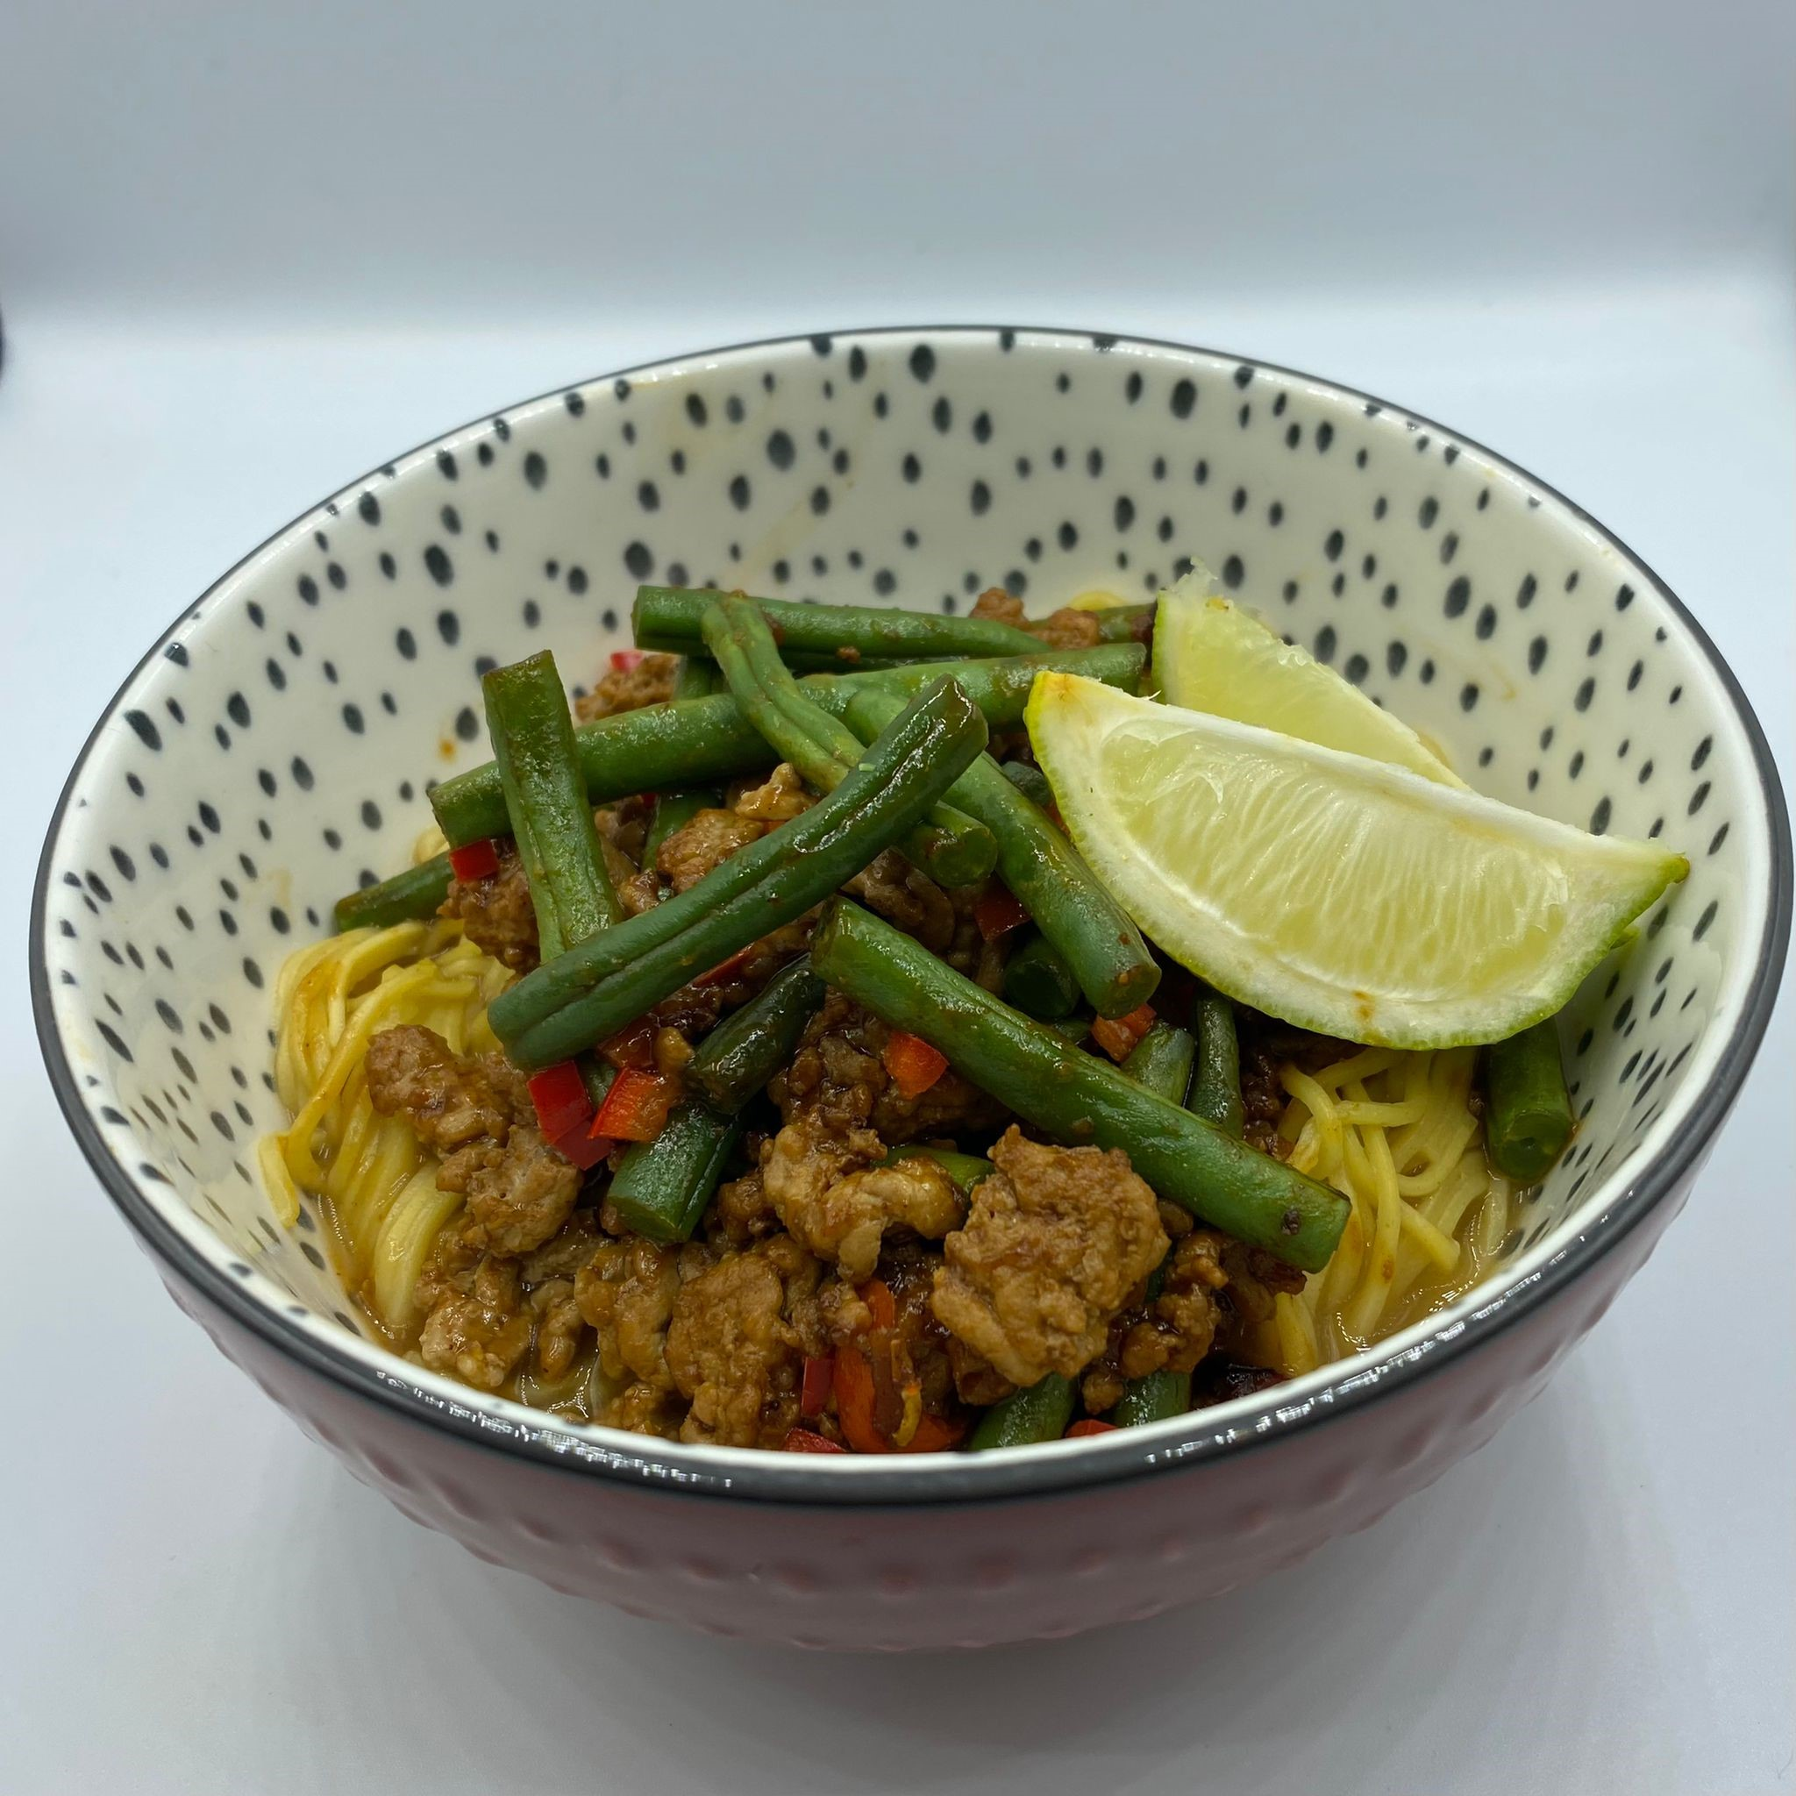
1 clove garlic
1 chilli
½ thumb-sized piece ginger
250g fine green beans
Spray oil
250g pork mince
1 x 15ml spoon soy sauce
1 ½ x 5ml spoons sugar
2 x 15ml spoon hoisin sauce
125g fine egg noodles
½ reduced salt chicken stock cube
1 lime

Equipment

Chopping board, vegetable knife, vegetable peeler, sieve/colander, large frying pan, mixing spoon, measuring spoons, kettle, large saucepan, ladle.

Method
- Prepare the ingredients:
- peel and chop the garlic clove;
- cut the fresh chilli in half lengthways, deseed and finely chop. do not touch face or eyes and thoroughly wash and dry hands after touching raw chilli;
- peel and thinly slice the ginger;
- wash the green beans and cut in half.
- Spray a large frying pan lightly with oil. Place over a high heat and fry the garlic, chilli and ginger for 30 seconds.
- Add the pork and fry for 5-6 minutes, until lightly golden.
- Add the green beans, ½ x 15ml soy sauce and the sugar and cook for a further 5 minutes until the pork and green beans are cooked. Add a little water if the mix becomes very dry.
- Stir in the hoisin sauce and remove from the heat.
- Crumble the stock cube into a large pan and add 400ml boiling water with the remaining ½ x 15ml soy sauce.
- Cook the noodles in the stock for 3 minutes, then drain, reserving the stock.
- Divide the noodles between serving dishes, then add one ladleful of the stock to each dish and top with the pork and green beans.
- Serve each dish with a wedge of lime.

Top tips
- Chicken or turkey mince could be used instead of pork.
- For a vegetarian dish, use a plant-based mince and a vegetable stock cube.
- Add shitake for extra umami flavour. Shiitake are quite mild when bought fresh, but drying concentrates their flavour. They have a firm, meaty texture that becomes slippery when cooked.

Food skills
- Weigh
- Measure
- Peel
- Slice
- Chop
- Sauté
- Boil
- Drain

Did you know?
Hoisin sauce is a sweet, spicy dark red sauce made from soya beans, vinegar, sugar, garlic, and various spices, widely used in southern Chinese cooking. Hoisin comes from the Cantonese word for seafood although it is not often used with seafood dishes.

Chinese egg noodles are classic Asian noodles made from wheat flour, water, and egg. Springy with a slight chew, the noodles are made in thin or thick strands. They can be bought in fresh or dried form.

This recipe was adapted from a recipe for Asian style hoisin pork noodles, kindly donated by Marks and Spencer.

