Minestrone soup

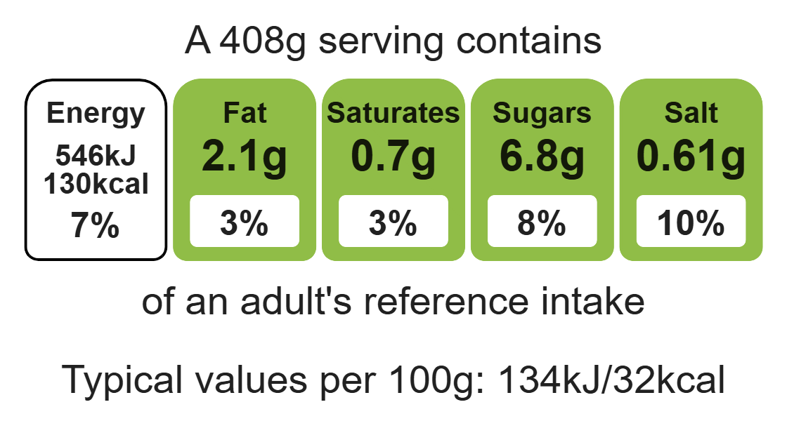


Ingredients (serves 3)
Complexity: medium

1 clove of garlic

¼ cabbage

1 onion

Equipment

2 chopping boards

2 sharp knives

Garlic press

Measuring spoons

Frying pan

Saucepan

Heat-resistant spoon

Measuring jug

1 rasher of bacon

1 carrot

1 stick of celery

1 potato

1 reduced-salt stock cube and 800ml boiling water

1 x 400g tin of chopped tomatoes

1 x 5ml mixed herbs

Black pepper

25g wholemeal pasta

Method
Top tips
- Reduce food waste: Use up any leftover vegetables such as courgettes or carrots.
- Vary your protein: Add 2 x 15ml spoons of beans or lentils to the soup such as cannelloni beans or lentils.
- Focus on fibre: Swap the pasta with a wholemeal variety to boost the fibre content of the dish.
- Serving suggestion: Serve with reduced-fat grated cheese.

1. Prepare the soup for the ingredients on a clean chopping board:
- peel and crush the garlic;
- shred the cabbage;
- peel and chop the onion;
- chop the bacon using a clean knife and clean red chopping board.
2. Heat the oil in the frying pan and fry the onion, garlic and bacon in the oil for 2 minutes.
3. Stir in the potato, celery and carrot.
4. Add the boiling water to the pan and the stock cube. Add the tin of chopped tomatoes.
5. Stir in the finely shredded cabbage.
6. Add the mixed herbs and black pepper, bring to the boil and then simmer for 10 minutes.
7. Add the pasta and allow to simmer for a further 10 minutes.

Food skills
Weigh, measure, peel, cut, chop, slice, dice and trim, fry and sauté, melt, simmer and boil.

