Food waste pick and mix
Try these food waste activities from this pick and mix selection!
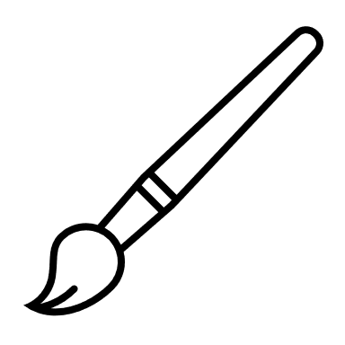  Create a collage or mixed-media artwork using images, packaging, and non-perishable scraps of food-related items that would otherwise be discarded. | 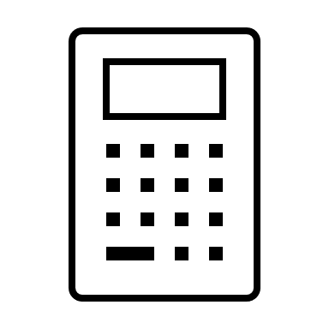  Gather any leftover or unused food items from a meal or a sample snack (e.g. half an apple, crusts from a sandwich). Weigh each item using digital scales and record the weight.  Using the price of each item, calculate the cost of what was left over and project what the cost might be over a week, a month or a year. Reflect on how you can reduce the cost of food waste. | 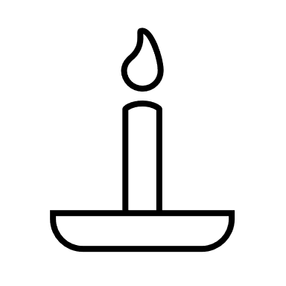  Research different religious teachings around the importance of gratitude for food, responsible use of resources and helping those in need.  Consider how these teachings help us to value food and make a personal pledge committing to a specific action to reduce food waste. |   Create a short rap or song about the importance of reducing food waste, incorporating facts and actions to spread awareness.  Be creative – use rhythm, rhyming, and even beatboxing or simple instruments for a background beat.
  Research food waste statistics from different countries.  Using a blank world map, colour or shade each country, using a colour scale, to visualize where food waste is most prevalent.  Identify the reasons why food waste might be different across the world and how food waste could be reduced globally. | 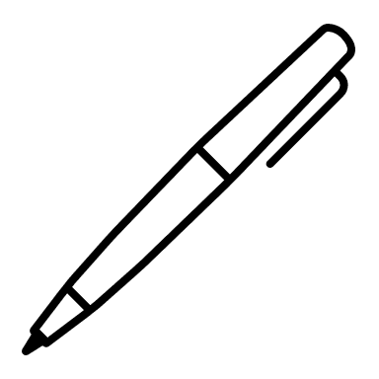  Research food waste issues and write a news article or blog post to inform your peers about the topic, emphasizing local and global perspectives.  Make sure you use credible sources and include data, quotes, and stories to bring it to life. |   Create a short video (1-3 minutes) that raises awareness about food waste, its impact, and solutions.  Consider focusing on a specific angle, e.g. the journey of food, how to reduce waste at home, or community initiatives. |   Research the five most commonly wasted food items in the home.  Be creative and write a recipe that uses each of the food items  Make one of the recipes next time you have some of the food left over.
This resource meets the Guidelines for producers and users of school education resources about food.

