International ideas using lamb

Lamb is a popular meat that is used in many cuisines worldwide. It is a very versatile meat and can be used in traditional and modern variations of recipes.

Task 1
Compare the traditional recipe for Lamb tagine with a more modern recipe for Minced lamb tagine.
Lamb tagine

Ingredients
5 onions
6 garlic cloves
1 x 5ml spoon saffron strands
2kg lamb neck fillet
Black pepper
3 x15ml spoon oil
2 x 5ml spoon ground turmeric
2 x 5ml spoon ground ginger
1 x 15ml spoon ground coriander
1 x 15ml spoon ground cumin
1 x 15ml spoon ground cinnamon
500ml water
500ml fruity ale
2 cinnamon sticks
250g dried prunes
250g dried apricots
3 x 15ml spoon honey
500g couscous
800ml water
200g flaked almonds (optional)

Method
- Prepare the ingredients:
- peel and finely chop the onions;
- peel and crush the garlic;
- crush the saffron strands.
- Using a clean knife and chopping board, trim the neck fillet, cut into large cubes and season with a few twists of black pepper.
- Heat 2x 15ml spoon oil in a non-stick frying pan, brown the meat on all sides in small batches and set aside.
- Fry the onions and garlic in 1x15ml spoon oil until soft.
- Stir in the turmeric, ginger, coriander, cumin and cinnamon and cook for 2-3 minutes.
- Return the meat to the pan with and add the water, ale, saffron and cinnamon sticks.
- Reduce the heat and cover the pan.
- Simmer gently for an hour.
- After 30 minutes, add the prunes, apricots and honey to the tagine.
- Simmer for a further 30 minutes.
- Remove the cinnamon sticks and set aside.
- Pre-heat the grill.
- Place the couscous in a bowl and pour over 800ml of boiling water.
- Cover the couscous and leave to stand for 10 minutes.
- Place the flaked almonds onto a baking tray and grill for 2-3 minutes until lightly toasted.
- Stir the almonds to the couscous using a fork.
- Serve the lamb tagine with the couscous.

Minced lamb tagine

Ingredients
1 onion
75g dried apricots
2 x 15ml spoon fresh coriander
450g lean lamb mince
1 x 5ml spoon ground paprika
1 x 5ml spoon ground coriander
1 x 5ml spoon ground ginger
1 x 5ml spoon ground turmeric
1 x 400g can chopped tomatoes
1 x 400g can chickpeas

Method
- Prepare the ingredients:
  - peel and finely chop the onion;
  - cut the apricots into quarters;
  - roughly chop the fresh coriander.
- Dry-fry the lamb mince, onion, paprika, coriander, ginger, and turmeric for 3-4 minutes.
- Stir in the chopped tomatoes.
- Bring the mixture to the boil, reduce the heat and then simmer for 15-20 minutes.
- Drain the canned chickpeas.
- During the last 5 minutes, add the dried fruit and chickpeas.
- Stir in the fresh coriander and serve with couscous and a side salad.

Explain how the ingredients, recipe, cooking methods for these two recipes differ.

______________________________________________________________________

______________________________________________________________________

______________________________________________________________________

______________________________________________________________________

______________________________________________________________________

______________________________________________________________________

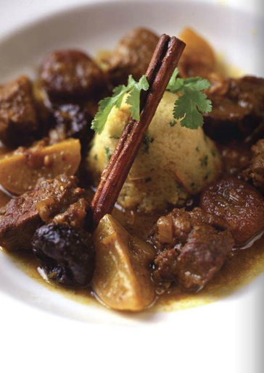

Minced lamb tagine
Traditional lamb tagine

Task 2
- Research lamb recipes and identify three examples that demonstrate the following:

- the versatility of lamb – the use of different cuts and different methods of cooking.

- the use of lamb in different cuisines.

- Identify what cuts of lamb could be used to make a quick evening meal. How would you prepare them?

___________________________________________________________________

___________________________________________________________________

___________________________________________________________________

___________________________________________________________________

- State three accompaniments that might traditionally be served with roast lamb. Identify three modern alternatives that could be served instead.

Traditional accompaniments | Modern alternatives

