Raisin and banana cookies

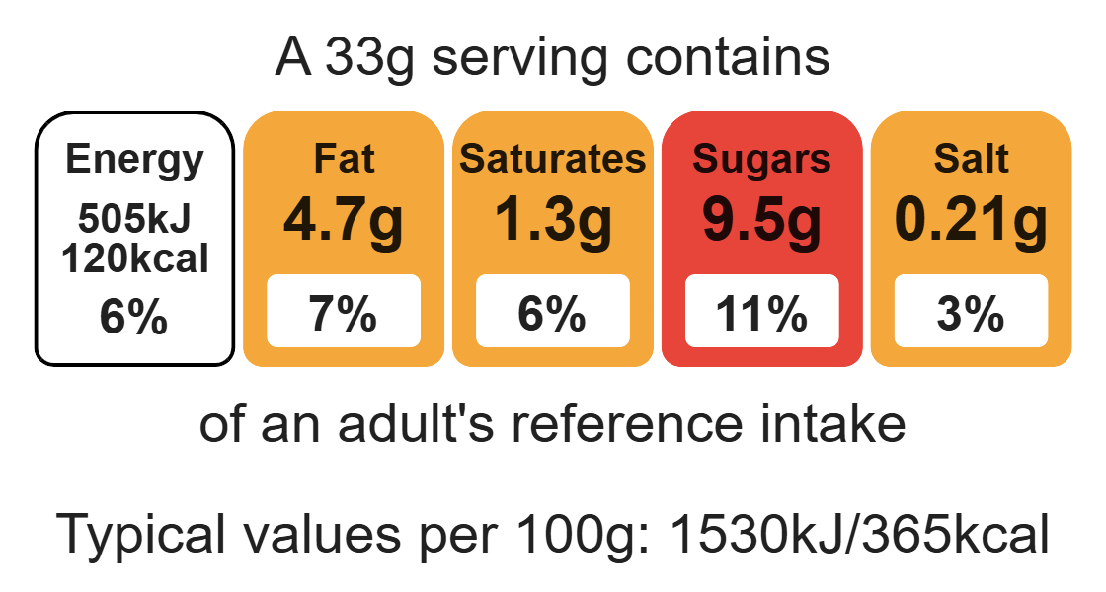
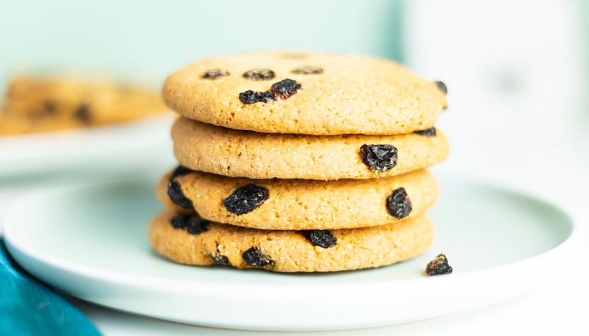

Ingredients (makes 16)

85g reduced-fat spread

80g light brown soft sugar
Complexity: low - medium

A few drops of vanilla extract

1 egg

Equipment

Baking tray

Weighing scales

Mixing bowl

Mixing spoon

Measuring spoons

Sieve

Metal spoons

Cooling rack

1 ripe banana

175g wholemeal self-raising flour

85g raisins

16 banana chips to decorate (optional)

Method
- Preheat the oven to 180°C or gas mark 4.
- Grease or line a baking tray.
- In a large bowl combine the fat (spread), sugar and vanilla and cream together using a mixing spoon, until light and fluffy.
- Crack the egg in a separate bowl, whisk and add to the bowl.
- Peel and mash the banana and add to the bowl.
- Mix all the ingredients together.
- Sift in the flour and add the raisins.
- Mix well until all the flour is incorporated.
- Using a spoon divide the mixture into 16 equal amounts and place on the baking tray leaving space in between each to allow for spreading during cooking. Top each cookie with a banana chip (optional).
- Bake in the preheated oven for 8-10 minutes or until golden brown.
- Remove from the oven and leave to cool for 2-3 minutes before removing from the baking trays and transferring to a cooling rack to cool completely.

Top tips
- Turn up the flavour: Try adding 1/2 5ml of cinnamon to the mixture.
- Focus on fibre: Using wholemeal flour in this recipe will help to boost the fibre content of the dish.

Food skills
Weigh, measure, cream, peel, mash, mix, stir and combine, sift, portion/divide, decorate and garnish, bake.

