Food commodities: Fruit and vegetables

Leaves – e.g. cabbage, kale, spinach
Plant leaves capture sunlight and use the energy from it to make food. This process is known as photosynthesis.

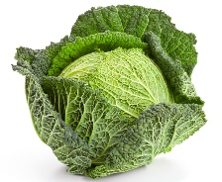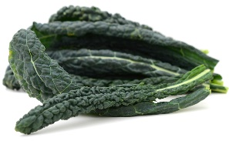

Citrus fruits – e.g. lemon, orange
Citrus fruits are usually quite large and round. They have a waxy outer layer that needs to be peeled off before they can be eaten.

They also tend to have a sour taste.
Fruit
One of the main purposes of fruit is to spread the seeds of the plant.

Fruit can be classified as:
- berries;
- citrus fruit;
- fleshy fruit;
- pomes;
- stone fruit.
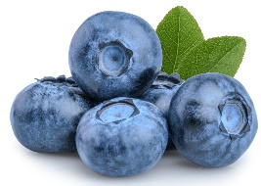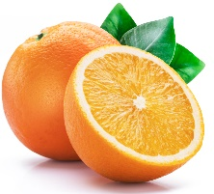
Berries Citrus fruit
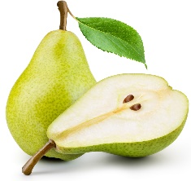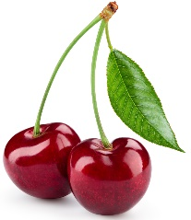
Pomes Stone fruit
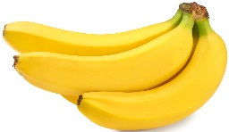
Fleshy fruit
Vegetables are the edible part of a plant.
They are often grouped according to the part of the plant that is eaten:
- bulbs;
- flowers;
- fruit;
- leaves;
- roots;
- seeds;
- stem (stalk).

Key terms
Fruit: The mature ripened ovaries of flowers.
Vegetables: The edible part of a plant.
Flowers: The part of the plant that allow it to reproduce.
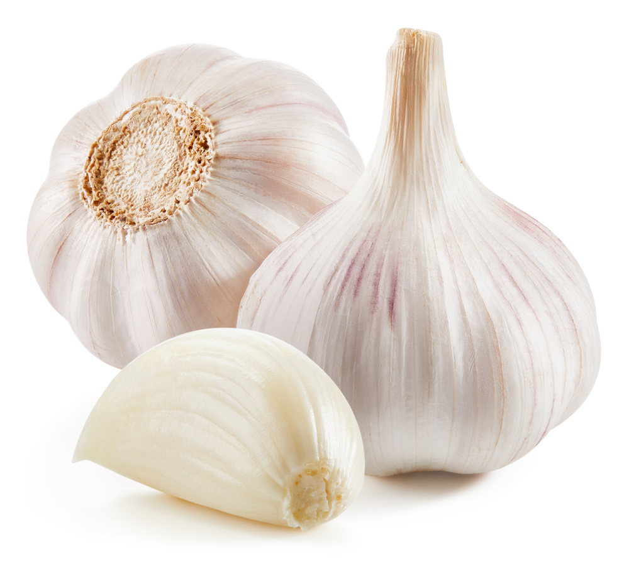
Legumes – e.g. garden peas, kidney beans
Legumes are grown for their edible seeds, known as beans and peas. They are the fruit (seed) of a plant. Legume seeds that are dried and used as food are called pulses (e.g. lentils).

Stem (stalk) – e.g. asparagus, celery
The stalk of the plant helps to keep it standing up, provide support and carry water and nutrients to different parts of the plant.
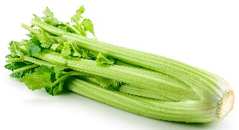

Garlic is a bulb
Pomes – e.g. apples, pears
Apples and pears are a special type of fruit called a ‘pome’.
These fruits have a core which is usually not eaten and contain several ‘pips’.
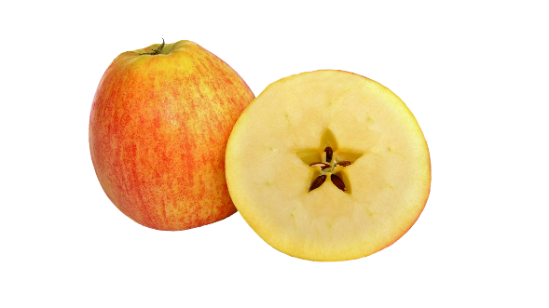
Tasks
- Keep a diary of the different fruit and vegetables you eat – can you get 10 different types in one week?
- Create a poster on the different types of fruit and vegetables. Include an example of each type and explain how they can be used in dishes.
Stone fruit – e.g. cherries, peaches
Stone fruits are those that have a large, hard ‘stone’ in the middle of them that is not eaten.

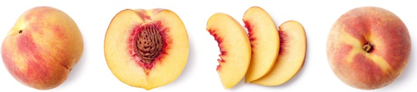

Fleshy fruits – e.g. banana, melon
These fruits are usually fairly large and do not have a central stone.
Often, the seeds in the fruit are eaten along with the flesh as they are small and soft, but this is not true with melons.
Tubers – e.g. casava, potatoes, yams
Tubers store nutrients for the plant and also propagate new plants by forming stems and leaves. Tubers are often high in carbohydrates.

Roots – e.g. beetroot, carrot, parsnip
The roots of the plant take up water and nutrients from the soil for growth.
They also anchor the plant to the ground.

Fruit – e.g. cucumber, pepper, tomatoes
The fruit of a plant is created after its flowers have been pollinated. Many fruits are sweet, but some fruits are not and are usually used like a vegetable in food.
Flowers – e.g. broccoli, cauliflower, capers
Flowers are part of the plant that allow it to reproduce. Some flowers are edible, but many others are not.
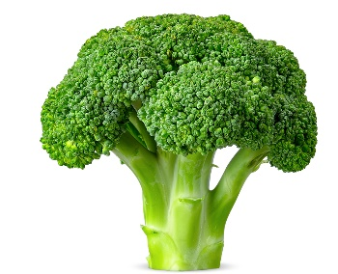
Berries – e.g. grapes, strawberries
A berry is a small, sweet fruit.
They are often coloured red, blue or black.

Berries contain small seeds, which are usually edible and do not have a large stone.

Raspberries
Botanically, raspberries are not a true berry (a fruit with many seeds scattered throughout the pulp) but an etaerio (or aggregate fruit) made up of drupelets (individual sections of fruit each with its own seed).
For more information, go to: https://bit.ly/3fGKgT0
Mushrooms – e.g. button, chestnut
Mushrooms are different kinds of fungi, rather than plants. Many types of mushrooms are dangerous to eat.

Mushrooms available for consumers to buy are carefully selected to be safe.
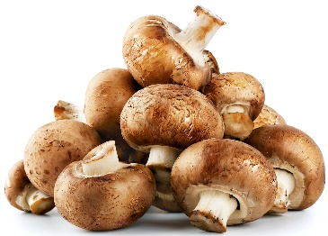
What counts?
All fruit and vegetables count, including fresh, frozen, canned, dried and juiced varieties.

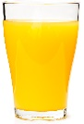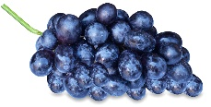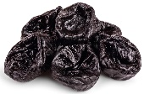
150ml 80g 30g

Eat 5 A DAY!
Fruit and vegetables are an important part of a healthy, balanced diet.
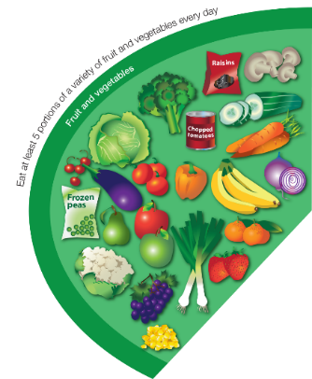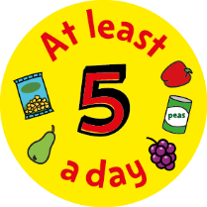

Some types are good sources of fibre, as well as providing lots of essential vitamins and minerals.

Eating lots of fruit and vegetables can help you maintain a healthy weight (as they are naturally low in calories) and having your 5 A DAY could reduce your risk of some diseases.

Bulbs – e.g. garlic, fennel, onions, shallots Some plants have bulbs which stay underground to store food for the plant when it is not growing.
When the time is right, the bulb produces shoots which grow up through the soil.

