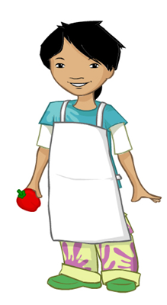
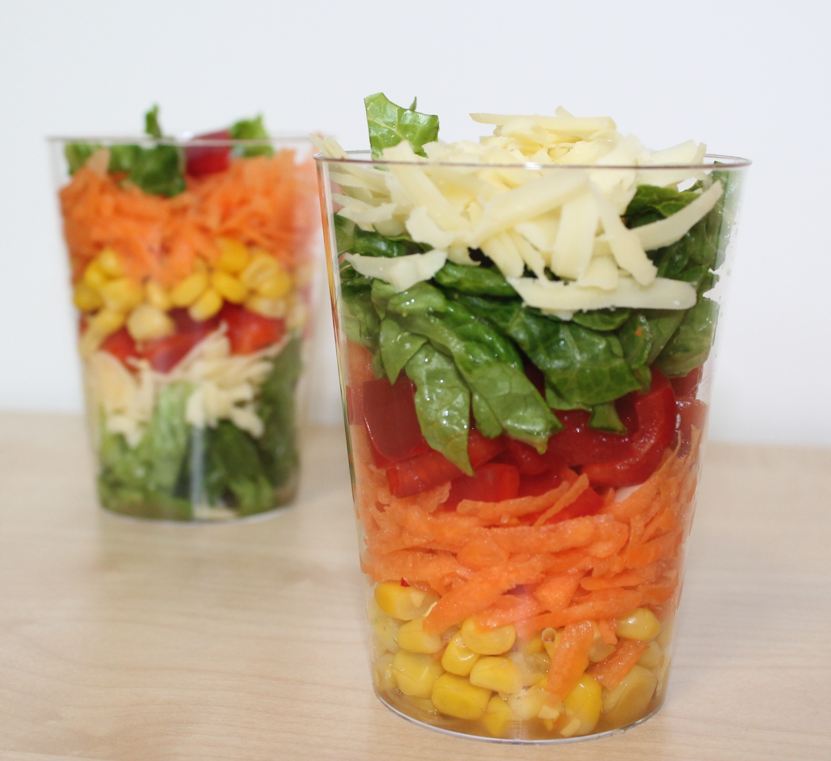
Risk assessment for Stripy salad pots
Equipment
Chopping board
Peeler
Grater
Vegetable knife
Kitchen scissors
2 clear plastic cups

Ingredients
30g Cheddar cheese
1 small carrot
½ red pepper, deseeded
2 lettuce leaves
4 x 15ml spoon sweetcorn
Remember:
- Shopping for ingredients
- Safe storage (including allergens)
- Preparation of classroom and equipment
- Getting ready to cook (pupils and staff)
- Preparation of ingredients
- Safe use of equipment
- Preventing cross-contamination (including allergens)
- Safe cooking (if appropriate)
- Safe cooling
- Safe storage
- Cleaning, washing up and putting equipment away
- Pupils taking food home
Getting ready to cook:
- Hair tied up
- Jumper removed
- Nail varnish, jewellery and watches removed
- Clean apron on
- Hands washed with anti-bacterial soap and thoroughly dried.

Method/process | Hazard | Precautions/controls | Time/temperature if appropriate
Buying ingredients | Poor quality food, out of date, bacterial multiplication | Buy from a reputable supplier. Check quality and date marks. | Use a cool bag/ice blocks for high risk foods
Reheat to 75°C or until piping hot (but only once)
Fridge
0-4°C
Cool hot food quickly and store in a fridge within two hours.
Cook to at least 75°C, or until piping hot
Freezer below -18°C

