Algerian meatballs

Ingredients
Complexity: medium

1 slice of dry bread

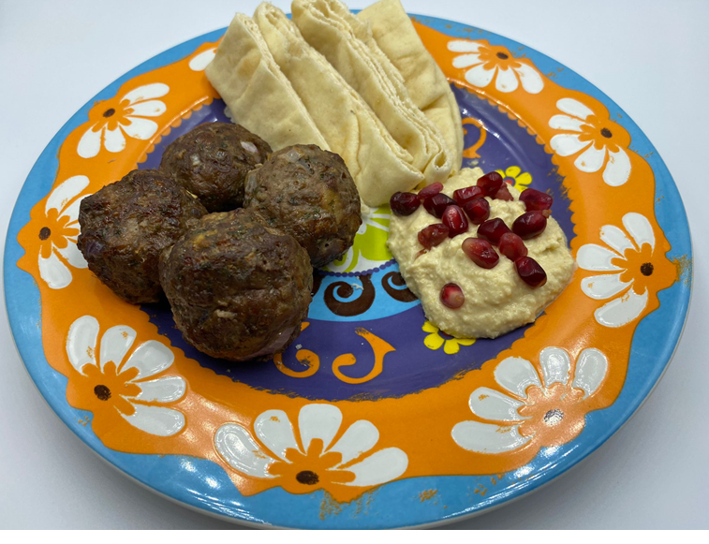
70ml milk

1 small onion

4 x 15ml spoons fresh parsley or 1 x 15ml spoon dried parsley

1 x 5ml spoon fresh mint or ½ x 5ml spoon dried mint

½ x 5ml spoon fresh dill or ¼ x 5ml spoon dried dill

1 egg

250g minced beef or lamb

Fresh black pepper for seasoning

Equipment

Baking tray, greaseproof paper, 2 x small bowls, measuring jug, chopping board, vegetable knife, fork, large mixing bowl, measuring spoons, mixing spoon.

Method
- Preheat the oven to 200°C or Gas mark 6.
- Line a baking tray with greaseproof paper.
- Break the bread into small pieces and place in a small bowl. Cover with the milk and leave to soak until the bread is soft.
- Prepare the ingredients:
- peel and finely chop the onion;
- chop the fresh parsley, mint and dill (if using);
- crack the egg into a small bowl and beat lightly.
- Place the minced beef/lamb, parsley, mint, dill, a grind of black pepper and half the beaten egg in a large mixing bowl.
- Squeeze out the excess milk from the bread and add bread to the meat mixture.
- Stir the mixture well to combine the ingredients.
- If the mixture is too thick to shape easily add a little more beaten egg to achieve the right consistency for shaping.
- Roll the mixture into 12 even sized 3cm balls and place on a lined baking tray. Remember to thoroughly wash and dry your hands after touching the raw meat mixture.
- Bake in the oven for 20-25 minutes.

Top tips
- Check to make sure the meat balls are thoroughly cooked by piercing the centre with a fork or skewer, the juices should run clear and there should be no pink meat.
- The spice blend Ras el hanout could be used to season and add extra flavour to the meat mixture.
- Serve with flatbreads and hummus or couscous.

Food skills
- Weigh and measure
- Peel
- Slice
- Chop
- Mix
- Combine
- Portion and divide
- Bake

Did you know?
The cuisine of Algeria is influenced by its history and is a blend of North African, French and Mediterranean flavours. Couscous is the most popular food in Algeria and is prepared each Friday and at funerals. Couscous is also called “Taam”, “Seksou”, “Berboucha” and “Naama”, depending on geographical region of the country.

Mhajab is eaten almost every day. It consists of a thin loaf that is made from flour and water and filled with onions and tomatoes. Mhajab is then prepared in layers of square dough and finally folded several times before it’s fried in oil.

