Session 1: Getting to grips
Welcome
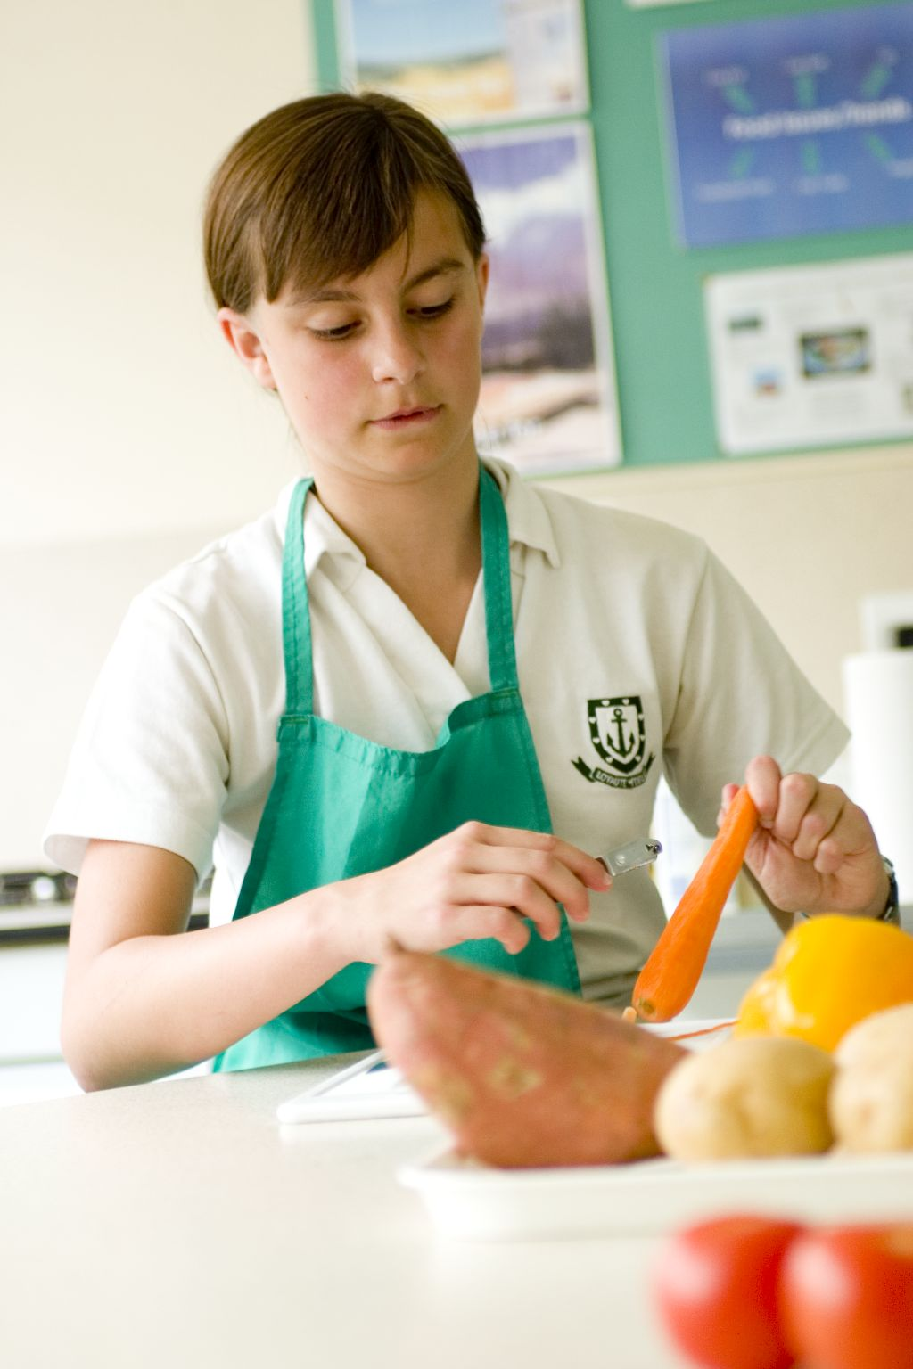
This is an introductory session about students getting to grips with cooking and the working area. Some students may have had experience handling food before; others may not. This session allows all students to become familiar with, and therefore more confident in using, the cooking area. It also provides you with the opportunity to assess their practical capability, e.g. handling of food and use of equipment. You could use the practical observation sheet to help.

During this session, students will make either a fruit fusion or dippy divers. These recipes have been selected as they do not require the application of heat. They provide a context for teaching of specific knife skills and preparation techniques, as well as the use of basic equipment.

There is lots of room for students to be creative, selecting different types of fruit and vegetables to use. If they already have some relevant skills, you could get your students to use the fruit fusion or dippy divers recipe writing frames before cooking to develop their own ideas. The students’ own recipe creations could then be used in this session.

If you have an established lesson plan and/or recipe, which supports the aims and objectives of this session, feel free to use it instead. Look at the support materials provided within this session as they may well be useful in your own lessons, e.g. worksheets, PowerPoint presentations.

This session can act as a stand-alone lesson, perhaps to focus and build on key skills. Alternatively, it could be integrated into a series of lessons, e.g. exploring fruit and vegetables from around the world; creating fruit based desserts or developing sensory vocabulary.

Aims and objectives

Aim
For students to:
- become more familiar with, and confident in using, the cooking area.

Objectives
Students should be able to:
- use a range of basic equipment safely, e.g. chopping board, knife, spoon, mixing bowl;
- handle and prepare a range of fruit or vegetables, e.g. peeling;
- cut fruit or vegetables safely using the bridge hold and claw grip;
- make a fruit or vegetable dish, e.g. a fruit fusion or dippy divers.

Cooking session
Two cooking session plans, based on the Licence to Cook recipes supplied within this session.

If you have your own tried and tested fruit fusion or dippy divers recipe, feel free to use it instead. In addition, you may wish to make fruit or vegetable kebabs or a vegetable based salad, e.g. coleslaw, tabbouleh.

Each plan refers to aspects of healthy eating, wise food shopping and food safety and hygiene which are themes which run through each session.

Before the cooking session
There are a number of factors that you need to consider before the cooking session. More detailed guidance is available in the Cooking session guide.

You will need to consider:
- Ingredients: who will be providing the ingredients and where will they be stored? In the fruit fusion recipe, 2x15ml spoons orange juice are used and in the dippy divers, fresh chives are used. It may be easier for the school to provide a carton of juice or fresh chives for students to share.
- Recipe: are pupils going to use a printed-out copy or follow instructions on an interactive whiteboard?
- Equipment: is all the equipment needed for the session available, clean and in good working order? If time and resource permit, you may wish to have the exact equipment out for each student for this first session, to build their confidence. In subsequent lessons, you may wish the students to locate their own equipment from cupboards and drawers.
- Aprons: do you have enough and are they clean?
- Hair: do you have ties/bands for long hair?
- Containers: will students be able to take away the food they cook? If so, in what?
- Waste: do you have adequate disposal facilities, including recycling or composting?
- Cooking area: is it clean and ready to use?

Differentiation and inclusion
Before the cooking session, you will need to consider the age, ability, previous experience and any special requirements of your students. This will determine recipe selection, any advanced ingredient preparation and equipment used.

Do any of your students need:
- ingredients partly pre-prepared, e.g. peeled or cored?
- assistance with their practical work, e.g. slicing?
- different types of fruit and vegetables, some of which are easier to prepare or some which are more challenging?
- share tasks, by working in pairs?
- extension activities, such as making a yogurt-dip to serve with their fruit fusion?

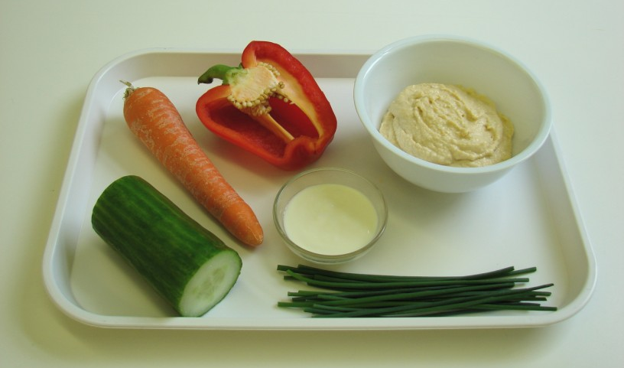
Demonstration
During the session you will be demonstrating the safe use of a knife, as well as the use of other basic pieces of equipment.

Ensure that you have all the ingredients and equipment you need ready before the session, perhaps on trays for ease, for your demonstration.

Think about:
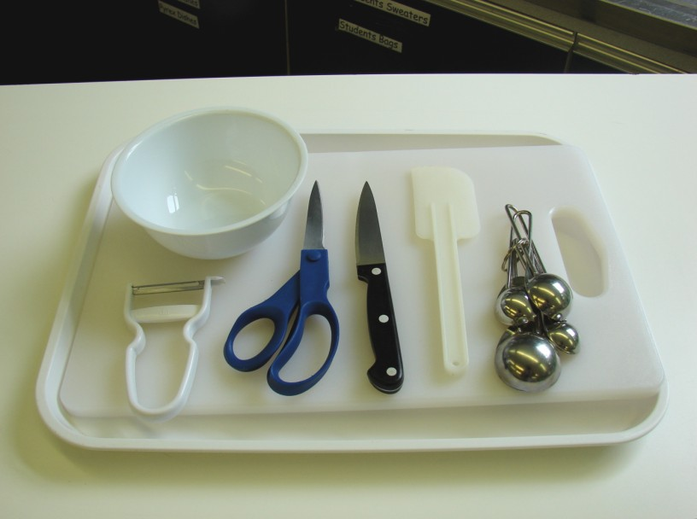
- describing the ingredients and equipment used;
- highlighting key skills, such as peeling, cutting and slicing safely – using the bridge hold and claw grip techniques;
- ensuring that students have followed and understood the method.

More detailed guidance is available in the Demonstrating guide.
Risk assessment

The two cooking session plans and recipes highlight a number of different hygiene and safety issues which need to be considered before, during and after the cooking session.

Before the cooking session, you will need to assess these risks in relation to the number of students being taught, as well as their experience, and consider measures that can be put into place to manage the risk. Below are examples of potential risks, along with preventative measures.

Fruit fusion
Potential risk | Measure | Likelihood
Dirt or food poisoning bacteria present on raw food, causing cross contamination | Wash fruit | Low/Med
Cuts from using a knife unsafely | Demonstrate safe use of knives and monitor students’ use | Med
Cuts due to running in room with knife | Remind students of rules in kitchen and instil safe conduct | Low
Peelings on floor causing accidents | Container on work surface for peelings and other waste | Low

Dippy divers
Potential risk | Measure | Likelihood
Perishable foods are not stored correctly, leading to contamination | Ensure that the yogurt and hummus are refrigerated before use
Dirt or food poisoning bacteria present on raw food, causing cross contamination | Wash vegetables | Low/Med
Out of date hummus or yogurt used during cooking | Check date marks before purchase and use | Low
Cuts from using the knife unsafely | Demonstrate safe use of knives and monitor students’ use | Med
Peelings on floor causing accidents | Container on work surface for peelings and other waste | Low

Time
The session plans are based on a 60 minute session If you have less time available, you will need to modify the session plan to better suit your circumstances. For example, within this session you might:
- demonstrate key skills in a separate session, leaving more time for cooking;
- demonstrate key aspects from the recipe, rather than every stage;
- reduce the number of fruits, or change them for those which are easier to prepare;
- use a canned fruit, to reduce preparation time;
- have ingredients pre-measured or partly prepared;
- allow students to work with a partner.
During the session
Time (mins) | Activity: fruit fusion | Equipment/ Resources
0 | Registration.  Explain to the students that they will be making a fruit fusion. Go through the aims and objectives for the session. | PowerPoint-  Fruit fusion recipe
5 | Gather the students around a demonstration area, with your tray of ingredients and equipment. Get students to put on their aprons, tie back long hair and wash their hands.  Briefly talk through the recipe – note your expectations, for example:  * washing the fruit before use;  * using a knife safely to prepare the fruit on a clean chopping board;  * placing peelings in a bowl (or something similar);  * being hygienic and safe when preparing food, e.g. washing hands, wearing an apron;  * becoming a confident cook in the food room. | Aprons  Demonstration ingredient and equipment tray
 | Demonstration  * Place out the chopping board, vegetable knife and bowl.  * Explain that you will be showing two safe ways of using a knife – these are called the bridge hold and the claw grip.  * Use the apple to demonstrate the bridge hold. Cut in half, then into quarters. Use the claw grip to show how to remove the core of the apple.  * Next, take the kiwi fruit and slice away both ends, using the claw grip. Stand it on one end, and again, using the claw grip, show how to peel the skin away. Cut the kiwi fruit into slices, using the claw grip as a guide.  * Check that students understand both cutting techniques. If not, repeat on the other fruits, e.g. bridge hold cutting grapes in half, claw grip slicing the banana. | Aprons  Demonstration ingredient and equipment tray
20 | Ensure that students all wash their hands.  Allow them to start making their fruit fusion.  During this time, circulate the room to ensure that the correct equipment is being used and that the two knife skills are being employed. In this time, students should:  * peel the satsuma and banana;  * quarter, core and slice the apple;  * peel and slice the kiwi fruit;  * halve the grapes;  * mix everything together with 2x15ml spoons orange juice. | Ingredients (  Basic equipment

50 | Give a 5 minute time warning.  Remind students that all washing-up should be completed, work surfaces should be clean and their fruit fusion should be placed into a container.  Circulate the room, checking that sinks are clean and equipment is put away properly.
55 | Plenary  Pose the following questions to the students:  * What were the main skills demonstrated today?  * Could canned, frozen and dried fruits be used? Would they count towards 5 A DAY? What varieties could be used?  * What seasonal fruits could be used from the UK?
60 | Finish

After the session
Check that the room is clean and tidy. Students should leave the room as they find it.

The fruit fusions may need to be refrigerated until the end of the school day, if so, ensure that each container is covered and clearly labelled with the student’s name and group. The refrigerator should be between 0-5ºC.

If the same students are with you for another cooking session in the next few days or week, remind them of the ingredients and/or containers they need to bring, if appropriate. You may wish to provide students with recipes or writing frames.

During the session
Time (mins) | Activity: dippy divers | Equipment/ Resources
0 | Registration.  Explain to the students that they will be making a dippy divers. Go through the aims and objectives for the lesson. | PowerPoint Dippy divers recipe
5 | Gather the students around a demonstration area, with your tray of ingredients and equipment. Get students to put on their aprons, tie back long hair and wash their hands.  Briefly talk through the recipe – note your expectations, for example:  * washing vegetables before use;  * placing peelings into a bowl (or something similar);  * using a knife safely to prepare the vegetables on a clean chopping board;  * being hygienic and safe when preparing food, e.g. washing hands, wearing an apron;  * becoming a confident cook in the food room. | Aprons  Demonstration ingredient and equipment tray
 | Demonstration  * Place out the chopping board, vegetable knife and vegetable peeler.  * Explain that you will be showing two safe ways of using a knife – these are called the bridge hold and the claw grip.  * Remove the seeds using your fingers, and place these into a bowl, or something similar, for waste. Using the claw grip, start to slice the pepper into strips.  * Cut the cucumber into slices to demonstrate the claw grip.  * Next, take the carrot and cut away both ends using the claw grip. Taking the peeler, run it down the length of the carrot away from you. Repeat this process, placing peelings into a bowl (or something similar). Cut the carrot in half, then using the bridge hold, cut in half length ways. Repeat this process to make sticks.  * Check that students understand both cutting techniques. If not, repeat using another vegetable.  * Remind students how to make the simple dip. You may not need to demonstrate this – but check with the students first. | Aprons  Demonstration ingredient and equipment tray
20 | Ensure that students all wash their hands.  Allow them to start making their dippy divers.  During this time, circulate the room to ensure that the correct equipment is being used and that the two knife skills are being employed. In this time, students should:  * peel and slice the carrot into sticks;  * deseed and slice the pepper;  * slice the cucumber;  * snip the chives into a bowl using scissors;  * mix the dip together. | Ingredients  Basic equipment

50 | Give a 5 minute time warning.  Remind students that all washing-up should be completed, work surfaces should be clean and their dippy divers should be placed into a container.  Circulate the room, checking that sinks are clean and equipment is put away properly.
55 | Plenary  Pose the following questions to the students:  * What were the main skills demonstrated today?  * Name 5 other vegetables that could be used as a dipper.  * What other ingredients could be used to make a dip?
60 | Finish

After the session
Check that the room is clean and tidy. Students should leave the room as they find it.

The dippy divers may need to be refrigerated until the end of the school day, if so, ensure that each container is covered and clearly labelled with the student’s name and group. The refrigerator should be between 0-5ºC.

If the same students are with you for another cooking session in the next few days or week, remind them of the ingredients and/or containers they need to bring, if appropriate. You may wish to provide students with recipes or writing frames.
Extending this activity
This session provides a great opportunity to be integrated into existing lessons or be developed into a mini-scheme of work.

For example, students could:
- explore fruit and vegetables from around the world, including taste tests;
- plan, and create new ideas for fruit based desserts and dips and dippers, perhaps based on a theme, for a person or inspired by a specific country;
- evaluate their own recipes, learning about different types of sensory tests and subject specific vocabulary.

Appropriate aspects of ICT could also be integrated, including:
- recording sensory data;
- creating and writing recipes, and time plans;
- modelling costs and portion sizes;
- exploring the internet for background research.

Shopping list

Fruit fusion

Ingredient | x 1 | x 10 | x 20
satsuma | 1 | 10 | 20
grapes | 6 | 60 | 120
kiwi fruit | 1 | 10 | 20
banana | 1 | 10 | 20
apple | 1 | 10 | 20
orange juice | 2 x15ml spoons | 300ml | 600ml

Dippy divers

Ingredient | x 1 | x 10 | x 20
carrot | 1 | 10 | 20
red or yellow pepper | ½ | 5 | 10
cucumber | ¼ | 2½ | 5
hummus | 3x15ml spoons | 450g | 900g
plain yogurt | 1x15ml spoons | 150ml | 300ml
fresh chives | 1-2 strands | 10-20 strands | 20-50 strands

Equipment list

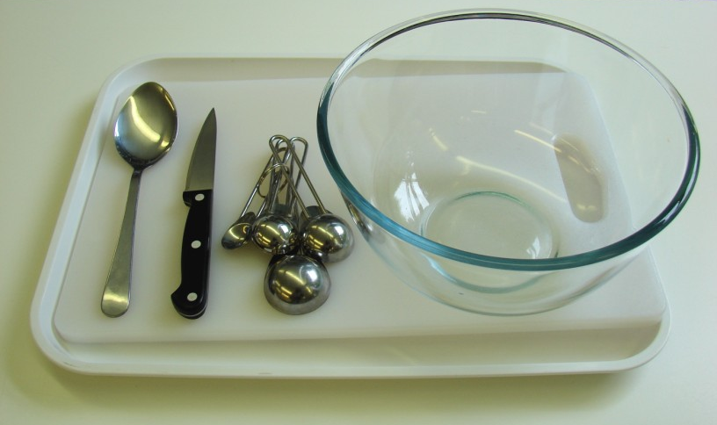
Fruit fusion

Vegetable knife
Chopping board
Bowl
Measuring spoons
Spoon

Dippy divers

Vegetable knife
Chopping board
Vegetable peeler
Small bowl
Measuring spoons
Kitchen scissors
Spatula

Other
You may also wish to have a bowl to collect peelings.

Containers

If pupils take home, they will need to bring (or be provided with by the school) a suitable container, such as a reusable tub or foil container with a lid.

