Lamb rogan josh

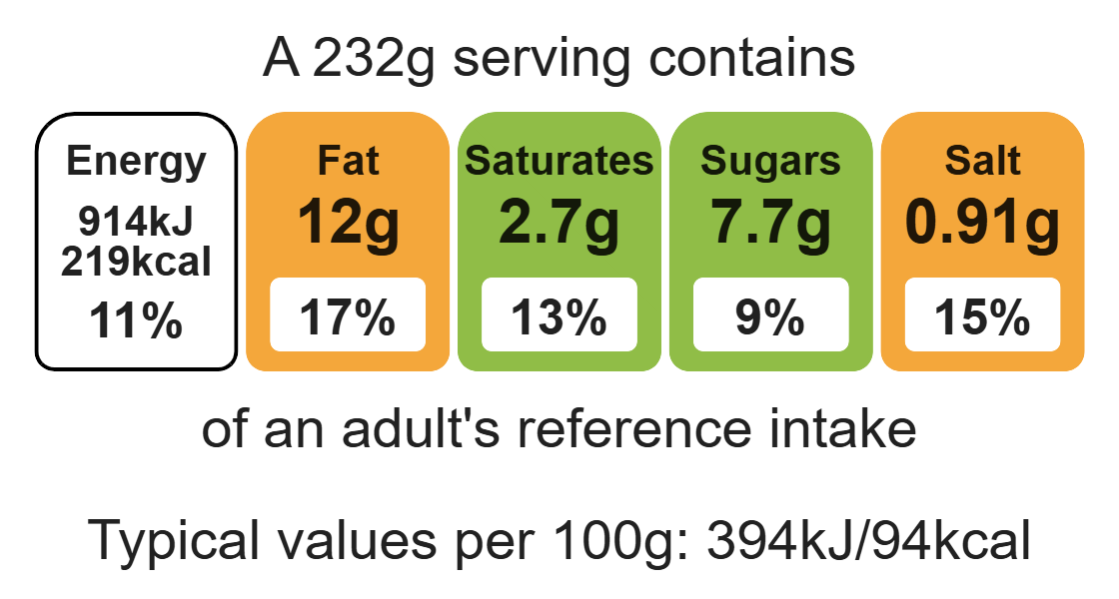
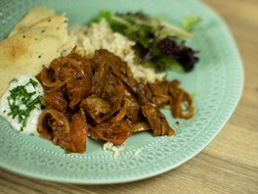

Ingredients (serves 3)
Complexity: low - medium
225g lean lamb leg steaks or neck fillet
1 onion

Equipment

Sharp knife

2x chopping boards

Garlic press

Large saucepan

Heat-resistant spoon

Measuring spoons

Mixing spoon

Can opener

2 tomatoes
1 clove garlic
1 x 15ml spoon fresh coriander
1 x 5ml spoon oil or spray oil
2 x 15ml spoons Rogan josh curry paste
200g (½ a can) chopped tomatoes

Method
1. Prepare the lamb on a clean chopping board. Cube the lamb and remove any visible fat. Thoroughly wash and dry hands.
2. Prepare the vegetables, on a clean chopping board:
- peel and slice the onion;
- cut the tomatoes into wedges;
- peel the garlic and crush;
- roughly chop the coriander.
3. Heat the oil in a large pan and add the lamb. Cook for 3-4 minutes.
4. Add the Rogan josh curry paste, sliced onions and garlic. Cook for a further 2-3 minutes.
5. Add the canned and fresh tomatoes and cook for further 2 minutes.
6. Stir the chopped coriander into the curry and serve.

Top tips
- Serving suggestion: Serve with rice, naan bread and a side salad.
- Reduce food waste: Replace the fresh tomatoes with thinly sliced courgettes, peppers or okra depending on what vegetables you need to use up.
- Focus on fibre: Serve with brown rice to boost the fibre content of this dish.

Food skills
Cut, chop, slice, dice and trim, peel, fry and sauté, mix, stir and combine, weigh, measure.

