Chicken shawarma flatbreads

with yogurt
Complexity: medium-high

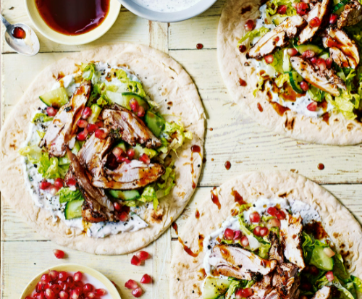
Ingredients

½ lemon

1 garlic clove

1 sprig thyme

Small bunch mint

3 skinless and boneless chicken thigh fillets

1 x 15ml spoon olive oil

1 x 5ml spoon sumac

¼ x 5ml spoon chilli flakes

100g Greek yogurt

Black pepper

Optional- for serving

1 little gem lettuce

5cm piece of cucumber

2 flatbreads

1 x 15ml spoon pomegranate seeds

Equipment

Baking tray, tin foil, chopping board, vegetable knife, lemon juicer, garlic press, red chopping board, measuring spoons, large bowl, mixing spoon, tongs, plate, small bowl.

Method
- Line a baking tray with tin foil.
- Prepare the ingredients:
  - cut the lemon in half and juice one half;
  - peel and crush the garlic clove;
  - pick the thyme leaves from the stalk;
  - chop the mint leaves.

Optional for serving:
- shred the lettuce;
- dice the cucumber.
- Remove any fat from the chicken thigh fillets. Thoroughly wash and dry your hands after touching the raw meat.
- Place the chicken, oil, ½ x 5 ml spoon of sumac, half the lemon juice, garlic, thyme and chilli flakes in a large bowl.
- Mix well making sure the chicken is covered in the marinade. Cover and leave to marinate for 10 minutes.
- Preheat the grill to high.
- Put the chicken on a lined baking tray and grill for 10-12 mins turning frequently, until the outside is browned, and the middle is cooked through with no pink juices.
- Remove from the grill and set aside.
- Place the yogurt, mint, remaining sumac and lemon juice in a bowl. Season with black pepper and mix well.

Optional to serve:
- Warm the flatbreads.
- Spread each flatbread with a spoonful of the yogurt mixture, then top with lettuce and cucumber.
- Slice the chicken into bite-size pieces and divide between the flatbreads.
- Top with the pomegranate seeds.
- Roll up the flatbread and serve warm.

Top tips
- For a vegetarian alternative use thinly sliced halloumi; brush with the marinade and then grill on a lined baking tray turning once until golden brown.
- To check the chicken thighs for ‘doneness’ it should have an internal temperature of at least 72°C. To probe chicken thighs the thermometer should be inserted into the thickest part of the meat. You can also test to see that the chicken is cooked if the juices run clear when cut and pressed.

Food skills
- Weigh
- Measure
- Cut
- Dice
- Juice
- Peel
- Crush
- Mix
- Grill

Did you know?
Originating from the Ottoman Empire in the 18th or 19th century, shawarma, means “turning” in Arabic. It is a Levantine meat preparation, where thin cuts of lamb, chicken, beef, or mixed meats are stacked in a cone-like shape on a vertical rotisserie. Shavings are cut off the block of meat for serving, and the remainder of the block of meat is kept heated on the rotating spit.

Today, shawarma is a staple street food in the Middle East traditionally served as a sandwich or in a wrap. Shawarma is usually eaten with tabbouleh, fattoush, taboon bread, tomato, and cucumber. Toppings include tahini, hummus, pickled turnips, amba (pickled mango with chilli) and toumaia (garlic sauce).

This recipe was adapted from a recipe for Chicken shawarma flatbreads with yogurt, which was kindly donated by Tesco plc.

