Testing food for protein 2

Introduction
In this test blue copper sulphate solution is used as an indicator. It will turn violet or purple if added to soluble protein.

This is the Biuret test which can be used for protein which dissolves in water but not for insoluble material.

You will need
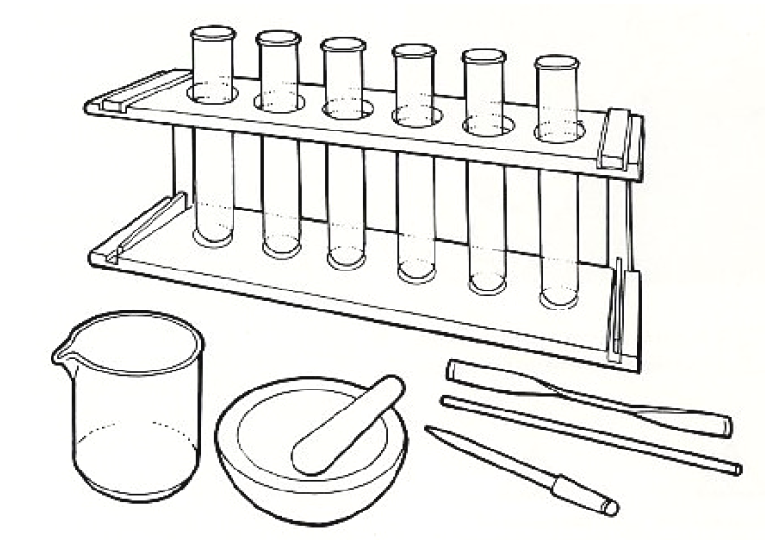
Equipment
Test tubes
Test tube rack
Glass rod
Spatula
Mechanical grinder or pestle & mortar
Dropping pipette
Eye protection

Materials
Food samples
Distilled water
Copper sulphate solution (1%)
Sodium hydroxide solution (10%)

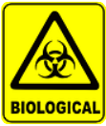
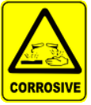

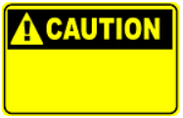

Some people are allergic or intolerant to a particular food or ingredient. Refer to the 14 allergens and check against student records before completing this experiment.

Wear eye protection.
CARE: Sodium hydroxide is corrosive.
Do not consume food in a laboratory, or any food used for experiments, because it may contaminated.

Method
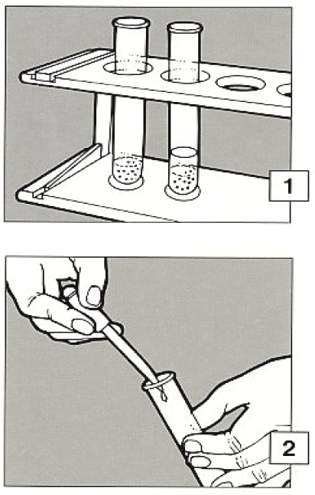
- If the food to be tested is liquid, go to 2. If the food to be tested is solid, make an extract. Grind, crush or chop a small amount and put it into a test tube to a depth of about 2cm. Add a similar amount of distilled water and stir with a glass rod. Allow to stand for a few minutes.

- Draw up about 1cm³ of the clear liquid into a pipette and transfer it gently to a test tube containing about 2cm³ dilute sodium hydroxide. Add 2cm³ copper sulphate solution.

- A purple or violet colour indicates that there is protein in the sample.

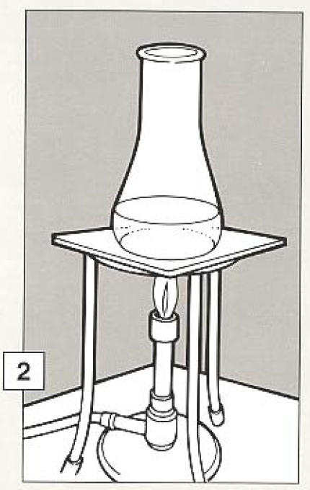

Extension work
If no colour change occurs there may be protein in the food which is insoluble. If it is present and can be dissolved then the Biuret test can be used to detect.

- To dissolve protein, crush and grind food as before but put it in a small conical flask. Add enough dilute hydrochloric acid to cover it completely.

- Boil the mixture gently for 10-20 minutes. If necessary add more acid to prevent it boiling dry. The turn off the heat and allow everything to cool.
- Using this liquid, repeat the Biuret test starting at stage 2.

A violet colour indicates protein which has been made soluble by the treatment with acid.
Wear eye protection.

