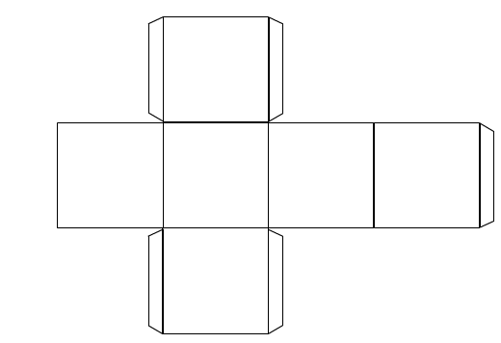
Food labelling – blank packaging net

Print on A3 paper. Cut out the packaging net and add all the information that is required by law including the information that relates to food hygiene and safety, i.e. a date mark, ingredient list (with allergens identified) and storage instructions. Consider carefully which side of the box you would like the information to appear. Assemble the box by gluing the flaps.

