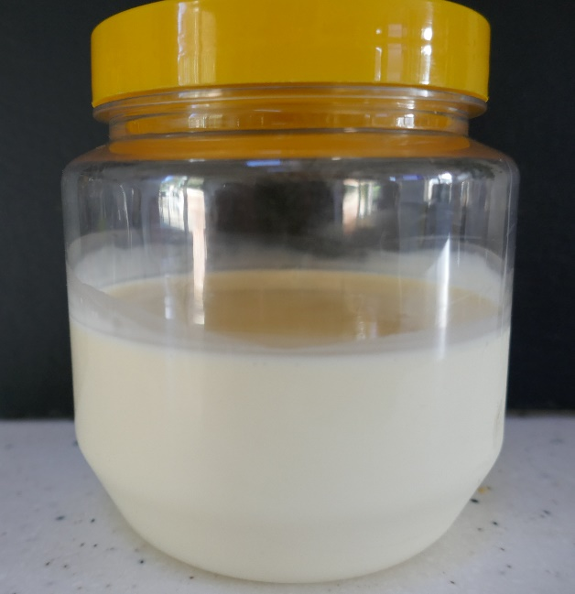
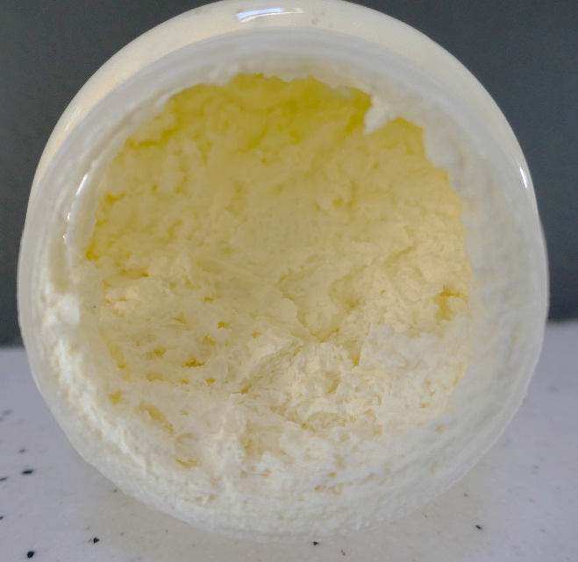
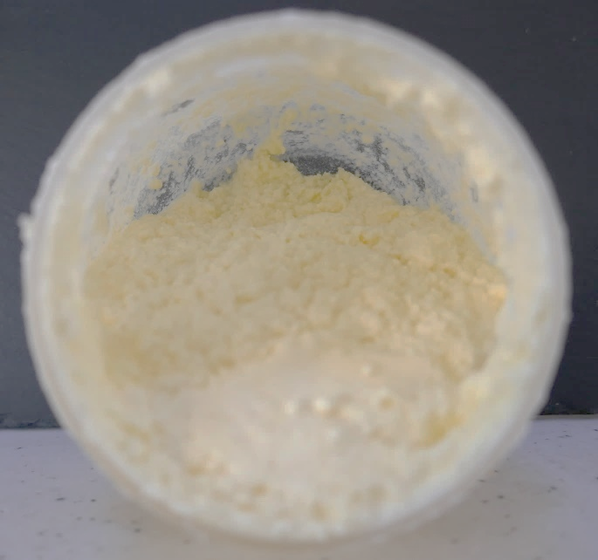
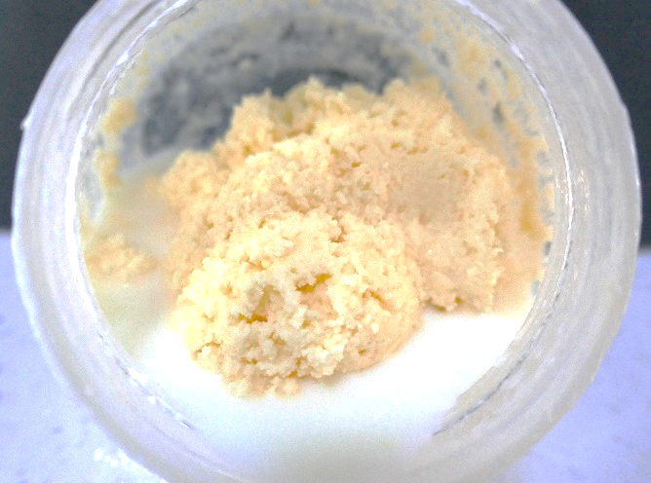
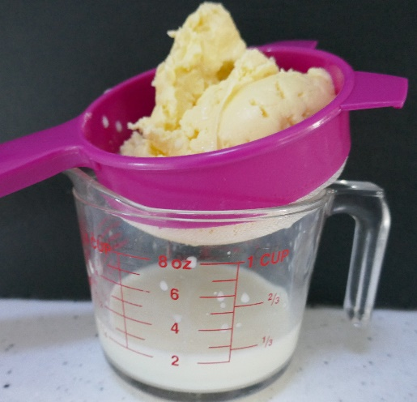
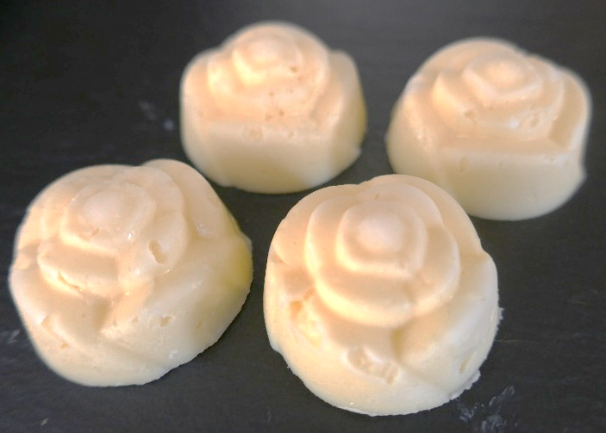
Homemade butter

What you will need per pair
- 125ml double cream
- Measuring jug
- Empty plastic or glass screw top jar
- Sieve
- Ice cube tray, butter mould or small dish/plastic container

Method
- Pour the double cream into the jar and screw on the lid.
- Shake the jar until butter forms. This could take between 5 and 20 minutes. You will probably hear a lump of butter hitting the sides of the jar as you shake it. The butter will be a pale-yellow lump and the liquid will be milky.
- Drain the liquid away. This buttermilk could be used to make soda bread or scones.
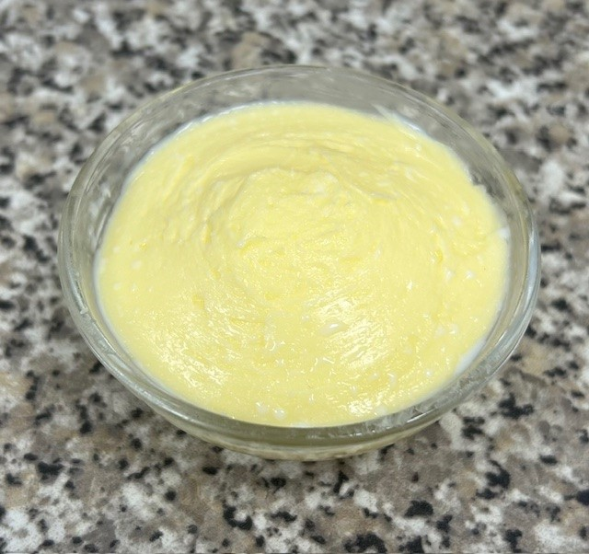
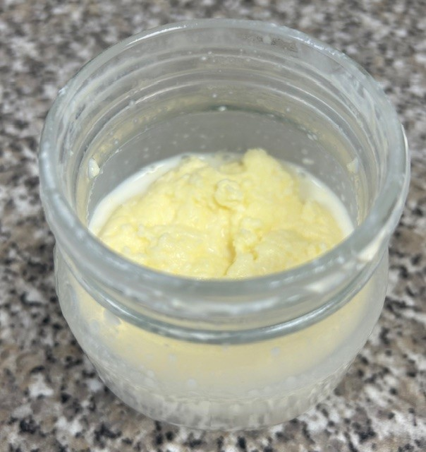
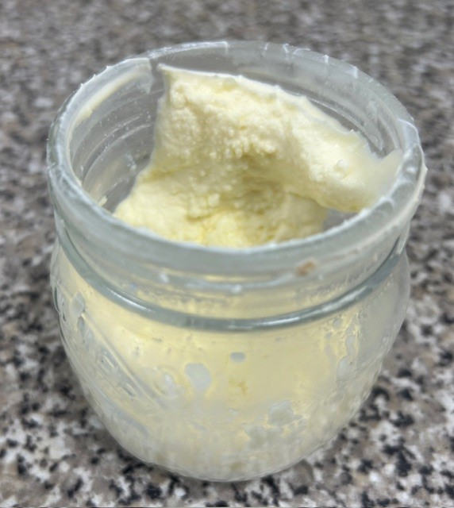
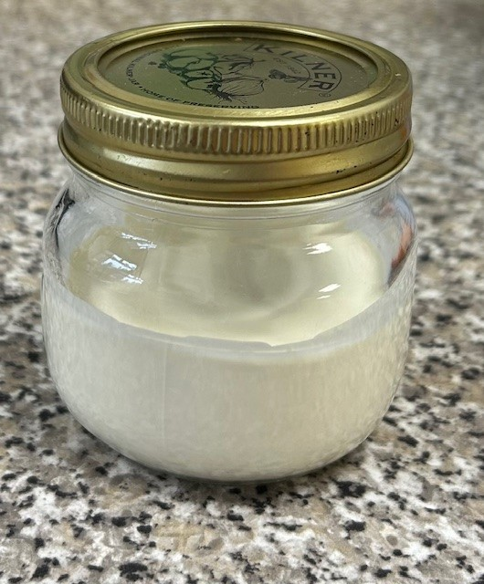
- Press the butter into an ice cube tray, butter mould or small dish and chill in a refrigerator until firm.
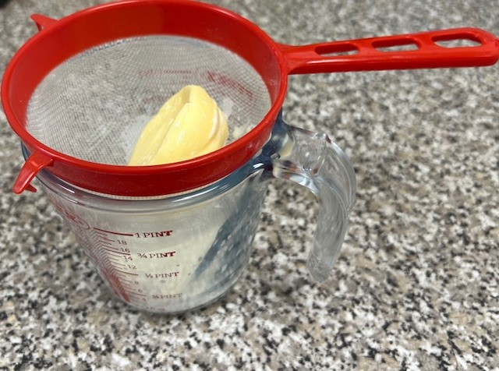
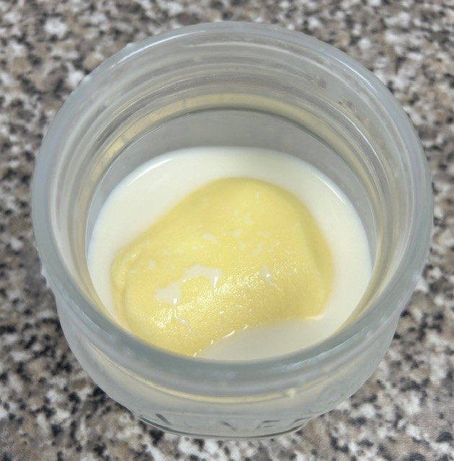
There are physical and chemical reactions:
- In a physical reaction, a substance changes form, but does not transform into a different chemical substance. Many, but not all physical reactions, are reversible, such as freezing and thawing of water.
- In a chemical reaction, one or more substances react to form a different substance. These reactions are usually irreversible. For example, boiling an egg results in a chemical change, where the proteins coagulate and the egg becomes solid. You cannot ‘unboil’ the egg.

Think about the changes that happened when you made butter.
- What did you see happening?
- Did it feel and sound different as you shook it for longer? Explain why.
- What do you think has happened to the cream?
- Where has the butter come from?
- Do you think we can turn the butter back into cream?
- Was making the butter a physical or chemical change? Explain your answer.
- In what ways is the butter different to the cream you started with?
- What was left in the jar? How are they different?

What about the bread?
This resource meets the Guidelines for producers and users of school education resources about food.
- Describe how the sliced bread and toast look different.
- Describe how the sliced bread and toast smell different.
- Describe how the sliced bread and toast tastes.
- Are the changes that take place when you toast bread reversible or irreversible?
- Is toasting bread a physical or chemical reaction?

