Pasta fiorentina

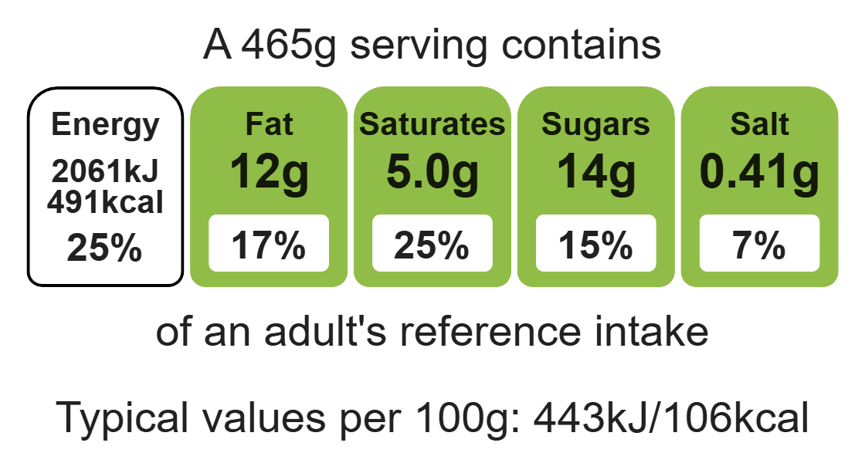
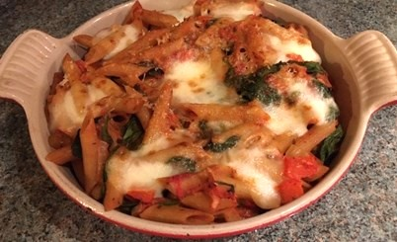

Ingredients (serves 4)
Complexity: medium – high

1 pepper

1 onion

Equipment

Weighing scales

Chopping board

Sharp knife

Garlic press

Large saucepan

Frying pan

Heat-resistant spoon

Colander

Ovenproof dish

1 clove garlic

350g wholemeal pasta

1 x 15ml spoon vegetable oil

2 x 400g cans chopped tomatoes

Fresh basil leaves or 1 x 5ml spoon dried basil

200g baby spinach

Black pepper

100g mozzarella

20g parmesan cheese

Method
Top tips
- Focus on fibre: Use whole wheat pasta to boost the fibre content.
- Reduce food waste: Use up any leftover vegetables such as courgettes.
- Turn up the flavour: Add chilli or paprika to enhance the flavour.
- Vary your protein: Why not use the sauce to top fish such as coley, haddock or hake.

- Prepare the ingredients:
- deseed and chop the pepper;
- peel and chop the onion;
- peel and crush the garlic;
- slice the mozzarella cheese;
- grate the parmesan cheese.
- Bring a large pan of water to the boil, add the pasta and cook for 10-15 minutes.
- Heat the oil in a frying pan, add the peppers, onion and garlic and cook gently for about 5 minutes until the peppers and onion are soft.
- Stir in the chopped tomatoes and basil. Simmer for 5 – 10 minutes.
- When the pasta is cooked remove from the heat and stir in the spinach and allow to wilt.
- Drain the pasta and spinach thoroughly and then return to the saucepan.
- Stir in the tomato sauce and mix. Season with black pepper.
- Place the pasta and sauce in a shallow ovenproof dish. Lay the sliced mozzarella cheese on top of the pasta. Add the grated parmesan cheese.
- Heat the grill. Place the dish under the grill and cook until the cheese has melted.

Food skills
Weigh, measure, cut, chop, slice, dice and trim, peel, crush, grate, melt, simmer and boil, fry and sauté, drain, mix, stir and combine, grill.

