Ful medames dip with quick flatbread

Ingredients
Complexity: medium
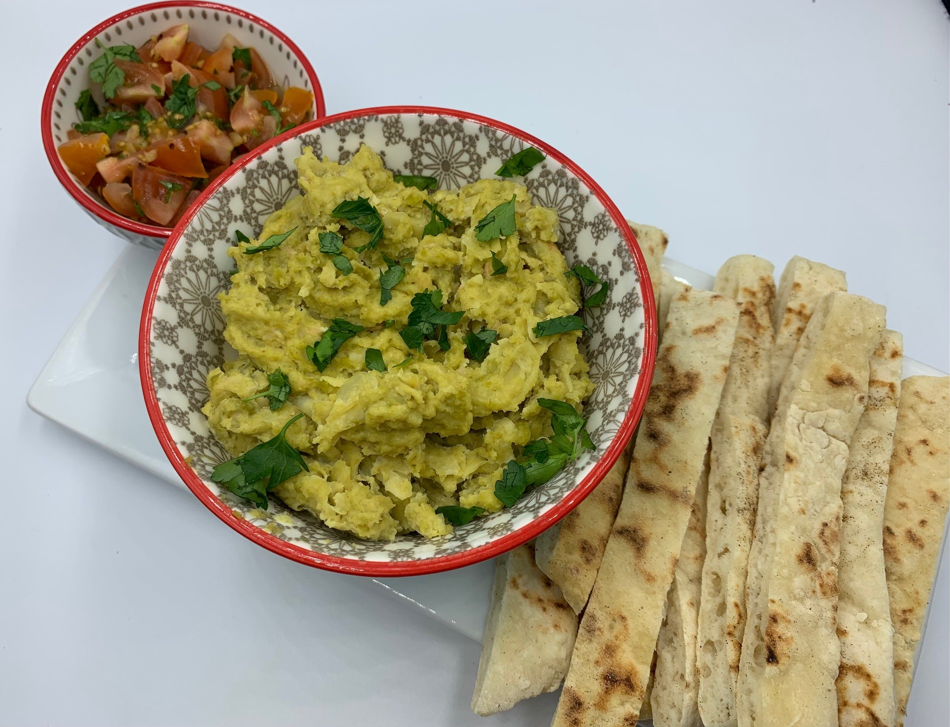
1 x 300g can fava beans or broad beans
2 garlic cloves
1 x 5ml spoon lemon juice
1 x 15ml tahini*
3 x 15ml hot water
1 x 15ml olive oil

Optional
15g fresh parsley - garnish

Quick flatbreads
150g self-raising flour
150g low fat natural yogurt
Black pepper
Extra flour for kneading

Equipment

Garlic press, saucepan, colander, fork or potato masher, measuring spoons, mixing spoon, chopping board, vegetable knife, mixing bowl, mixing spoon, small frying pan.

Method – Ful medames dip
- Peel and crush the garlic.
- Place the fava beans or broad beans, with their liquid, crushed garlic, and ½ x 5ml spoon lemon juice in a saucepan.
- Bring to the boil and then remove from the heat.
- Drain the excess liquid and return to the saucepan.
- Coarsely mash the beans with a fork or a potato masher in the saucepan.
- Return the saucepan to low heat. Add the tahini, hot water, olive oil and ½ x 5ml spoon lemon juice. Stir and cook gently for one minute, until heated through. Add more water if needed.
- Roughly chop the parsley, if using, and sprinkle over the dip.
Method - Flatbreads
- Mix the flour, yogurt and black pepper in a bowl.
- Tip onto a clean, floured surface and knead gently until smooth.
- Divide the dough into four and shape into balls.
- Flatten and shape into a circle, about the size of a saucer or 12-14 cm.
- Heat the non-stick frying pan and cook the flatbreads one by one until they are crisp and golden, approximately 3 minutes each side.
- Cut into slices and serve with the dip.

*Tahini contains sesame seeds, nut butters such as cashew or almond can be used as an alternative. Natural or Greek yogurt, or reduced fat cream cheese can also be used, but these will give a milder taste to the dip. If using yogurt, omit the olive oil.
Top tips
- Serve ful for breakfast with hot pitta or flat bread.
- Top with a mixture of chopped tomatoes, crushed garlic, chopped parsley, chopped fresh chilli and lemon juice.

Food skills
- Weigh
- Measure
- Peel
- Crush
- Boil
- Drain
- Mash
- Stir
- Chop
- Mix
- Knead
- Form and shape
- Fry

Did you know?
Fava beans are used nearly as much as chickpeas in Middle Eastern cuisine and particularly in Egyptian food. The word ful is, in fact, Egyptian for fava bean. Fava beans are often fried, salted and spiced and sold as a street food. The traditional way to eat ful medames is for breakfast with warm pitta bread.

In Syria, ful medames is served with a red small amount of red pepper paste, made from Aleppo pepper (also known as Halaby pepper).

Fava beans are grown in pods, which are usually removed before the beans are eaten or cooked. Fava beans can be eaten raw or boiled, steamed, fried or added to stews, soups and salads, and made into dips.

Tahini is used in many Mediterranean and Middle Eastern dishes. It is a paste made from ground sesame seeds and is often used in dips such as hummus and baba ghanoush (made with grilled or roasted aubergines). Tahini-based recipes appear widely in Armenian, Cypriot, East Asian, Greek, Indian, Iraqi and Turkish cuisines.

