The water content of fats

and spreads

Introduction
Many types of butter and spreads contain 15% - 18% water; low-fat spreads contain as much as 50% water. This is bound to the fat by chemical emulsifiers (usually stated as ingredients on the packet).

Heating breaks the emulsion so that the water separates from the fat and can be seen.

As the fat is less dense than water it floats to the surface.
Equipment
Test tubes
Labels
Test tube rack
Test tube holder
Fine pipette or dropper
Spatula
Beaker (500cm³ or large enough to hold the test tubes)
Thermometer
Bunsen burner
Tripod
Gauze
Mat
Eye protection

Materials
Samples of solid and liquid fats
Cobalt chloride test papers or Cobalt II thiocyanate test papers

You will need
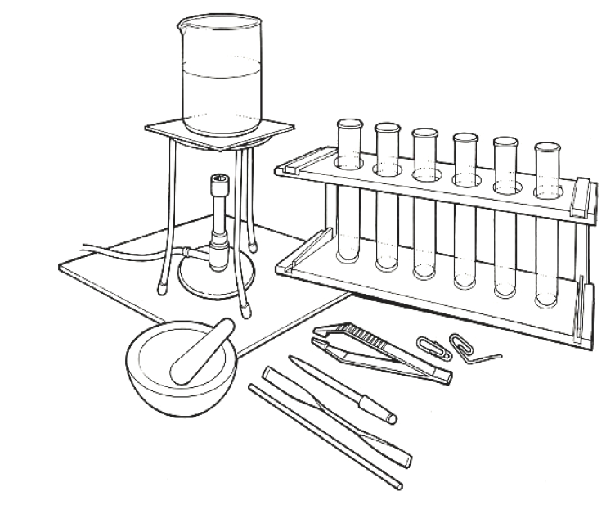


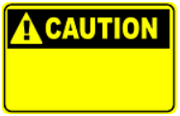


Some people are allergic or intolerant to a particular food or ingredient. Refer to the 14 allergens and check against student records before completing this experiment.

Do not consume food in a laboratory, or any food used for experiments, because it may contaminated.
Wear eye protection.
Care should be taken when heating the water and handling hot test tubes.

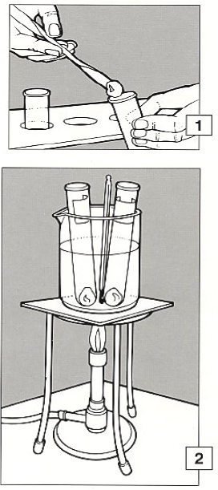
Method
- Push a lump of fat into a warm test tube so that it runs easily to the bottom. Add more until it is about 4cm deep. Do the same with other samples of fat and label the tubes.

- Stand the test tubes in a beaker of water, heat until the water temperature is 50 - 90ºC; continue for 10 – 20 minutes.

- Using a test tube holder, put the test tubes in a rack and let them cool. Look carefully for changes in the appearance of the fat. Measure and record the depth of any layers that can be seen.

- If a layer looks like water, carefully take out a sample, using a fine pipette, and put a drop on a cobalt chloride (or cobalt thiocyanate) test paper.

A change from blue to red confirms that it is water.

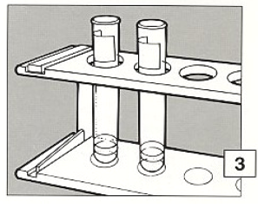

Extension work
Look at the label or packet of each fat. If ingredients are shown as grams per 100g, add up all the amounts to see if they total 100. If they do not, work out the shortfall and compare it with the thickness of the water layer in the test tube.

