Lemon and herb coley goujons

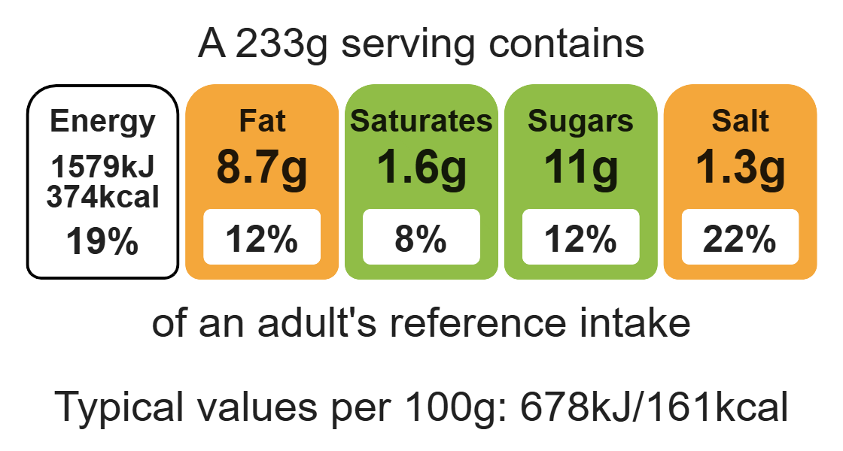
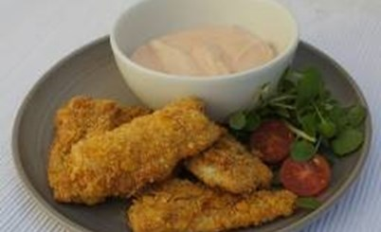

Ingredients (serves 2)

225g coley fillets, skinned

45g corn flakes
Complexity: medium

½ lemon

1 x 5ml spoon mixed herbs

Equipment

Baking tray

Weighing scales

Measuring spoons

Sharp knife

Chopping board

Grater/ zest

Small plastic bag

Small bowl

Fork

2 small plates and 1 large

Small bowl for dip

1 egg

2 x 15ml spoons plain flour

For the tangy dip:

2 x 15ml spoons reduced-fat mayonnaise

2 x 15ml spoons reduced-fat plain yogurt

2 x 15ml spoons tomato ketchup

½ x 5ml spoon paprika

Dash Worcestershire sauce

Method
- Preheat the oven to 200ºC or gas mark 6.
- Grease or line a baking tray.
- Cut the coley into finger-sized pieces. Cover and put in the fridge.
- Zest the lemon.
- Place the corn flakes, lemon zest and herbs into a small plastic bag. Press everything together to crush the flakes into crumbs. Pour onto a plate.
- Beat the egg in a shallow bowl. Spread the flour on a plate.
- Toss each piece of fish in the flour. Then dunk in the egg and roll in the crumbs. Place on the baking sheet and continue with remaining fish.
- Cook the coley goujon for 10-15 minutes, until golden.
- To make the dip, mix all of the ingredients together in a small bowl. Serve with the coley goujons.

Top tips
- Vary your protein: Try different fish such as salmon or haddock.
- Turn up the flavour: Add pesto or garlic to the egg instead of lemon and herbs to the corn flakes.
- Focus on fibre: Use breadcrumbs instead of corn flakes.

Food skills
Weigh, measure, cut, chop, slice, dice and trim, zest, crush, beat, glaze and coat, portion/ divide, bake.

