Spicy tomato soup

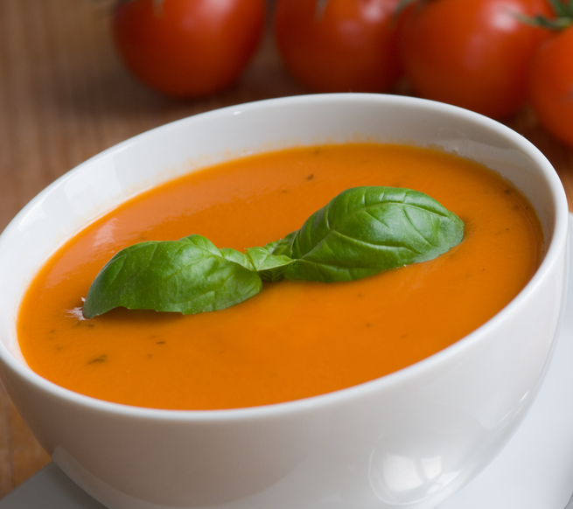
Complexity: medium
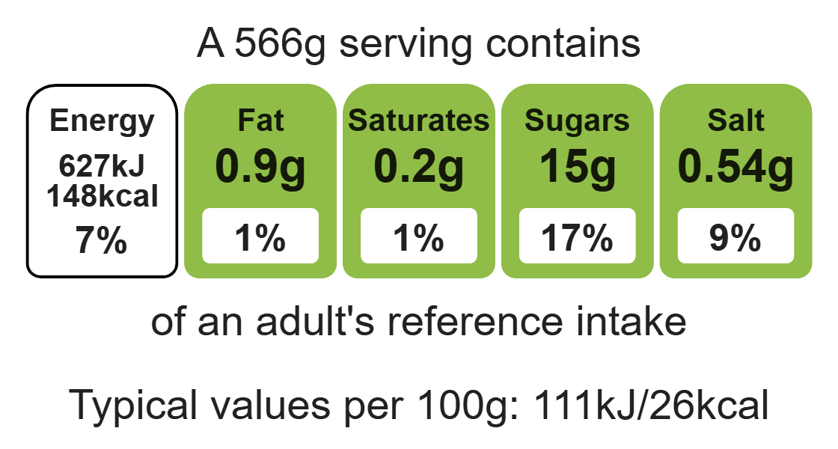

Ingredients (serves 2)
1 onion

Equipment

chopping board

sharp knife

vegetable peeler

saucepan

can opener (optional)

measuring spoon

measuring jug

heat- resistant spoon

blender

ladle

1 carrot
1 potato
1 can chopped tomatoes (400g)
500ml water
1 reduced-salt stock cube
½ x5ml spoon dried chilli flakes
1 x15ml spoon tomato puree

Method
- Prepare the vegetables:
- peel and slice the onion;
- top and tail, peel and slice the carrot;
- peel and cut the potato into small pieces.
- Heat the oil in the saucepan. Add the onion and sauté until soft.
- Add the carrot, potato, chopped tomatoes, water, reduced-salt stock cube, chilli flakes and tomato puree.
- Stir everything together, bring to the boil and then simmer for 20 minutes.
- Ladle the mixture into the liquidiser and blend until smooth.

Top tips
- Reduce food waste: Use up any leftover vegetables to prevent food waste e.g. peppers, mushrooms.
- Focus on fibre: Serve with wholemeal bread to boost the fibre.
- Turn up the flavour: Try adding ½ x 5ml spoon of herbs and spices e.g. basil, mixed herbs, paprika.

Food skills
Measure, peel, cut, chop, slice, dice and trim, mix, stir and combine, melt, simmer and boil, blitz, puree and blend.

