Rosca de reyes
(Mexican Christmas bread)
Complexity: medium

Ingredients

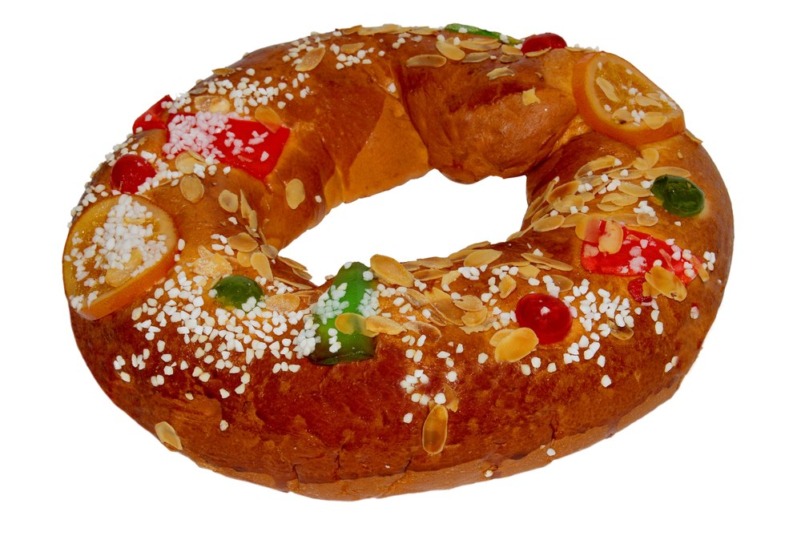
100ml semi-skimmed milk

45g sugar

50g butter or soft baking spread

1 x 15ml spoon instant yeast

200g strong plain flour

½ 5ml spoon salt

2 eggs

2 x 15ml vegetable oil

Candied fruits

Equipment
Small saucepan, mixing bowl, measuring jug, wooden spoon, flour dredger, baking tray, oven gloves, cooling rack.

Method
- Preheat the oven at 190°C or Gas mark 5. Grease or line a baking tray.
- Place the milk, sugar and fat in a small saucepan. Over a gentle heat combine the ingredients and heat until slightly warm to the touch and the fat has melted.
- Lightly beat the eggs and oil together. Stir in the milky mixture.
- Place the flour, yeast and salt in a mixing bowl.
- Add the liquid to the flour and mix well until the dough pulls away from the side of the bowl.
- Place the dough on a lightly floured surface and knead the dough for about 10 minutes until smooth and elastic.
- Return the dough to a greased mixing bowl, cover and leave to rise in a warm place until doubled in size; about an hour.
- Gently knock back the dough and shape as required. Divide into 12 equal pieces for rolls or shape into a ring.
- Place on a greased tray, decorate and leave to rise for 20-25 minutes until doubled in size.
- Bake for 20-25 minutes until golden brown.
- Cool on a cooling rack.

Top tips
- Candied fruits are traditionally used for decoration to symbolise jewels in the crown so make sure you get some that are ruby and emerald like.
- Don’t forget to put your shaped dough onto the baking tray before you start decorating it as moving it can disturb your efforts.

Food skills
- Weigh.
- Measure.
- Melt.
- Stir.
- Beat.
- Knead.
- Prove.
- Form and shape.
- Decorate.
- Bake.

