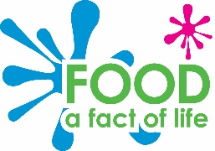

On the go product
planning sheet
This planner belongs to:
_____________________

Date: ________________________

Evaluating
Did your on the go product meet all your design criteria? _____

Explain what you did and anything that you did not manage to do.
_______________________________________________________
_______________________________________________________
_______________________________________________________
Did your on the go product look and taste as you expected?
Explain your answer.
_______________________________________________________
_______________________________________________________
_______________________________________________________
Explain how you would improve your product.
_______________________________________________________
_______________________________________________________

Design a flyer to advertise your product.

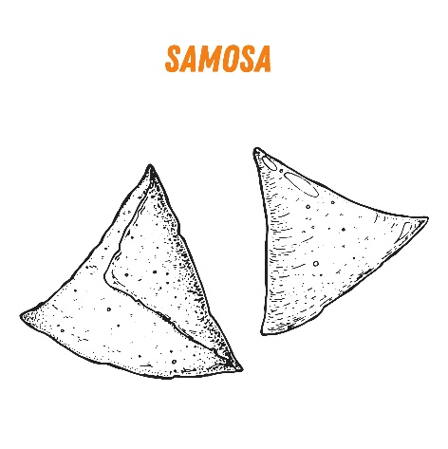
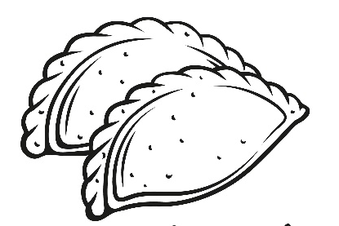
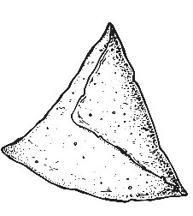

© Food – a fact of life 2023
Planning
Recipe name: ___________________________________
Ingredients:
____________________
____________________
____________________
____________________
____________________
____________________
____________________

Equipment:
____________________________________________________
____________________________________________________
____________________________________________________
Method:
___________________________________________________
___________________________________________________
___________________________________________________
___________________________________________________
___________________________________________________
___________________________________________________
___________________________________________________
___________________________________________________
___________________________________________________
___________________________________________________
___________________________________________________

Design criteria

The on the go product will:
______________________________________________________
______________________________________________________
______________________________________________________
______________________________________________________
______________________________________________________
______________________________________________________
______________________________________________________
______________________________________________________
______________________________________________________ ______________________________________________________
______________________________________________________
______________________________________________________ ______________________________________________________
______________________________________________________

Labelled drawings of how the product will look.
From the outside On the inside

© Food – a fact of life 2023

