What went wrong?

- Explain what may have caused this apple cake to sink.

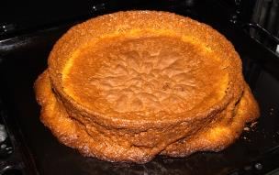
a) ………………………………………………

………………………………………………….

b) ………………………………………………

………………………………………………….

c)……………………………………………….

………………………………………………….

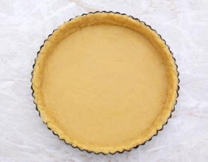
- Explain how to prevent a shortcrust pastry case from shrinking.

a) ………………………………………………

………………………………………………….

b) ………………………………………………

………………………………………………….

c)……………………………………………….

………………………………………………….

- Identify the reasons why this bread has a heavy, dense texture and appearance.

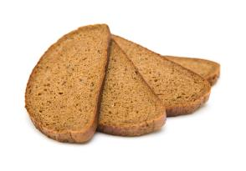
a) ………………………………………………

………………………………………………….

b) ………………………………………………

………………………………………………….

c)……………………………………………….

………………………………………………….

