Food skills guide

When teaching children to prepare food, it is important that they learn how to use kitchen equipment correctly. This is so they can work safely, efficiently and independently.

The following photographs and notes are designed to help demonstrate good practice when using kitchen equipment.

The bridge hold
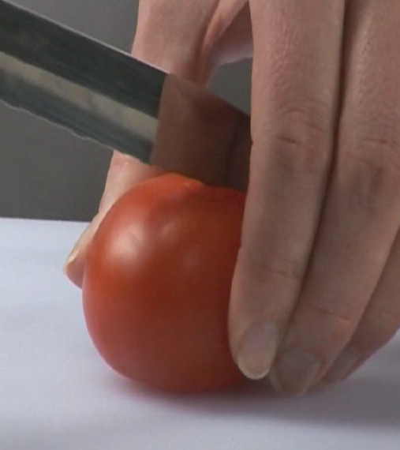
Method: Create a bridge over the food with your hand. The fingers should be on one side and the thumb should be on the other. Hold the food to be cut between the fingers and thumb creating a bridge. The knife should go through the bridge to cut the food.

Safety: This method ensures that fingers are out of the way as the knife cuts through the food.

Tips: To help children remember this method, they might like to think of the knife as a train which goes under the bridge and through the tunnel.

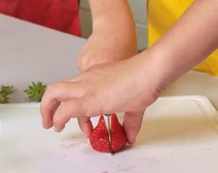
Use: This method is useful in lots of situations. It is especially useful for cutting circular items into halves and quarters, e.g. tomatoes, apples.

The claw grip

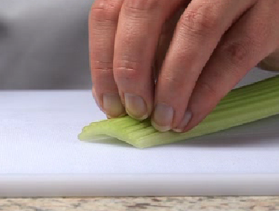
Method: Create a claw by partly curling your fingers together into a claw shape. Press the tips of your fingers (nails) against the food to be gripped and then lean your fingers slightly forward of your nails so that you cannot see your nails when you look down on your hand.

Safety: This method ensures that finger tips are tucked out of the way and will not get caught by the knife.
Tips: To help children remember this method emphasises creating a claw, gripping food and tipping the hand – claw, grip, tip, cut.
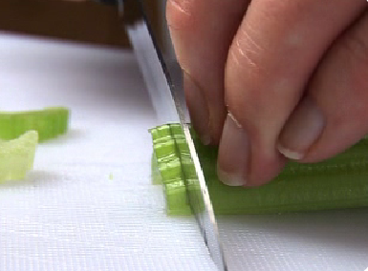
Use: This method is used to secure items so they can be cut safely. It is the best method to use when food needs to be cut into slices or diced.

Fork secure

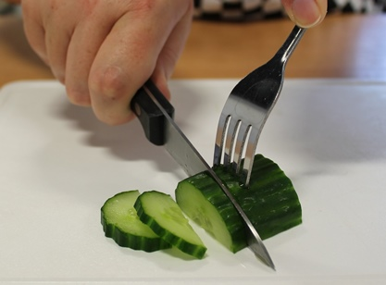
Method: Place the food to be cut on a chopping board. If the food is likely to move or wobble, e.g. a tomato, hold it securely around the edges or sides. In a firm but controlled way, dig the fork into the food with the fork prongs going downwards towards the chopping board. Continue holding the fork in one hand, take a knife with the other hand and slice the food.
Safety: This method ensures that the food is stable and keeps fingers out of the way while it is cut.
Tips: Ensure that children take their time while embedding the fork in the food and make sure they are driving the fork downwards and not diagonally which could cause it to come out at the side of the food and go into their hands.

Use: This method is used if an adult feels that the claw method would be too challenging for children, perhaps because of their age or ability.

Flat surface down
Make sure that the food being cut has a flat surface or most stable surface face down on the chopping board so it is stable while being cut.

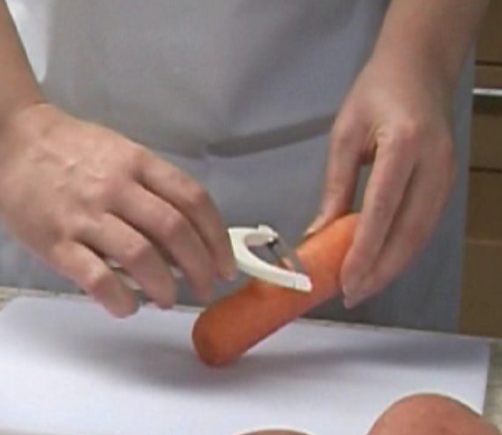
Peeling
Teach children to peel away from themselves while using a peeler. With long foods such as carrots they should hold one end and peel from the middle away from themselves and then hold the peeled end and repeat the same process.

Grating
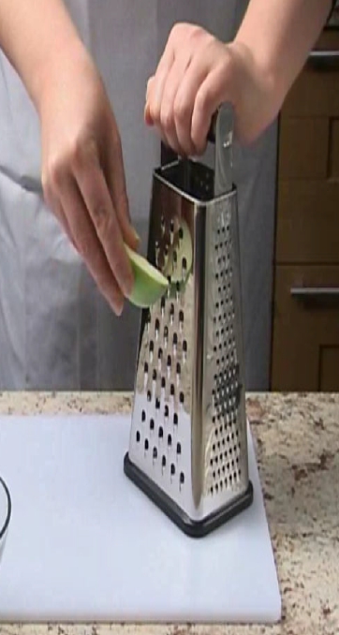
Remember, you do not have to grate every bit of the food. It is best to leave a small chunk at the end to hang on to. This means that fingers are not pressed against the grater.

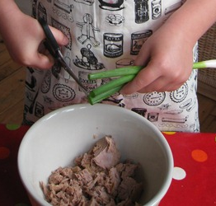
Scissors
Kitchen scissors can sometimes be a useful alternative to a knife, especially if children are quite young. Scissors are good for snipping herbs and spring onions – even pepper slices!

Part prepare
It may sometimes be necessary to partly prepare foods so they are at a stage where children can handle them safely and confidently. For example, when making coleslaw, the teacher could quarter the cabbage and cut out the heart. Children would then be able to take a quarter, separate the layers of leaves with their hands and cut one or two leaves at a time using the methods previously mentioned.

