Mealtimes

Time | Meal
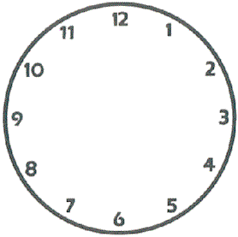 | At breakfast time, I have…
 | At lunchtime, I have…
 | In the evening, I have…
 | At other times, I have…

