Down on the farm
What do you think you might find living on a farm?
Draw a picture in the spaces.
What things do the animals need to be happy and healthy?
Which animal do these foods come from?
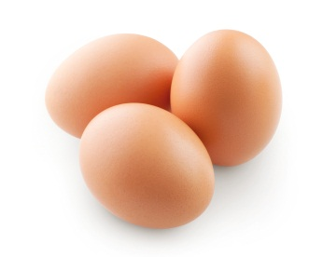  Eggs | 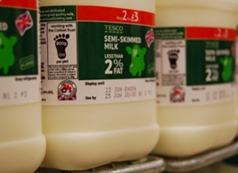  Milk | 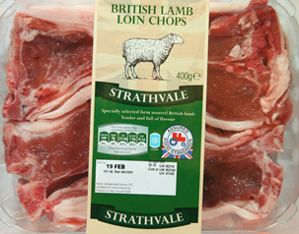  Lamb chops

