Tomato and basil tart
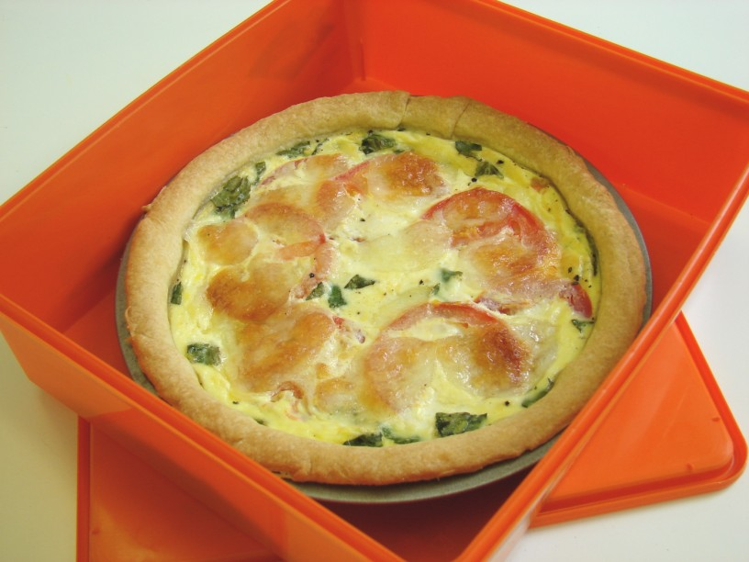
Complexity: medium
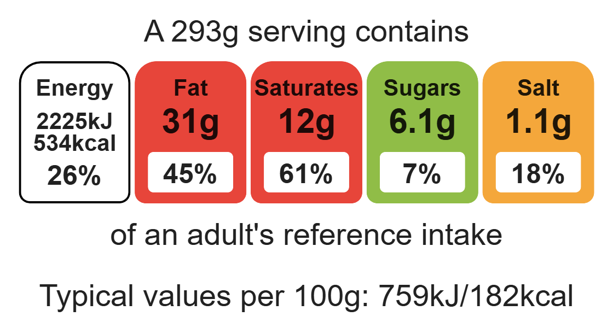

Ingredients (serves 2)

Equipment

weighing scales

mixing bowl

sieve

measuring spoons

palette knife

flour dredger (optional)

rolling pin

sandwich tin or 18cm flan ring

fork

chopping board

sharp knife

grater

measuring jug

baking tray

100g plain wholemeal flour
50g baking fat/block
2-3 x 15ml spoons cold water
2 tomatoes
50g reduced-fat cheese
Handful of basil leaves
2 eggs
125ml semi-skimmed milk
Black pepper

Method
1. Preheat oven to 180°C or gas mark 4.
2. Make up the shortcrust pastry:
- sift the flour into the bowl;
- rub in the fat into the flour, using your fingertips, until it resembles breadcrumbs;
- add the cold water and start to mix together;
- mix to form a firm, smooth dough.
3. Roll out the pastry, on a lightly floured surface.
4. Line the flan ring or sandwich tin.
5. Trim the edges of the pastry using the palette knife.
6. Prick the bottom of the pastry with a fork.
7. Slice the tomatoes.
8. Slice the cheese.
9. Whisk the eggs and milk together in the measuring jug using the fork. Tear the basil into the mixture, then add a few twists of black pepper.
10. Pour the egg mixture into the pastry shell
11. Arrange the tomato slices and cheese, over the top.
12. Place on a baking tray and bake for 30 minutes, until golden and firm.

Top tips
- Vary your protein: Add cooked chicken or tuna to your tart.
- Turn up the flavour: Add 1 x5ml spoon of herb or spices e.g. basil, oregano or dried chilli flakes
- Reduce food waste: Use up any leftover veg e.g. peppers or courgettes. Roast them and serve with the tart.
- 5 A DAY: Serve with a seasonal side salad.

Food skills
Weigh, measure, sift, rub- in, mix, stir and combine, roll out, cut, chop, slice, dice and trim, whisk, bake.

